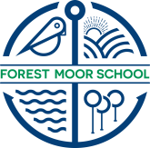
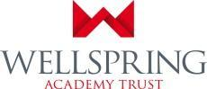

Do you want a job where you make a difference to the lives of children and young people?
Do you want to be inspired on a daily basis by your work?
Are you passionate about inclusion and committed to meeting the needs of all children?
Do you have the ability to engage, motivate and promote the learning and personal development of pupils?

Vacancy at Forest Moor for:
DT Instructor

Permanent Contract - Required from September 2022
Three days a week – 22.5 hours (Days & hours negotiable)
Salary: SCP 18-23
FTE £22’875 - £25’277
Actual £13’910 - £15’371

We require an exceptional Design & Technology instructor at Forest Moor Special School who is passionate about providing the best possible education and care for vulnerable students in an inspiring learning environment. This is a new post for the school and is another part of the jigsaw for development at Forest moor School. You will have your own purpose built workshop (See pictures) which you will have the opportunity to develop. Funding has been set aside to work with the successful candidate to develop this fantastic space. DT is a very important subject for SEMH students and you will be given the flexibility to design a programme suited to the needs of the students. For some, that might be up to a relevant qualification level, but for other it might be at a more therapeutic level.
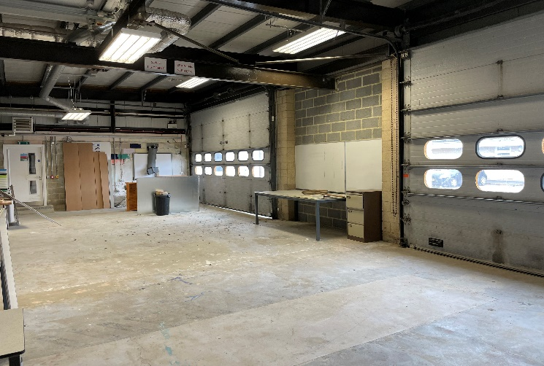
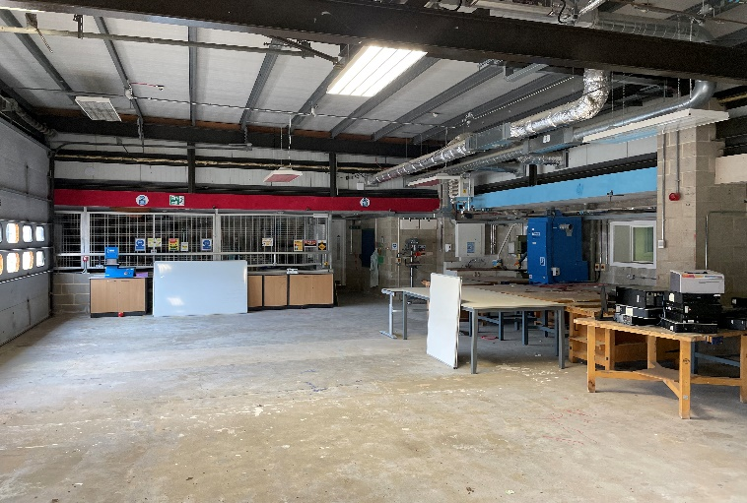

In this new post you will work closely with the Assistant Principal and other instructors to work towards a new exciting vocational, practical offer for the students. The post is initially for 22.5 hours over three days a week. There may be some flexibility of days and hours and this could be discussed upon appointment.

It could not be a more exciting time to join Forest Moor School. The school recently joined Wellspring Academy Trust and has just had nearly one million pounds invested in making the building a high quality SEMH provision. The school is very much on a rapid improvement plan and many visitors have remarked about the changes they can see since September. We are excited about our journey and are looking for creative teachers to join us on the next part of our journey.

Forest Moor is a cross-phase SEMH Special School with around 80 students on roll serving a wide catchment across North Yorkshire. This post is ideal for a person looking for a fresh challenge in an inspiring learning environment where we provide children with ‘second chance’ learning. The post will suit a candidate who has the commitment, passion and resilience to make a difference to pupils who have a range of social, emotional, mental health and special educational needs.

This post would suit someone with a proven track record of exceptional practice, who is able to work with vulnerable pupils with social, emotional and mental health difficulties (SEMH). It would suit an individual who is passionate about making a real difference to student’s life chances and supporting them in achieving their potential in essential life skills, which is a high priority for Forest Moor School. The ability to be creative and use imaginative flair to engage is essential, along with having resilience, drive and high expectations to inspire students to achieve.

We are looking for a team player with presence, passion and a commitment to inclusion with the ability to work creatively for the benefit of pupils at our school. In return, you will have the opportunity to work with great colleagues as part of a supportive team and the ability to develop your career in our specialist setting.
Successful candidates will be working alongside dedicated, talented and highly skilled people and will be given a full induction at both Forest Moor and one of the Trusts other SEMH provisions.

We encourage visits to the school, particularly for those mainstream teachers considering the switch into an SEMH special setting.

If you would like visit the school before you apply, please call Steve Tighe, Interim Associate Principal on 01423 779232 to arrange a school visit.

Completed applications should be e-mailed to: Gemma.Ashton@forestmoor.org.uk
Your letter of application should outline why you feel your experience makes you a strong applicant for this exciting opportunity
The closing date for this post is: Thursday 30th June at 9am.

We expect that interviews will take place the following week.

Forest Moor School is committed to safeguarding and promoting the welfare of children and young people and expects all staff and volunteers to share this aim. We ensure that all our recruitment and selection practices reflect this commitment.

