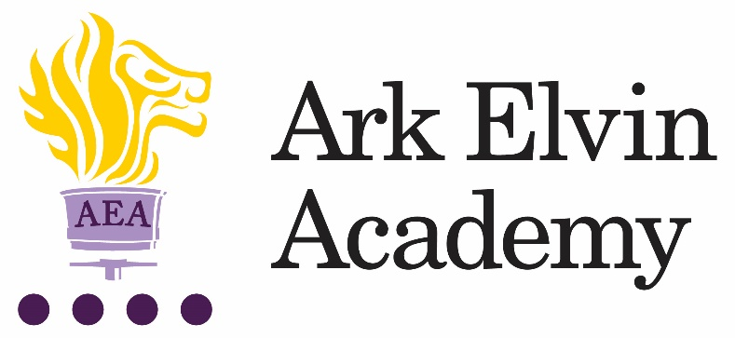

Mainscale DT Teacher

At Ark Elvin Academy we are proud of the excellent education we offer each of our pupils. Our team of enthusiastic, high expectations staff have transformed our school and we are just as excited about the next step in our school improvement journey as we work together to deliver the outstanding education our community need and deserve. We are deeply committed to our mission:
“To ensure that every pupil leaves Elvin confident, articulate, and culturally aware; able to pursue careers they are passionate about, contribute to society and live happy, healthy and fulfilled lives.”
In our last OFSTED inspection (October 2019) it was recognised that at Ark Elvin Academy:
“Pupils, parents and staff all agree that Ark Elvin Academy has improved out of all recognition. Pupils are proud of the school.”
“The headteacher and leaders have very high expectations…… Staff want all pupils to succeed in every area of their lives, not just academically.”
“The school is a calm, safe and supportive place for pupils. Pupils behave very well in lessons. They get on well with one another and with adults.”
We are a large non-selective secondary school in the London borough of Brent, with excellent transport links to central London. We are committed to ensuring teachers can focus on teaching and have the opportunity to refine and develop their practice in the classroom and develop their leadership skills, we have:
- twice as many training days as is standard
- weekly professional development for all staff.
In recruiting our next mainscale DT Teacher, we are seeking the following from applicants:
- A passion for their subject, curriculum development and teaching and learning
- A commitment to serving our diverse community in Brent
- High expectations for themselves and our pupils
- A keenness to learn and develop both as a teacher and a leader
- A team player with high standards of professionalism and courteousness.
You will become part of a close-knit professional community of enthusiastic colleagues who benefit from the training, guidance, and support from both the Ark network, one of the country’s top performing school groups.
Our Design Technology department is a small, experienced and committed team of teachers. We are passionate about offering our pupils the wrap around opportunities, including subject-specific enrichment opportunities.
We passionately believe in our six pillars, and they drive all our thinking and our school improvement at Elvin:
Strong Discipline
Calm, purpose, and order are established through the consistency of expectations and explicit teaching of discipline.
High Quality Teaching
Teachers are subject experts with an excellent understanding of the intellectual journey they are taking their pupils on and have mastery in effective teaching skills.
Mastery Curriculum
Our curriculum design enables pupils to make rapid progress and develop a framework of knowledge and understanding in each subject area that provides a solid foundation for further study.
Raising aspirations and enrichment
Pupils understand the opportunities that a school and university education will afford them in terms of careers and quality of life. Pupils develop their passions and interests through an Our extensive enrichment programme.
Character development
Pupils develop the characteristics that support their academic achievement, create thoughtful citizens, and allow them to make reflective choices over their personal lives.
Developing leaders
All members of staff see themselves as leaders within an aligned community of professionals and are systematically trained in best practice. We create high performing teams to drive our school improvement.
Ark Elvin is on an exciting improvement journey – join us and be part of that change.
Interested in finding out more? Please email our HR advisor, Chantel: c.mutongole@arkelvinacademy.org for an initial conversation and to arrange a call with our principal, Rebecca Curtis.
Closing date: | Tuesday 5th July 2022
Interview: | TBC
Start date: | Sept, Oct 2022 or January 2023
Salary: | Ark main pay scale/ Upper pay scale (£32,960 - £53,341)
Ark is committed to safeguarding children; successful candidates will be subject to an enhanced DBS check
Job Description: DT Teacher
Reporting to: Head of Department
Key responsibilities
- To plan, resource and deliver lessons and sequences of lessons to the highest standard, thereby ensuring meaningful learning takes place and pupils make rapid and sustained progress
- To develop one’s own teaching practice to a level of advanced proficiency
- To fully implement all academy routines and techniques for creating a culture of high expectations
- To contribute to the enrichment, extra-curricular and raising aspirations programmes
- To provide daily pastoral tutoring to a form group
- To contribute to the effective daily working of the academy.
Outcomes and Activities:

Teaching and Learning
- With direction from the Head of Department and within the context of the academy’s curriculum and schemes of work, to plan and prepare effective teaching schemes and lessons
- To teach engaging and effective lessons that motivate, inspire, and improve pupil attainment
- To use regular assessments to set targets for pupils, monitor pupil progress and respond accordingly to the results of such monitoring
- To produce/contribute to oral and written assessments, reports and references relating to individual and groups of pupils
- To develop plans and processes for the classroom with measurable results and evaluate those results to make improvements in pupil achievement
- To ensure that all pupils achieve at least expected progress and the majority of pupils make more than expected progress
- To maintain regular and productive communication with pupils, parents and carers, to report on progress, sanctions and rewards and all other communications
- To provide or contribute to oral and written assessments, reports and references relating to individual pupils and groups of pupils
- To direct and supervise support staff assigned to lessons and when required participate in related recruitment and selection activities
- To implement and adhere to the academies behaviour management policy, ensuring the health and well-being of pupils is maintained at all times • To participate in preparing pupils for external examinations.

Academy Culture
- To support the academy’s values and ethos by contributing to the development and implementation of policies, practices and procedures
- To help create a strong academy community, characterised by consistent, orderly behaviour and caring, respectful relationships
- To help develop a school/department culture and ethos that is utterly committed to achievement and good discipline
- To be alert and active on issues relating to pupil welfare and child protection
- To support and work in collaboration with colleagues and other professionals in and beyond the school, covering lessons and providing other support as required.

Other
- To undertake, and when required, deliver or be part of the appraisal system and relevant training and professional development
- To undertake, within reason, other various responsibilities as directed by the Head of Department or Principal.

Person Specification: Design & Technology

Qualification Criteria
- Qualified to at least degree level in an applicable subject
- Qualified to teach and work in the UK

Experience
- Evidence of being, or having the potential to be, an outstanding teacher of the subject.

Knowledge
- Up to date knowledge in the curriculum area
- An understanding of what an outstanding education looks like in the classroom
- An understanding of the strategies needed to establish consistently high expectations

Behaviours Leadership
- Effective team worker
- High expectations for accountability and consistency
- Vision aligned with Ark’s high aspirations, high expectations of self and others
- Genuine passion and a belief in the potential of every pupil
- Motivation to continually improve standards and achieve excellence • Effective listening skills that lead to a strong understanding of others • Commitment to the safeguarding and welfare of all pupils.

Teaching and Learning
- Excellent classroom teacher, or potential to be one, with the ability to reflect on lessons and continually improve their own practice
- Effective and systematic behaviour management, with clear boundaries, sanctions, praise and rewards
- Thinks strategically about classroom practice and tailoring lessons to pupils' needs
- Understands and interprets complex pupil data to drive lesson planning and pupil attainment
- Good communication, planning and organisational skills
- Demonstrates resilience, motivation and commitment to driving up standards of achievement
- Acts as a role model to staff and pupils
- Commitment to regular and on-going professional development and training to establish outstanding classroom practice.

Other
- Commitment to equality of opportunity and the safeguarding and welfare of all pupils
- Willingness to undertake training
- This post is subject to an enhanced Disclosure & Barring Service check.

