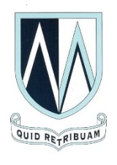
MOUNT ST MARY’S CATHOLIC HIGH SCHOOL

THE E ZONE

In the E Zone, we strive to create a calm, caring atmosphere where students feel safe and can make friends from all over the world. Everyone is welcome, whether EAL or not, and our students regard it as a sanctuary. The E Zone is packed every lunch and break time with students from every year group; it is a hive of activity, buzzing with an eclectic mix of languages.

Our staff are qualified EAL teachers with additional subject specialist knowledge. Moreover, we are all bi-lingual or tri-lingual ourselves, giving us an added layer of insight into language learning and the extra needs of students learning English as an additional language.
Our support ranges from in-class support to 1:1 and group sessions within the E Zone. We are a diverse and adaptable team who go the extra mile to ensure our students achieve the best they possibly can and are equipped with the life skills needed beyond our very special MSM community.

- EAL students at Mount St Mary's achieve one grade higher than EAL students nationally.
- 75% of EAL students at Mount St Mary's achieve a Grade 5 or higher at GCSE.
- At least 51 different languages are spoken by EAL students at Mount St Mary's.

