“A place for everyone…to work and succeed!”

Welcome from the Principal
We live in exciting times – our great city of Liverpool is currently undergoing an amazing renaissance, with new jobs, investment and opportunities. We are proud to tell you that North Liverpool Academy is also undergoing its own renaissance. Our most recent Ofsted inspection has graded us as a ‘good’ school in all areas. Our exceptional academic results and reputation continue to confirm us as one or the fastest improving schools in Liverpool.
NLA lies at the heart of the local community. It is our task to prepare our young people for the exciting challenges and opportunities ahead. Our curriculum inspires a lifelong passion for learning and equips our students with the confidence and skills to take advantage of the tremendous opportunities on our doorstep and further afield.
Our ethos and core values are built around a culture of enjoyment and achievement. We believe that when joining our team as a student, parent, member of staff or a member of the local community, by embracing our values of high aspiration, transformational experience, community engagement and excellent achievement we will deliver outstanding educational outcomes for all.
We believe it is our job to ensure that our students take pride in all they do and graduate from North Liverpool Academy with the confidence to take on the competitive and ever-changing world around us. This is a truly exciting time for the North Liverpool Academy as we establish a world class academy with excellence for personal development, leadership, teaching and learning.
If you have any questions, would like a conversation or if you wish to come and see the outstanding work happening across our academy please feel free to contact us.
Emily Vernon
Principal

History of NLA

North Liverpool Academy opened in 2006 as one of the first Academies in the country and has benefitted from the various advantages that brings. The Academy is well resourced both in terms of facilities and staff. It is housed in a superbly equipped building, erected in 2009 and enjoys an excellent reputation within the local community.

The Trust

Northern School Trust is a not-for-profit education charity. It is a well-developed MAT (Multi-Academy Trust) held in high regard by the DFE. There are currently four schools in the Trust including an innovative Studio School and a Life Sciences UTC in the centre of Liverpool and a UTC based in Wigan.

The Trust is proud of its collaborative way of working and is developing into a nationally recognised and trusted academy sponsor with an excellent reputation. The Trust has a wide range of expertise and specialised experience to call upon, having access to the FE, University, private and voluntary sectors as well as partner schools and consultant expertise drawn from across the UK.

The Trust has a central team that provides best value and an efficient service delivery in areas of HR, Finance, Enterprise & Marketing, Governance, Strategic ICT Development, Data and Facilities Management to all NST schools.

Latest Ofsted

North Liverpool Academy’s recent Ofsted inspection rated the school officially as a Good School, along with the improving trend in academic results confirms the school as one of the most improved in Liverpool.

Ofsted recognised the significant improvements and achievements made as well as the aspirational ambition of the academy. The inspectors praised the “highly effective leadership, clear vision, high standards” and “strong ambition” and emphasised that “the schools is well placed to continue improving”.

Rated Good across the board, inspectors said that: “Pupils enjoy their learning and have positive relationships with one another and their teachers.”

“Pupils behave well in lessons and take pride in their work”

The report also praised the Sixth Form saying: “It is effectively led and consequently has improved since the last inspection. Outcomes are good because students are taught well. When they leave, an increasing number of students move on to University courses, further education, employment and training” showing a sustained picture of improvement.

Latest results
Key Stage 4
2018 Exam Results – Invalidated
Attainment
- Our Attainment 8 score is 41.4
- 59.5% of pupils achieved a 4 or above in one of the English GCSEs
- 51.8% of pupils achieved a 4 or above in GCSE Maths and in one of the English GCSEs
- 30.4% of pupils achieved a 5 or above in GCSE Maths and GCSE English
- 58.9% of pupils gained a grade 4 or above in GCSE Maths
Progress
- Our Progress 8 score is -0.16
- Our Maths Progress 8 score is -0.04
- Our English Progress 8 score is -0.63
Destinations
96% of students from this cohort have continued to be in education or training, or move on to employment at the end of 11 to 16 study
Key Stage 5
Value added by qualification category.
*Figures taken from SISRA Analytics and currently in-validated

*This is currently only available for A level and Applied General qualifications; this will be updated January 2018 when national data is released.
- The Progress Measure for A level results is -0.20
- The Progress Measure for Applied General qualifications is -0.56
Average grade by qualification category
*Figures taken from SISRA Analytics and currently in-validated
- The average grade that students achieve in A level qualifications is D+
- The average grade that students achieve in Vocational qualifications is Distinction-
- The average grade that students achieve in Applied General qualifications is Distinction-
- The average grade that students achieve in Technical level qualifications is D-
Progress in English and Maths (from Key Stage 4)
*Figures taken from SISRA Analytics and currently in-validated
- The Progress measure for English Level 2 qualification is 1.06
- The Progress measure for Maths Level 2 qualification is 0.06
Retention
- 86% of students in Year 12 2016/17 have progressed to Year 13 in 2017/18

Key stage 5 destinations
- 75.6% of students in Year 13 in 2017/18 now attend university or college
- 12.8% of students in Year 13 in 2017/18 are now in full-time employment
- 5.1% of students in Year 13 in 2017/18 are now in an Apprenticeship
- 93.5% of students continue in education or training, or move on to employment at the end of 16 to 19 study

Key stage 4 destinations
*This data is in-validated at present, and will be updated on publication of the September Guarantee
For the academic year 2017/18, 92.1% of students continue in education or training, or move on to employment at the end of 11 to 16 study

Charter Mark & Achievements
- Flagship Inclusion Mark
- Leadership Academy Award
- Sainsbury’s School Sports Mark Gold
- Career Connect Quality Awards
- Healthy Schools Award
Our Amazing Facilities:
North Liverpool Academy moved into a purpose built state of the art building in September 2009 and has the following outstanding facilities to name a few:
- 7 Technology classrooms
- 13 state of the art Science classrooms which are fully supported by 2 full-time Science Technicians
- Outstanding Drama Theatre which includes movable walls and bleacher seating to accommodate 220
- High quality dance studio with 2 designated teaching spaces
- Music practice and performance rooms
- Designated sixth form provision with LRC, classrooms and space for study or research
- Library
- ICT facilities including banks of I-Pads, Chromebooks and laptops
- Multi-purpose media suite
- Teaching & learning hub
- Sports hall and fully equipped Gym and Fitness Centre
- Full size Astro pitch
- On site Scoot 66 Scooter supplies shop
- Secure car parking with spaces for up to 140 cars
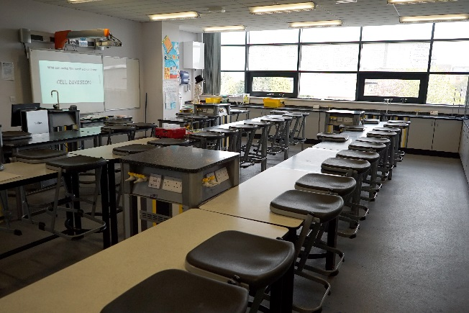
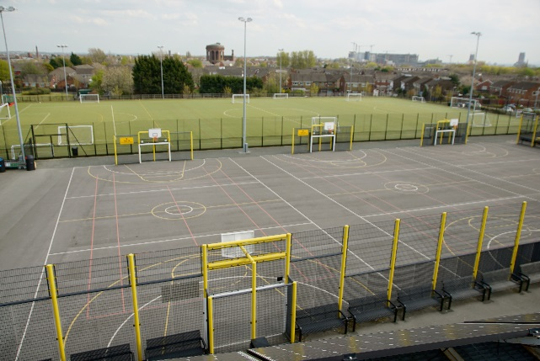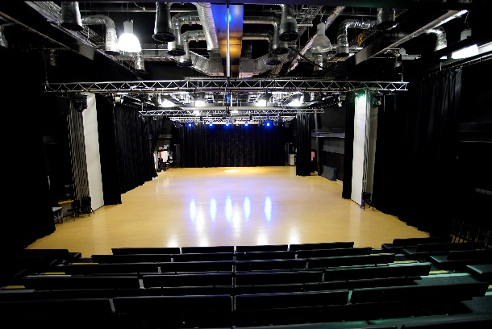

So why choose North Liverpool Academy?
All Staff
- Excellent opportunities for advancement & promotion
- Bespoke training as part of our talent management programme and online accredited CPD courses
- Well lead and managed teams
- Inclusive induction programme
- Designated reprographics support & ICT helpdesk
- Pay related benefits such as Childcare vouchers and Cycle to Work scheme
- Proactive approach to mental health and wellbeing including a supportive HR Department who can provide access to wellbeing services such as Counselling & Occupation Health
- Free on-site secure parking
- Free access to Fitness suite
- Complementary tea & coffee facilities
- Duke of Edinburgh
- Extended opening hours to promote a better quality of work/life balance
Teachers
- Fast track UPS/Leadership progression
- Main scale teachers have a minimum 15% timetabled PPA time
- Training and support for middle or emerging leaders and access to NPQML/SL programmes
- Comprehensive NQT/School Direct/Teach First programme
- Paid Development post opportunities
Support Staff
- 35 days paid annual leave
- Support for staff wishing to progress into teaching through School Direct
- Membership into the local Government pension scheme, where we as employers pay an additional 11% of contributions
- Time off in lieu when available
- Non contractual discretionary leave during school closure periods

Dear Applicant,

Thank you for requesting further details about the position of Learning Support Assistant (EAL).

This is an exciting opportunity to join a growing department, that is passionate and devoted to the continued improvement of the progress and prospects for all of the students in our care, whilst systematically enhancing the cultural environment of the school.

The department currently consists of 2 members of staff, an EAL Coordinator and an EAL support assistant. We consistently strive to improve our knowledge and understanding of English as an additional Language as well as our strategies for teaching these key students within our school community, so the opportunities for CPD are vast within the academy.

As an EAL LSA you will play an important role in supporting the learning of a range of students of varying background and levels of English language. With over 40 different first languages within North Liverpool Academy, this role promises to be diverse, enriching but most of all rewarding.

As an EAL LSA you would be supporting the literacy for our EAL learners, using a range of strategies to meet their complex and individual needs. You will assess EAL students’ initial language level using the established assessment methods and implement the required intervention to support students learning.
You would be joining a hardworking and well-respected team who work within a wider staff of supportive, friendly colleagues.
Should you have any questions, if you wish to discuss the position further or if you would like to visit the Academy prior to your application, please feel free to contact me either by email r.bailey@northliverpoolacademy.co.uk or by telephone.

I look forward to receiving your application.

Rebecca Bailey

EAL Coordinator

JOB DESCRIPTION
Post Title: | Learning Support Assistant (EAL)
Purpose: | - To develop and secure the implementation of provision for students with English as a second language  - To support individual students and groups of students with EAL to access learning  - To provide support to teachers in enabling EAL students to learn
Reporting to: | SENDCO/EAL Coordinator
Liaising with: | Teaching staff, other student support, students services staff
Working time: | 37 hours per week – Term/Time
Salary: | NJC Point 5 £19,312 (pro-rata as term time only)
Qualifications/experience required: | The ability to speak Polish or another language is desirable.  Experience in teaching English as an additional language or literacy would be an advantage.  An ESOL or TEFL qualification would also be desirable.
MAIN (Core) DUTIES
Main tasks | Under the direction of the EAL Coordinator and SENDCO and working in collaboration with Progress Leaders and Curriculum Leaders secure appropriate provision for the academy’s EAL students:  by supporting learning through in-class support under the direction of the EAL Coordinator.  Work within the EAL programme as directed by EAL Coordinator  Assist with the delivery of English language by teaching and non- teaching staff to support students with English as an additional language to develop their acquisition of the English language.  Liaise with all staff to ensure EAL students are supported,  Develop knowledge and keep abreast of external strategies on EAL support and national initiatives.  Play a role in developing a learning environment and curriculum that recognises values and enhances cultural and linguistic diversity, promoting an anti-discriminatory ethos, implementing school policy to meet the learning needs of students with English as an additional language.  Work with the SENDCO and EAL Coordinator to develop the confidence and skills of teaching and support staff to manage and provide an effective and improving EAL programme.  Make use of appropriate opportunities such as co-ordinators handbooks, open learning materials, EAL associations and other relevant networks  by withdrawing students for support on any aspect of learning or organising learning when directed by EAL Coordinator  in preparing materials and resources to support learning.  in record keeping and evidence gathering to support the knowledge of students.  by ensuring that students behave in accordance with academy policy and reporting any such breaches that cannot be dealt with under your competency
Information management | - to support and contribute to the keeping records on students as requested  - responsible for data entry on students as requested and use it to inform future planning
As a team member | To work within the team and to have an understanding and working knowledge of others roles to enable support across the team at times of critical workload  - To promote teamwork and work with others to ensure effective working relationships.  - To participate in the Academy's Professional Development Review process both in terms of self and other staff as appropriate.  - To participate in collaborative planning teams with relevant members of staff
Quality Assurance: | - To participate in the Academy quality assurance policies and a whole Academy approach to self-assessment
Communications: | - To develop and implement effective communication systems and procedures.  - To communicate and refer any relevant incidents to relevant parties
Marketing: | - To ensure the promotion of a welcoming environment to students, visitors and callers.  - To contribute to the creation of an engaging and purposeful learning environment by displaying students’ work and assessment for learning information
Health and Safety | - To ensure that all students in your care are safe  - To have an understanding of child protection and the actions you must take in given circumstances and the reporting procedures
Corporate Responsibility: | - To actively promote the Academy's corporate policies, eg Health & Safety Policy and Equal Opportunities, etc.
Training: | - To continue one's own personal development in relevant areas.  - To actively engage in, take advantage of opportunities for and contribute to Continuing Professional Development
OTHER SPECIFIC DUTIES

To support the Academy Mission Statement and ethos.
All support staff posts have the following tasks added as appropriate
Exam invigilation, Lunch supervision, AM/PM registration, after school clubs, break duties
This post is subject to the enhanced level of DBS disclosure.
This job description is current at the date shown but in consultation with you may be changed by the Principal to reflect or anticipate changes in the job commensurate with the salary and job title.

DATE: April 2021

The Academy is committed to the safeguarding of its students and the promotion of the welfare of children and young people and expects all staff and volunteers to share this commitment.

Liverpool and Mersey region
Whether you are a native to Merseyside or looking at relocating, it’s clear that Liverpool and Merseyside as a whole has a lot to offer. Being European Capital of Culture in 2008 it’s evident why.
Here in Liverpool, there is something for everyone to enjoy, whether it’s visiting one of the many museums for a spot of history and culture, to experiencing a taste of the orient – Liverpool has the biggest Chinese arch outside of mainland China!
Here are some other reasons to enjoy our City
- 2 amazing Cathedrals
- Amazing parks and gardens
- 2 top premier league football clubs – both of which are located within walking distance of the Academy
- House prices in the North West are far cheaper than anywhere else in the UK
- Excellent transport links
- Top tourist attractions
- Fantastic range of shopping, restaurants and nightlife

Why not visit www.visitliverpool.com to see why Liverpool is great!

