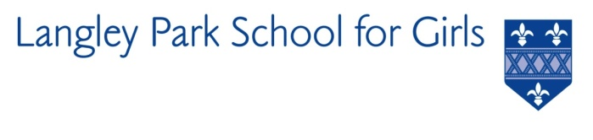

Langley Park School for Girls

Hawksbrook Lane

Beckenham

Kent BR3 3BE

Headteacher: Ms Katie Scott

EAL SUPPORT WORKER

Required ASAP

Salary: NJC Scale 5 (£24,691 to £26,519 per annum pro rata)

39 weeks per year / term time only

LPGS is a thriving and academically successful school. 2019 results were the best ever at both GCSE and A-Level and put LPGS in the top 200 schools in the UK (including selective schools). We are the highest performing non-selective school in Bromley.

We are seeking to appoint a talented and confident individual with natural authority, excellent communication and organisational skills to support our EAL students both in the classroom and in small group/ 1:1 intervention settings. The role is part of the Student Support Department; a large faculty with a range of expertise in supporting young people with learning and pastoral needs.
A job description, person specification and application form are available on our website at www.lpgs.bromley.sch.uk

Please note that whilst you are also welcome to submit a CV, shortlisting will be based solely on our application form and covering letter. All applicants must complete the LPGS Application Form. Applications should be emailed to Helen Partridge, hpa@lpgs.bromley.sch.uk.

We are a diverse school and an equal opportunities employer. We encourage applications from BAME and LGBT colleagues.

The closing date for applications is Friday 14th May 2021. It is anticipated that interviews will be held during the week commencing 17th May 2021. However, please note the school reserves the right to appoint earlier than w/c 17th May 2021.

This school is committed to safeguarding and promoting the welfare of children and young people and expects all staff and volunteers to share this commitment. The successful applicant will be subject to an Enhanced Disclosure & Barring Service check.

