EARLY CAREERS TEACHER FOR EYFS
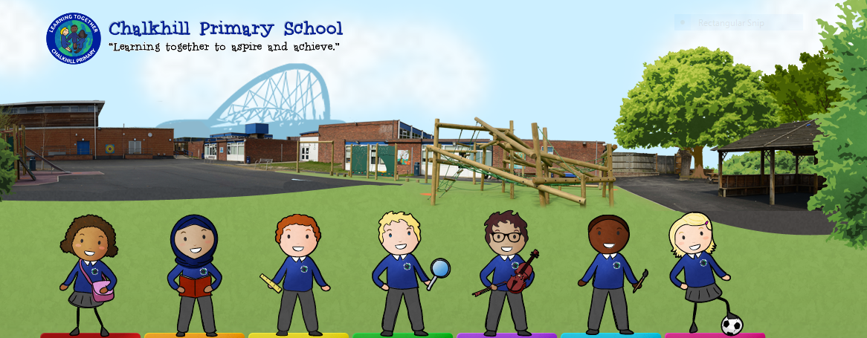

Job details

Employer: Chalkhill Primary School Closing Date: Thursday 19th May 2022 by 12.00p.m.

Location: Brent Interviews: Tuesday 24th May 2022

Salary: MPS 1 to MPS 6 Start date: 1st September 2022

Contract Type: Full Time

Contract Term: Permanent
‘Learning Together to Aspire and Achieve’
Are you ready to make a difference - with children who really want to learn - at our dynamic and forward-thinking school?
Chalkhill Primary is a two-form entry school, with excellent transport links and within walking distance to Wembley Stadium and the Wembley London Designer Outlet.
We are a successful, ambitious and well-resourced school, judged as ‘Good’ by Ofsted (February 2020) with the letter of recommendation to become ‘Outstanding’ if we were to be inspected again. Our school is an exciting place to be.

Chalkhill Primary School is seeking to appoint highly motivated, enthusiastic and creative individuals to join our hardworking and supportive team. The successful candidate will be required to teach pupils who have a range of abilities across the Primary phase.

What we can offer:
• Wonderful, well-behaved and articulate children
• Strong, supportive leadership and a talented, welcoming and enthusiastic team
• Excellent and varied CPD opportunities both in school and through outside training providers

What we are looking for:
The right candidate will:

- Have strong subject knowledge to teach in a creative and innovative way
- Be passionate about teaching and learning and is able to work with others to develop their practice
- Be a passionate classroom practitioner with a proven track record of skills, high expectations and aspirations for our children’s achievement
- Be keen to take on new ideas and opportunities
- Understand how children learn and how we can make an impact on their future
- Have an understanding of good classroom behaviour management and how to promote this
- Be an excellent communicator with good interpersonal and organisational skills
- Understand how pupils with special educational needs can be integrated in the classroom
- Possess knowledge of formative assessment practice and other assessment strategies

The successful candidate will be required to teach pupils who have a range of abilities across the Primary phase, but specifically have a passion drive to teach in Early Years to start with.

Applications are welcome from all suitably qualified candidates regardless of gender, age, ethnicity or disability.
How to apply:

Complete the teaching application form and return it to the School Office at shahs@chalkhill.brent.sch.uk.
Application packs are available to download from the school website at www.chalkhillprimaryschool.co.uk.
Visits are warmly welcome. Please contact the school office on 0208 904 4508 to make an appointment or email the bursar at shahs@chalkhill.brent.sch.uk.
Chalkhill Primary School is committed to the welfare and safety of its pupils and expects all staff to share this commitment. The successful candidate will be required to undergo the necessary Disclosure & Barring Service (DBS) checks.

