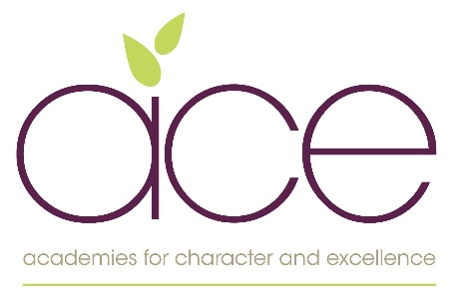

JOB DESCRIPTION
Job title: Early Career Teacher
Reports to: Headteacher
Grade: MPS
Supervisory Responsibility: The post holder may be responsible for the deployment and supervision of the work of teaching assistants relevant to their responsibilities

Trust Ethos and Mission statement
Excellence through cultivating character, sharing talents and pursuing excellence.

A teacher’s job description adheres to the conditions laid down in the School Teacher’s Pay and Conditions document and for Church schools the Diocesan guidelines. In addition to this, teachers undertake to develop children using their understanding and knowledge of their professional qualifications, skills, qualities and where appropriate their faith.

All members of the team employed by the Academies for Character and Excellence support and promote the Trusts mission and vision and promotes character education which is a values led approach. Our Trust values and ethos enable us to fulfil our mission of transformation through making a positive difference to ourselves, others and the world around us.

Teaching and managing pupil learning
- Act as a role model by providing inspirational and creative teaching, which secures high standards of learning and behaviour.
- Carry out the professional duties of a teacher as set out in the School Teachers’ Pay and Conditions document and the DfES Teachers’ Standards Framework.
- Play a significant role in creating and maintaining a climate which promotes and secures outstanding teaching, effective learning, high standards of achievement and good behaviour throughout the class and also the school.
- Implement the curriculum and its assessment; plan, monitor and evaluate practice in order to identify and act on areas for improvement.
- Actively promote the application of literacy, mathematics and ICT across the curriculum for all pupils
- Help to create and implement positive strategies to celebrate diversity and to promote good relations and community cohesion.
- Help to ensure that pupils develop study skills in order to learn more effectively and with increasing independence.
- Should the need arise, take full responsibility for the leadership and management of an agreed subject.

Pupil Achievement
- Play a significant role in making explicit to pupils, parents, teachers and the wider community the school’s high expectations that all pupils can flourish to be the best they can be.
- Ensure that resources are dedicated to ensuring the highest standards of achievement for all pupils.
- Have a clear understanding of the needs of all pupils, including those with special educational needs; gifted and talented; EAL; disabilities; and to be able to use and evaluate distinctive teaching approaches to engage and support them.

Managing own performance and development
- Take responsibility for own professional development.
- Use effective ICT skills for teaching, learning and management.
- Prioritise and manage own time effectively, particularly in relation to balancing the demands of teaching with additional school commitments
- Work under pressure and to deadlines
- Where required work with other teachers collaboratively across the Trust in order to improve standards and cross fertilisation of ideas and initiatives.
- Attend Trust Improvement Groups (TIGS)

Behaviour and Safety
- Establish a safe, purposeful and stimulating environment for pupil rooted in mutual respect and establish a framework for discipline with a range of strategies, using praise, sanctions and rewards consistently and fairly.
- Manage classes effectively using approaches which are appropriate to pupils’ needs in order to inspire, motivate and challenge pupils.
- Be a positive role model and demonstrate consistently the positive attitudes, values and behaviour which are expected of pupils and staff alike
- Maintain good relationships with pupils, exercise appropriate authority, and act decisively when necessary
- Have high expectations of behaviour, promoting self-control and independence of all learners
- Be responsible for promoting and safeguarding the welfare of children and young people within the school, raising any concerns following school protocol/procedures

Relations with parents and the wider community
- Actively seek opportunities to develop effective relationships with the community to extend the curriculum and to enhance teaching and learning.
- Create and maintain an effective partnership with parents to support and improve pupils’ achievement and personal development.
- Ensure that parents and pupils are well-informed about all relevant matters.

Health and Safety
- As an employee of the Academies for Character and Excellence, you have a responsibility to prioritise the health and safety of yourself, your colleagues, and any individuals who may be affected by your work activities. In accordance with our commitment to maintaining a safe and healthy work environment, you are required to adhere to the Trusts health and safety responsibilities.

Whole school commitment
- To demonstrate a commitment to the full life of the school and to work with all members of the team to ensure the success of the whole school and the Trust
- To be supportive of the school’s and Trusts extra-curricular activities
- To take an active part in the school and Trusts involvement with the wider community
- To ensure the children’s safety at all times.

To actively take part in the Trust’s ECT program which is run and monitored by the Trust’s ECT Lead.

