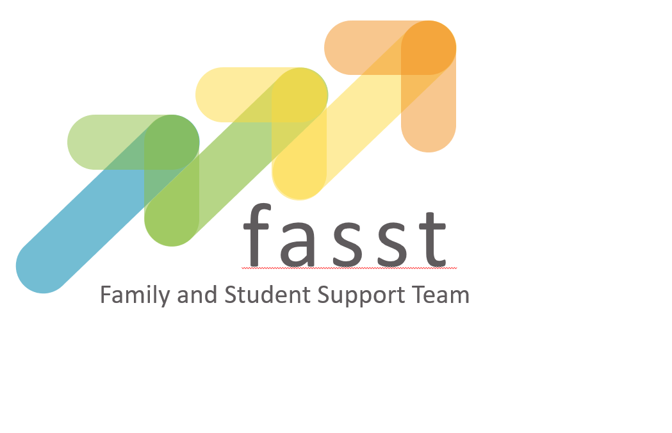
part

FASST KEY WORKER
2 x vacancies

1 position will be mostly (but not exclusively) working in East Staffordshire/South Derbyshire/Derby City and surrounding areas

1 position will be mostly (but not exclusively) working in Derby City/Amber Valley/Erewash/Chesterfield and surrounding areas

Grade 08, Points 12-15
Actual Salary £20,257 - £21,893
Contract: 37 hours per week, term time only

CANDIDATE INFORMATION PACK

Version: July 22

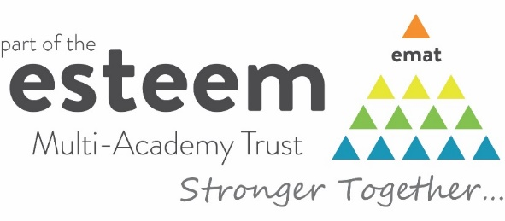
What is included within this pack?

Within this pack you will find both information and advice on applying for a role with Esteem Multi-Academy Trust including:

- Welcome from the CEO
- About Esteem Multi-Academy Trust
- Job advertisement
- Job description and person specification
- Safeguarding and checks
- Application process and timeline

Welcome from Esteem Multi-Academy Trust

Dear applicant,

Thank you for your interest in Esteem Multi-Academy Trust (MAT) and the Family and Student Support Team (FASST). The FASST Key Worker position presents a fantastic opportunity for somebody who shares our values and beliefs to join our team at a very important time.

We are eager to appoint an individual with a passion and commitment to improving the lives and opportunities of children and young people with special educational needs and challenging behaviours. Having excellent interpersonal and communication skills with the ability to demonstrate empathy you will be part of a team of FASST Key Workers responsible for delivering the Esteem Early Help Service to one or more academies across the MAT under the direction of the Safeguarding and FASST Manager.

If you think you have got what we are looking for, we look forward to receiving your application for consideration.

For further information, please contact Hannah Longley, Head of Safeguarding & FASST on 01623 859749, via email to hlongley@esteemmat.co.uk or visit our website at www.esteemmat.co.uk/jointheteam. Please use the relevant application form on the MAT website; CVs alone will not be accepted.

I wish you well in your application.

Yours faithfully

Julian Scholefield
Chief Executive Officer

About Esteem Multi-Academy Trust

Esteem Multi-Academy Trust currently comprises of eleven academies throughout Derbyshire, Derby City, and east Staffordshire. Formed by a group of like-minded school leaders in August 2018, the MAT is currently responsible for the education and care of approximately 1,200 students and employs around 750 staff. The total revenue budget for the MAT is approximately £23 million and plans are in place to expand further.

Esteem Multi-Academy Trust includes 7 special schools, 3 alternative provision academies and a mainstream infant and nursery school with an enhanced resource provision educating young people with autism and learning disabilities. We wish to grow further to fulfil our vision to become a centre of excellence for special educational needs and disabilities (SEND) in the midlands. We have a well-defined set of values and a clear vision for the MAT to become a regional hub for expertise in SEND and inclusion. We share a collaborative ethos, believing that we can achieve more for our pupils as a collective group of schools than we could separately. Our academies focus on the holistic needs of the young person, due to students’ vulnerabilities. So, ‘joined-up thinking’, between our academies and different agencies, is essential to deliver the right support for our students.

The main aims of Esteem MAT are to:

- Provide an ambitious, inspirational, bespoke education, setting the foundation for the future and ensuring our young people are ready for the world;
- Deliver high standards and value for money from our support services, resources, estate and technology; and
- Invest in and support our people, exploiting opportunities for collaborative, continual professional development, sharing of expertise and best practice.

As a group of academies working together, we can share and deliver better practice. We will be able to commission health, care and therapy services in a fully ‘joined-up’ way.

About FASST

Welcome to the Esteem Family and Student Support Team (FASST).

We are a team of dedicated and skilled Family and Student Support Workers based at Esteem academies across Derbyshire, Derby City and Staffordshire. We are part of Esteem Multi-Academy Trust consisting of 1 infant and nursery academy with an enhanced resource hub, 7 SEND academies and 3 alternative provision academies.

We are trained and skilled at delivering a range of group and 1:1 support sessions designed to support families and young people who recognise that change is required.

We only work with families and young people currently on role at an Esteem academy who have consented to the referral. This ensures that positive changes are made with people and not to, or for them.

We offer young people and their families solution focused support to overcome challenges and hurdles. This support can be family or community based or 1:1 sessions. We understand the challenging role of being a parent or carer and trying to balance supporting young people with managing the everyday demands of being an adult!

We use a holistic and flexible approach to empower families and young people to be increasingly self-sufficient. We will work collaboratively with our education colleagues and those from specialist services to ensure the right service at the right time.

We are trained to deliver HOPE, a project that delivers positive outcomes for young people that have an emotional need for support. This service is well established across schools in Staffordshire and we are really pleased to be introducing it to all of our Esteem academies.

We can accept referrals from our Esteem colleagues, parents and carers, young people and other professionals. We hold panel meetings to determine that we are the correct service and allocate to the most appropriate member of the team. The panel is made up of our team and representatives from education and health services; this ensures consistency and multi-agency decision making. If we are not the right service to help, we will endeavour to find the one who is.

​For further information about our service, signposting to various support groups and activities available in your area, visit the FASST website at https://www.fasst-esteem.co.uk/
The advertisement

Job Title: FASST Key Worker
Location: Esteem Multi Academy Central Offices are based at Lake View Drive, Sherwood Park, NG15 0DT. This role is a community based, peripatetic role with the majority of referrals for position 1 coming from East Staffordshire, South Derbyshire and Derby City, and for position 2 coming from Derby City, Erewash, Amber Valley and Chesterfield.
Grade/Scale: Grade 08 Points 12-15 Actual Salary £20,257 - £21,893
Start date: September 2022
Contract: 37 hours per week, term time only. There will be requirement for occasional evening work.

Esteem Multi-Academy Trust currently comprises of eleven academies throughout Derbyshire, Derby City, and east Staffordshire, consisting of 1 infant and nursery academy with an enhanced resource hub, 7 SEND academies and 3 alternative provision academies.

This key role will be part of a team of FASST Key Workers responsible for delivering the Esteem Early Help Service for academies across the MAT under the direction of the Safeguarding and FASST Manager.

The successful candidate will report to the Safeguarding and Early Help Manager and will provide focused support to referred families and young people within the MAT, deliver targeted activities to engage, empower and enable pupils and their families and assess the ongoing needs of the young people and families. This role will involve lone working with families and young people in their own home, in the community and in schools.

A minimum level 3 qualification in either childcare, community work, advice and guidance, education, health, social care or youth work is required along with a full driving license, access to a car and relevant business insurance.

Experience of delivering support to young people and families in a relevant service area,
mentoring, advisory work, coaching and problem-solving with young people and families is essential. The successful candidate will be a confident and competent verbal and written communicator who is self-motivated and assured when lone working. Experience of working with vulnerable families and young people who display challenging and anti-social behaviours is desirable.

Benefits include: LGPS Pension Scheme, mileage allowance paid at 45p per mile, school holidays and Westfield Health membership, access to a range of CPD opportunities, flexible working and opportunities to work from home.

For further information, please contact Hannah Longley, Head of Safeguarding & Early Help, on 01623 859749 via email to hlongley@esteemmat.co.uk or visit our website at www.esteemmat.co.uk/jointheteam. Please use the relevant application form on the MAT website or apply via TES; CVs alone will not be accepted.

Closing date for applications Friday 16 September 2022 12.00pm
Interview date: Wednesday 21 September 2022

Esteem Multi-Academy Trust is committed to safeguarding and promoting the welfare of all its students. We expect all staff, volunteers and agency staff to share this commitment. The successful candidate will be required to undertake a Disclosure and Barring Service (DBS) check. The possession of a criminal record will not necessarily prevent an applicant from obtaining this post, as all cases are judged individually according to the nature of the role and information provided.

Job description and person specification
Job Description: FASST Key Worker
Esteem Multi-Academy Trust
Post Title: |  | FASST Key Worker
Location: |  | Esteem Multi Academy Central Offices are based at Lake View Drive, Sherwood Park, NG15 0DT. This role is a community based peripatetic role.  FASST Key Worker position 1 - the majority of referrals coming from East Staffordshire, South Derbyshire and Derby City areas.  FASST Key Worker position 2 – the majority of referrals will come from Derby City, Amber Valley, Erewash and Chesterfield areas.
Purpose: |  | - To provide focused support to referred families and young people within the MAT by delivering coordinated, time limited, outcome focused and high-quality interventions  - To deliver targeted activities to engage, empower and enable pupils and their families to take ownership of their own solutions, develop resilience, and maximize educational opportunities.  - To assess the ongoing needs of the young people and families on their case load and liaise with other professionals and make appropriate referrals as required
Reporting to: |  | Safeguarding and Early Help Manager
Responsible for: |  | Own caseload and support to specific academies within the MAT
Liaising with: |  | Headteachers  Esteem Early Help Referral Panel  Family Support/Liaison staff within academies  Local authority safeguarding, education and social care services  Other agencies – public, voluntary and community sector
Working Time: |  | 37 hours per week, term time only.
Salary/Grade: |  | Grade 08 Points 12-15 Actual salary £20,257 - £21,893
Disclosure level |  | Enhanced
PRINCIPLE RESPONSIBILITIES
To Achieve the Above |  | - Effectively manage and progress a caseload to achieve positive outcomes based on a solution focussed approach  - Assess and identify levels of risk, vulnerability and safeguarding using prescribed assessment tools, operating within agreed models and in line with agreed frameworks and protection plans, ensuring that the pupil’s or families’ voice is captured throughout the whole assessment and intervention process  - Design and deliver targeted activity working either on a 1-1 basis or in groups using a holistic approach  - Maintain accurate records of all assessments, plans, actions, reviews, and outcomes using specified systems  - Deliver protective, supportive and needs led plans in line with case management standards, record all agreed exit strategies and manage cases within the prescribed time limits  - Participate in conferences, reviews, meetings and other forums as required to engage, empower and enable positive steps towards change  - Increase parent/carer engagement to strengthen family relationships and support children’s education  - Signpost parents to activities within the community to build resilience within the family  - Work co-operatively with colleagues and partners to share information, ensuring a joined-up approach.  - Follow all appropriate quality assurance frameworks, legislation, regulations, policies and procedures, which are central to good practice  - Engage with the development of the Early Help Service and Continued Professional Development through service meetings, events and supporting raising awareness sessions across the MAT on key and emerging issues  - Use IT systems to evidence change through recording and maintaining accurate case notes, family interactions and other records in line with policies and procedures  - Use appropriate marketing techniques to promote awareness of the service and represent the service at events as required  - Ensure that client information data is lawfully gathered, accurate, up to date and only divulged in accordance with the Data Protection Act 2018 and GDPR legislation
Other Generic Responsibilities:
- Represent and promote the ethos and values of Esteem Multi-Academy Trust
- To take and be accountable for all decisions made within the parameters of the job description
- Participate with performance management and training and activities that contribute to personal and professional development.
- Actively promote and act at all times in accordance with the policies of the MAT eg. Safeguarding, Health and Safety, Equal Opportunities
- Provide a high standard of customer service in all dealings internal and external to the MAT
- Whilst every effort has been made to explain the main duties and responsibilities of the post, each individual task undertaken may not be identified.
- Employees will be expected to comply with any reasonable request from a manager to undertake work of a similar level that is not specified in this job description
- The MAT will endeavour to make any necessary reasonable adjustments to the job and the working environment to enable access to employment opportunities for disabled job applicants or continued employment for any employee who develops a disabling condition

This job description is current at the date shown, but, in consultation with you, may be changed by the CEO to reflect or anticipate changes in the job commensurate with the grade and job title

Person Specification: FASST Key Worker
Esteem Multi-Academy Trust
QUALIFICATIONS AND EXPERIENCE
Essential |  |  | - Minimum of level 3 qualification in one of the following: childcare, community work, advice and guidance, education, health, social care, youth work  - Practical and procedural experience of delivering support to young people and families in a relevant service area  - Mentoring, advisory work, coaching and problem-solving with young people and families  - Experience of safeguarding practices and procedures  - Designing and delivering targeted 1-1 or group activities to achieve agreed outcomes  - Identifying levels of risk, vulnerability and needs  - Full, clean driving licence
Desirable |  |  | - Developing case management plans based on prescribed assessments  - Working with/in the special school and/or alternative provision sectors  - Experience of behaviour management techniques and practices  - Experience of supporting young people and families that may display challenging and anti-social behaviour
KNOWLEDGE AND ABILITIES
Essential |  |  |  | - A demonstrable, passionate commitment to improving the lives and opportunities of children and young people with special educational needs and challenging behaviours  - Procedural and policy knowledge related to assessments, case management and safeguarding  - Ability to assess, design and deliver activity within the MAT early help offer as the main point of contact  - Knowledge and awareness of issues which may have an impact on families whose children attend special schools or alternative provision  - Knowledge of the processes, agencies and legislation related to children and young people attending special schools or alternative provision  - Ability to manage casework and use case management methodologies  - Excellent interpersonal and communication skills with the ability to demonstrate empathy, be non-judgemental and build trust  - Accurate record-keeping and the ability to use IT systems to support efficient and organised working  - Ability to work as part of a team delivering a co-ordinated response  - Personal energy and resilience in the face of challenge  - Ability and willingness to work flexibly, travel and work occasionally into an evening
Desirable |  |  |  | - Knowledge of local support services and provision – public, private and voluntary sector – that can be accessed by children, young people and their families at special schools and alternative provision
Safeguarding and checks

Esteem Multi-Academy Trust is committed to safeguarding and promoting the welfare of all its students. We expect all staff, volunteers and agency staff to share this commitment. The successful candidate will be required to undertake a Disclosure and Barring Service (DBS) check. The possession of a criminal record will not necessarily prevent an applicant from obtaining this post, as all cases are judged individually according to the nature of the role and information provided.

Esteem Multi-Academy Trust’s Safeguarding Policy applies to all adults, including volunteers and agency staff, working in or on behalf of the MAT.

Each student’s welfare is of paramount importance. We recognise that some children may be especially vulnerable to abuse e.g. those with special educational needs and disabilities, those living in adverse circumstances. We recognise that children who are abused or neglected may find it difficult to develop a sense of self-worth and to view the world positively. We recognise that some children who have experienced abuse may harm others. We will always take a considered and sensitive approach in order that we can support all students within our academies.

The MAT pays full regard to the DfE ‘Keeping Children Safe in Education
September 2020’ guidance. We ensure that all appropriate measures are applied in relation to everyone who works for the MAT who is likely to be perceived by the students as a safe and trustworthy adult including volunteers and agency staff. As part of our safer recruiting practises, we scrutinise applicants; verify their identity, academic or vocational qualifications, obtain professional and personal references, check full employment history and ensure the applicant’s health and physical capacity is suitable to undertake the role. Interviews and DBS checks are also undertaken.

This post is exempt from the Rehabilitation of Offenders Act 1974 and therefore all convictions, cautions and bind-overs, including those regarded as “spent” must be declared.

If you are currently working with children, either paid or voluntary, your current employer will be asked about disciplinary offences, including those related to children or young people (whether disciplinary sanction is current or time-expired), and whether you have been the subject of any child protection allegations or concerns and, if so, the outcome of any investigation or disciplinary proceedings.

If you are not currently working with children, but have done in the past, that previous employer will be asked about these issues.

Where neither your current or previous employment has involved working with children or young people, your current employer will be asked about your suitability to work with children and young people, although it may be answered “not applicable”, where appropriate, if your work has not brought you in to contact with children or young people.

Application process and timeline

Application forms are available on our website at www.esteemmat.co.uk/jointheteam or you can email hr@esteemmat.co.uk to request a copy. Please specify the job vacancy, including which FASST position you wish to apply for.

After the closing date, shortlisting will be conducted by a panel who will match your skills and experience against the criteria in the Person Specification. You will be selected for interview purely on your application form, so please ensure that you read the Job Description and Person Specification carefully before you complete your application form.

All candidates invited to the interview and assessment day must bring the following documents; original documents only, copies will not be accepted:

- Documentary evidence for your right to work in the UK
- Documentary evidence of identity which meets the DBS requirements i.e. current photocard driving licence including a photograph and/or a passport and/or a full birth certificate
- Documentary proof of current name and address i.e. utility bill, financial statement etc.
- Where appropriate, documentation evidencing a name change
- Educational or professional qualifications that are necessary or relevant for the post

Further information relating to DBS check documentation requirements can be found on the Government website at https://www.gov.uk/guidance/documents-the-applicant-must-provide.

If you are not the successful candidate, all your personal information will be destroyed, in a secure way, in line with General Data Protection Regulations (GDPR May 2018) guidelines.

References will be sought for shortlisted candidates for any central office-based positions and we may approach previous employers for information to verify experience or qualifications prior to interview. Any relevant issues arising from references will be discussed at interview.

Your completed application form and supporting letter should address and evidence the essential and desired criteria in the Person Specification.

Closing date for applications: 16 September 2022 (12:00pm)
Interview date: 22 September 2022

Completed application forms can be returned electronically to the HR team via email to hr@esteemmat.co.uk

If you wish to submit your application form by post, please return it to the following address:
Private & Confidential: HR Team, Esteem Multi-Academy Trust, Suite 43, Pure Offices, Lake View Drive, Sherwood Park, Nottingham, NG15 0DT

