

Candidate Recruitment Pack

**Early Years Class Teacher**

**Wormholt Park Primary School**

***Learning today for a better tomorrow***



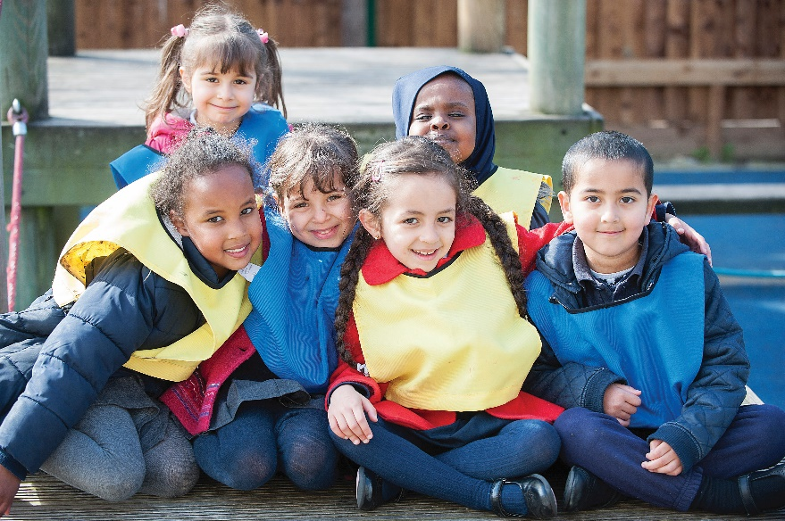



Dear Applicant,

I would like to thank you for your interest in applying for the position of Early Years teacher at our school.

Wormholt Park is a diverse, friendly, welcoming and inclusive school within the London Borough of Hammersmith and Fulham. We are a Gold UNICEF ‘Rights respecting’ school and one of the first in London to achieve the *EQualities* Award.

Our aim is to provide a fun, safe and nurturing environment, in which children are valued, inspired and enjoy their time at school. We strive to provide an exciting and stimulating curriculum with many opportunities for trips, visits and workshops which enrich the learning experience; this is combined with high expectations of attainment, achievement and behaviour.

Our working environment is supportive, collegiate and friendly, with excellent career development opportunities. Leaders are committed to ensure that teachers achieve their full potential, as well as the children!

You can find out more about us by visiting our website at [www.wormholtparkprimary.co.uk](http://www.wormholtparkprimary.co.uk), or by contacting the school and speaking to our Assistant Head, Sam Everett.

Application closing date: 05 June 2023 (at 12.00 noon)

Shortlisting: 05 June 2023

Interview Date: 08 June 2023

We look forward to meeting you.



Anika Hargie

Head Teacher

**About Our School**

Wormholt Park Primary is a two form entry inner city community school situated in the Wormholt and White City ward of Hammersmith and Fulham. It has its own Nursery provision.

The school is ethnically diverse with over forty home languages being spoken. Current levels of free school meal entitlement and pupil premium are significantly higher than the national average; consequently, the school is able to ensure that there are sufficient funds invested to meet the diverse needs of our pupils. Our SEND provision is excellent. We have a dedicated Arts studio and ensure that our curriculum is broad, stimulating and exciting.

Please visit the school website for a full picture of the work we do to make sure our children are happy and achieving their very best.

**Our Vision**

Our school vision states that every child will leave this school:

* Achieving their very best
* Happy and confident
* Tolerant and respectful of themselves and of others
* Always reaching for the stars!

**Intent**

To make this happen, we have designed a skills and knowledge based curriculum which recognises all children as individuals and supports them to recognise they have a role to play as members of the local, national and global community:

* We will promote children’s curiosity and enthusiasm for learning
* We will provide well planned, creative and experiential learning opportunities, building on prior knowledge and skills, that will be matched to the individual strengths and needs of the children
* We will provide opportunities through an exciting and engaging curriculum, including a wide range of workshops and trips and the Skills Builder programme, to develop skills for life
* We will create a happy, friendly, stimulating working atmosphere
* We will encourage self-confidence, resilience and the ability to make decisions
* We will celebrate all types of achievements so that everybody experiences the fulfilment of personal and shared success
* We will ensure that everyone has access to equal opportunities. We will expect sensitivity and acceptance of others, and good manners
* We will ensure that ‘Rights’ education is embedded within the curriculum and that all children know and can use the language of rights.
* We will continue to promote our status as a ‘Rights Respecting’ school, developing pupils’ tolerance and understanding of others and equipping them for life in a diverse and rapidly changing society
* We will ensure that curriculum across the school, including Personal, Social and Health Education, Relationships and Sex Education and Religious Education, teach children about those different to themselves; to promote tolerance and help children understand the importance of education in combating prejudice

**What we can offer you**

* Excellent professional development opportunities and career progression
* A strong, friendly team in a highly professional working environment
* Season Ticket
* Cycle scheme
* Workplace Options Employee Assistance Programme
* CSSC – Nationwide discount for staff and their families

***If you are Interested…***

If you wish to be considered for this appointment, please complete the application form with a covering statement outlining your reasons for applying for this position and what you believe you would bring to Wormholt Park Primary School. Please note previous applicants will not be considered for this role. Your application should relate to the person specification and job description.

Application closing date: 05 June 2023 (at 12.00 noon)

Shortlisting: 05 June 2023

Interview Date: 08 June 2023

Start Date: September 2023 (start date negotiable for the right candidate)

We welcome informal visits from prospective applicants for a tour of the school. Please contact Sam Everett, Assistant Head on 020 8743 5073.

Wormholt Park Primary School is committed to safeguarding and promoting the welfare of children and young people and our staff share this commitment. An enhanced DBS disclosure is required for successful appointees in accordance with Safeguarding Children and Safer Recruitment in Educational legislation.

**Job Description**

Pay Scale: Main Pay Scale and Post-threshold. All teachers in this school can expect to receive their full entitlement to 10% PPA time in line with the recommendations of the National Workload Agreement.

For post threshold teachers, this job description is to be read in conjunction with the professional standards for post threshold teachers.

Status of the Post: The post holder is accountable to a Phase Manager and Head Teacher

Main Purpose for the Post: To fulfill the professional duties and responsibilities of a class room teacher. To be responsible for the education and welfare of your designated class in accordance with the requirements of the School Teachers’ Pay and Conditions Document and the Teachers’ Standards (revised June 2013), having due regard to the requirements of the National Curriculum, the school’s aims and objectives, policies and the requirements of the governing body. You are also expected to share corporate responsibility for the well-being and discipline of all pupils.

**Professional Responsibilities:**

To implement and deliver an appropriately broad, balanced, relevant and inspiring curriculum for pupils, incorporating the areas of learning for Early Years Foundation Stage in line with the policies of the school.

To support children and parents when settling children into the class and school environment, according to each family’s needs.

To enable young children to make good progress in their learning by building upon the skills they have when they join the school in nursery or reception class.

To assist all children to develop emotional security, self-belief and mature social skills.

To promote a love of learning and an excitement about coming to school each day.

To maintain the highest levels of conduct and professional behaviour.

To take responsibility for safeguarding the welfare of children within the school.

To build good relationships with parents and carers and work in partnership to ensure the best outcomes for children and families.

Liaise as appropriate with agencies responsible for pupils' welfare.

Take responsibility for your own professional development and to keep up to date with research and developments in pedagogy.

Set a good example to the pupils you teach in your presentation and personal conduct.

Establish effective working relationships with professional colleagues.

To implement the school’s policies in full.

Work to the Teachers Standards Framework and undertaking appropriate training and development activities in order to meet the standards.

To take part in Performance Reviews as required by the governing body.

To play a full part in the development of the school, through engaging in discussion and meetings as required.

Undertaking any other duties that may reasonably be regarded as being commensurate with the grade and general purpose of the post.

This job description may be reviewed at the discretion of the governing body following appropriate levels of consultation.

The school is committed to the implementation of the National Workload Agreement and as such you are not expected to carry out the ’24 Tasks’ as stipulated in the agreement.

This job description should be read together with current documentation as of 2013

* School Teachers’ Pay and Conditions Document (September 2013)
* Teachers’ Standards (June 2013)
* Standards for Post-Threshold Teachers (June 2013)
* Pay Policy
* School Policies including Safeguarding policies
* Health and Safety Guidance and Policies
* The National Curriculum for England

**Person Specification**

The successful candidate will:

* Hold Qualified Teacher Status
* Have experience of EYFS teaching, preferably in a multi-ethnic setting
* Be a highly effective and dynamic classroom practitioner
* Have high expectations of pupil attainment and achievement
* Have experience of AfL procedures and be able to assess pupil progress in line with school procedures
* Be able to create an organised and stimulating classroom environment
* Be flexible in approach
* Work effectively as part of a team
* Be highly motivated and innovative
* Have the ability to inspire children
* Have a sense of humour!