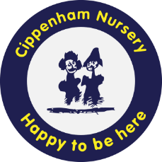

CIPPENHAM NURSERY SCHOOL
St Andrews Way, Cippenham, Slough SL1 5NL
Email: office@cns.slough.sch.uk Phone: 01628 661506 www.cippenhamnurseryschool.co.uk
We are seeking to recruit a Classroom Teacher. This is a fantastic opportunity to join our highly experienced and professional team.
The ideal candidate must hold QTS (Qualified Teacher Status)
Hours will be Full Time 37 Hours per week Monday to Fridays

Early Years Classroom Teacher required asap

Pay Range: TQUA01-TQUA05 (£34,398-£43,545) dependant on experience, Permanent position
Cippenham Nursery School is a happy and busy school on the outskirts of Slough, offering 186 PTE places. It has been a part of the community in Cippenham since 1941 and provides learning experiences through Forest School, allotment, yoga and carpentry studio on site. Cippenham is within easy reach of the M4 and M40, Burnham, Maidenhead and Windsor.
Visits to the school are warmly welcomed and appointments should be made via the school office on 01628 661506
Closing date: Friday 7th March 2026 Interview date: Commencing Monday 10th March 2026
To request an application pack, please email: office@cns.slough.sch.uk or call 01628 661506
We are committed to equal opportunities, safeguarding and promoting the welfare of children, young people and vulnerable adults
and expect all staff and volunteers to share this commitment. This post is subject to an Enhanced DBS check, along with other employment checks,
including online searches.







