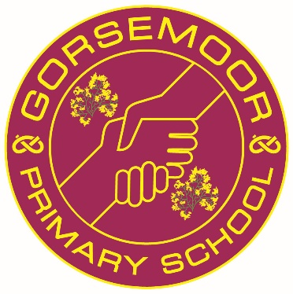

Gorsemoor Primary School

Recruitment Pack

2021 2022



Growing together, hand in hand

Our School Values
Mission Statement
Our vision is that by growing together, hand in hand, we ensure that there is no limit on what we can achieve.

Our school vision represents the strong bond between our school and its community and we aim to inspire everyone to grow together to create an atmosphere that will give our children the best education possible. Our staff are armed with a strong moral purpose where high expectations are our starting point, not our end goal. We are dedicated to sustaining a culture engrained in personal and social development with a determined and collective commitment to the school's values for growth.

In any community, values are the essential building blocks for developing positive relationships and creating a climate for opportunity and limitless possibility. Here at Gorsemoor, we share a common sense of values that guide our approaches, relationships, policies and behaviour. Our values underpin every decision that we make in our school.

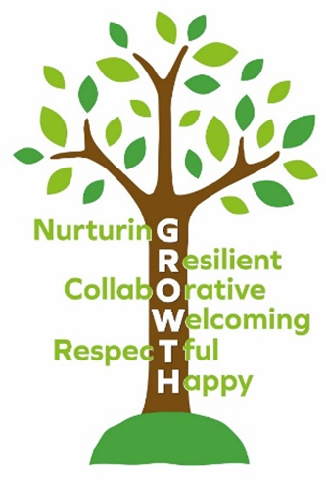

For further information, please visit the school values section of our school website.

Our School Aims

At Gorsemoor Primary School, we aim to:

- ensure our pupils are safe, establishing a trusting, open culture in which all adults place great emphasis on the safeguarding of all.
- consistently expect, from the whole school community, the highest standards possible in terms of good behaviour, respect for all and the school values.
- celebrate and respects everyone’s individual identity and promote equality of opportunity for all.
- embed a rich and balanced curriculum that reflects our awareness of both the local and wider community.
- ensure all of our pupils have access to a wide range of opportunities within and beyond the classroom.
- develop children’s self-belief, well-being and resilience in order to prepare them for the next stage in their lives.
- build a community in which all staff are supported, motivated and valued to enable them to deliver the highest quality of learning opportunities for our children.
- to encourage parents and the wider community to play an active and supportive role in their child’s education.
- to engage with a range of education providers, stakeholders and the community to better our provision.

Our Curriculum Intent

The curriculum design at Gorsemoor Primary School is centred around our offer of being ambitious, inspiring, engaging and motivational for all stakeholders. We firmly believe that this offer ensures that children and staff develop and foster a love of learning towards embedding it into the long term memory. We have considered the local community within our curriculum intent and have established a strong ethos and vision for ensuring consistency across the whole school. The curriculum’s intention offers rich coverage throughout all of our years and is inclusive of all children, considering both SEND and disadvantaged children. We provide a combination of experiences and opportunities for our children and provide them with memorable experiences to positively impact on their wellbeing and learning.
Gorsemoor’s curriculum is underpinned by our curriculum drivers; personal development, growth and community. We consider these in all aspects of our planning and delivery alongside the National Curriculum. They encompass the core values of our school and are broad and wide ranging to enable us to shift focus on those aspects, which are most pertinent. Alongside teaching the requirements of the National Curriculum, our key drivers are personal to our school and reflect the social and educational needs of our local area. They make our school curriculum unique. Please visit the curriculum section of our school website where you will find further information.



Personal Development

The circular shape of our school badge represents the whole child. It is like a protective bubble. It represents the traits that our children will need to develop as they venture into our complex world. It includes promoting physical health through Physical Education. However, it recognises the importance of good mental health too. It sees how developing characteristics such as resilience and independence are crucial skills that our children will need in order to face the challenges of life. Securing personal well-being is at the core of everything we do, for not only our pupils, but also our staff and community too.



Growth

Promoting each child’s personal growth is important to us and to our parents. Growth is represented on our badge by the Gorse bush. Gorse is a hardy and resilient plant that grows and flowers in a range of areas. A plant that grew right here long before the school was built. Like the Gorse on our school badge, we hope that our children grow to see the wide range of opportunities that are available to them. By developing social capital and providing a range of experiences, we hope that the children will begin to see that the possibilities are endless. This means developing a curriculum that introduces them to other cultures and heritage. It introduces them to a range of religions and beliefs and ideas about spirituality. It develops creativity through the arts, including music, drama and art itself. It promotes a rich language and develops good communication skills.


Community

The hands reaching out to each other on our school badge represent community. We have always had a strong sense of community here at Gorsemoor. Visitors and parents often comment on the ‘family feeling’ of our school. Our community starts with each family unit and the links they make with our school from the very beginning. It continues by including the outside agencies that we may need to reach out to in order to support the children in our care. Community is about understanding our identity and the bonds that join us together. It is also about recognising our place in the wider world and making connections with other people and places. This is not just within our own locality but also spreading out further onto a national, European and international scale. It is important for our children to understand the diverse nature of the world that they live in through promoting British Values and helping children to recognise their rights and responsibilities as a global citizen.

The School Curriculum

At Gorsemoor Primary School we follow the National Curriculum, which provides a broad and balanced education for our children. It is the aim of the teachers to provide and deliver a skills-based, creative curriculum which links subjects and is designed to make learning interesting and meaningful.
Children are taught in mixed ability classes with their own class teacher, who has the responsibility for their education and personal and social welfare. Following our first successful year of mixed-age teaching, children from Year Three onwards are taught in mixed-age classes, following a two-year planning cycle.
In addition to the class teachers, we are also fortunate to have highly skilled and experienced Teaching Support Assistants who enhance our ability to provide personalised learning.
English and Maths are taught on a daily basis. In addition to these subjects, other lessons help combine to create our wide and varied timetable, these lessons include; Phonics, Whole Class Reading, Science, Computing, History, Geography, Art, Design and Technology, Physical Education, Personal, Social and Health Education, Religious Education, Music and Spanish (in Key Stage 2 only).

Inclusion/Special Educational Needs

At Gorsemoor Primary School we are committed to providing high quality teaching through our school values. We believe that all children, including those identified as having special educational needs and disabilities, have a common entitlement to a broad and balanced academic and social curriculum, which is accessible to them so that they are fully included in all aspects of school life.
We believe that our children should be equally valued in school. We nurture an environment that is free from prejudice and discrimination where all children can flourish and feel safe. Gorsemoor Primary School is committed to inclusion. We believe that inclusion is about equal opportunities for all. We aim to engender a sense of community and belonging and to offer new opportunities to learners who may have experienced previous difficulties.
We will respond to our learners in ways which take into account their varied life experiences and needs. In order to do this, many steps are taken to support them through their learning journey. Quality teaching is vital. For some children there will also be occasions when further positive support may be needed to help them achieve their targets.
We believe that many pupils at some stage in their school career may experience difficulties which affect their learning and we recognise that these may be long or short term. Special needs may be academic, physical or emotional. Whatever the child’s needs, it is our job to meet those needs by offering a curriculum and support appropriate for them.
Children with special educational needs will, for the most part, work alongside their peers in the classroom and will work in ways suited to their needs with specific support materials and with support from the teacher and teaching assistant, if appropriate.
Application Guidance

Please complete the application form in full ensuring you have provided true and accurate information.

Where you are asked to provide a cover letter with your application form, it should be no more than two sides of A4 in size 11 font.

Please note: CV’s are not accepted. Only fully completed application forms are to be submitted for shortlisting.

Please send your application form and letter of application (if required) to recruitment@gorsemoor.staffs.sch.uk before the date and time specified in the advert. Applications received after the closing date/time will not be considered.

You may arrange a visit to the school before applying for a post or prior to interview if you are shortlisted, by contacting the School Office on 01543 274788.

After submitting your application
Please note, that if you have not received communication from Gorsemoor inviting you for interview within 10 working days of the closing date of the post, you can assume that you have not been shortlisted on this occasion. We thank you for your interest in our organisation and would encourage you to apply for suitable vacancies in the future.

Safeguarding
Gorsemoor Primary School is committed to safeguarding and promoting the welfare of children and young people/vulnerable adults and expect all staff and volunteers to share this commitment.

All vacancies are subject to an enhanced criminal records check from the Disclosure and Barring Service which will require you to disclose details of all unspent and unfiltered spent reprimands, formal warnings, cautions and convictions in your application form.

Please review the school’s website for Safeguarding and Child Protection Policies.

