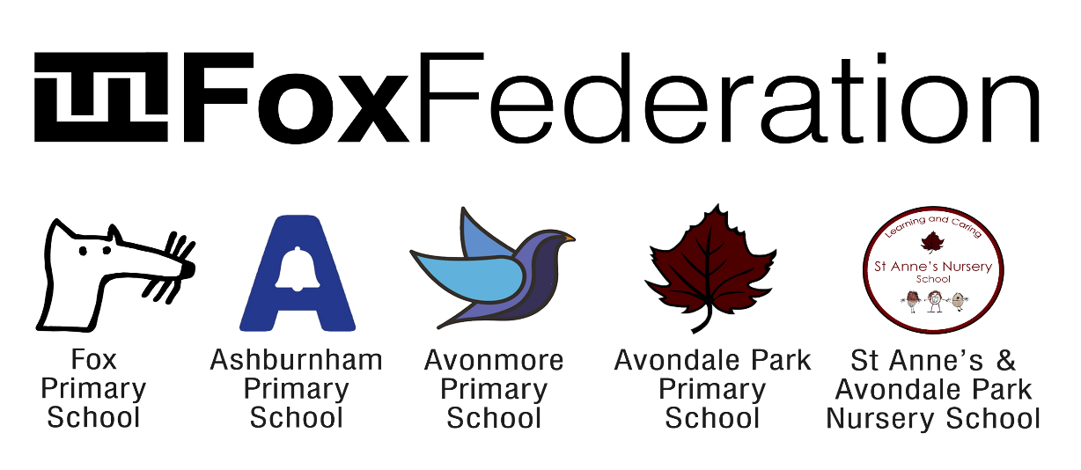

Respect. Resilience. Collaboration. Curiosity. Inclusion

Position: Early Years Educator at Fox Federation Schools – Avonmore Primary School W14 and Ashburnham Community School SW10

Grade: Scale 5 – 6, Spine Point 18 to 20
Salary: £29,364 – £33,510 depending on experience

Hours and Service terms: 33 hours a week, Monday to Friday term time only

Required from: September 2023 start

Closing Date: Friday 30th June (applications to be sent to hr@avonmoreprimary.co.uk)

Interview Date: Week commencing Monday 3rd July

We are committed to building a diverse team and strongly encourage applications from underrepresented groups such as people from minority ethnic backgrounds, LGBTQ+ people and people with disabilities.

We are looking for an inspiring Early Years Educator to join our team which is part of the Fox Federation from 1st September 2023. Fox Federation is a passionate community of four schools working collaboratively with other local community schools. All schools ensure equal access to consistent, excellent education for all pupils. Our schools are nurturing places to work, committed to innovation and have high academic standards. Staff who join our team are supported to grow and develop outstanding practice through exceptional CPD and support from a warm, passionate team of dedicated teachers and leaders.
The position would suit a new or experienced EYE. We offer competitive salaries and pay progression and, as a Federation, there are opportunities for staff to progress into areas of expertise and passion
If you are ambitious and determined to make a difference, we would like to meet you.

What the school staff say about Fox Federation:
‘Fantastic schools. Great staff. Supportive leadership team. Amazing children.’
‘A genuine educational family, providing a community beyond our gates. A network of schools, committed to providing the best education for children whilst creating a safe a happy place for them.’
‘It is incredible to be surrounded by so many competent, hard-working, passionate people - so committed to delivering fantastic education opportunities to our pupils.’
‘Management are always available to speak with, unbelievably approachable and create time to listen and come up with solutions.’
‘It is run in an extremely compassionate, supportive and nurturing manner for both staff and pupils, and I really do feel that the wellbeing of the whole community is at the heart of the school's ethos.’
‘A place of supportive colleagues who are constantly striving to improve what we do for our children and families.’
‘A shared vision of always going the extra mile to support and care for the families in our community.’
‘It is somewhere that has nurtured my career, but also a place where I have met friends that I know will be friends for life.’
‘The Fox Federation is an incredible support network of teachers and staff working together to ensure children's education is kept at the highest possible standard.’
Our ideal candidates would:
- Be hard working, flexible and resilient.
- Be friendly and want to be part of a team, who embodies our schools’ values and vision for excellence.
- Be willing to learn, reflect and become an excellent classroom practitioner who is self- reflective and is ambitious for our children.
- Be a skilled communicator with the potential to support staff through sharing best practice to get the best out of others.
- Be committed to inclusion and understand that different children learn in different ways and has a range of skills to ensure all children reach their full potential in all areas of school life.
- Enjoy teaching in the Early Years and want to make a real difference.
What else do we offer?
- An experienced Leadership Team with a shared vision working in partnership across the Federation.
- Hard-working Early Years team, who strive to ensure that both pupils and staff enjoy coming to school.
- We are passionate about supporting staff in their career development and success through care and guidance.
- A working environment that values wellbeing and supports work-life balance through working in partnership across schools.
- Vibrant, multicultural and inclusive city schools that have positive, diverse communities and a determination that all children will succeed.
- Exceptionally well-behaved children who love to learn.
- A relaxed and fun working environment where all adults are equally valued and supported.
The schools and the local authorities are committed to safeguarding and promoting the welfare of children and young people and expect to share this commitment. An enhanced Criminal Records Bureau Certificate is required for this post prior to commencement
Applications are assessed with names and protected characteristics removed.
To make an application or further information, please download our application pack or contact Emily Bishop Emily.bishop@avonmoreprimary.co.uk/emily.bishop@ashprimary.co.uk

