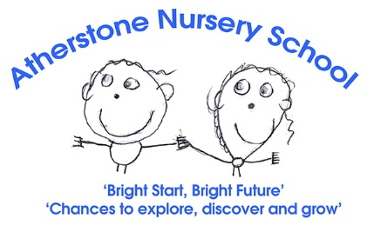


Person Specification: Early Years Educator Grade D4-5
 | Essential | Desirable
Qualifications | - English and Mathematics GCSE Grade 4 or above.  - Early Years Level 2 plus qualified  - Experience of working within an early years setting working with children aged 2–5-year-old.  From 1 September 2014, all level 2 and 3 qualifications must meet the early years educator criteria. Please check:  https://www.gov.uk/guidance/check-an-early-years-qualification to see if your qualification is recognised | - Evidence of further study at level 3 or above  - Safeguarding Training and PREVENT Training  - Paediatric First Aid training.  - Basic Food Hygiene training.  - Allergy Awareness training.
Experience / knowledge | - Minimum of 1 years’ experience working within the EYFS age range.  - Able to teach activities planned in partnership with colleagues to individuals and small groups  - Able to maintain and complete records and documentation to a high standard.  - Understand how to support and differentiate activities to help children with their learning.  - Encourage children to develop new skills.  - Partnership working with professionals and families.  - Follow relevant policies and codes of practice  - Experience of being a keyperson. | - Look for new ideas to introduce into the curriculum.  - Experience of, and commitment to, outdoor learning  - Understanding and use of a range of behaviour management strategies  - Knowledge of the new EYFS reform.  - Experience of supporting children with SEND.
Skills | - Ability to promote positive behaviour.  - Good observation skills.  - Good oral and written communication.  - Good ICT Skills across Microsoft office packages  - Able to maintain the rights of the child and create and inclusive practice.  - Manage time effectively and meet time related targets. | - Creative and able to develop learning environments and resources to meet individual needs  - Ability to set individual targets and write observations.
Attitudes | - Deal with conflict in an appropriate manner  - Be reflective and learn from past experiences  - Show resilience and an ability to work under pressure  - Be organised, self-disciplined, reliable, conscientious, hard working and honest.  - Flexible in approach and respond to change with a positive attitude  - Friendly, approachable, and kind with the ability to sustain good personal relationships across a team  - Commitment to inclusive education of children and genuine enjoyment ensuring all children achieve their potential.  - Uphold our commitment to safeguarding and have experience of following safeguarding policies and practices. | - Keen to access opportunities to grow and develop within the role  - Prepared to go the extra mile to contribute to the continued success of the team

