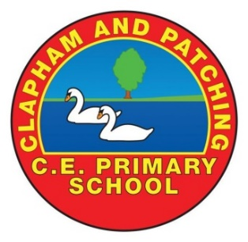

CLASS TEACHER - JOB DESCRIPTION

School: Clapham and Patching C of E Primary School | Location: Clapham, Worthing, West Sussex BN13 3UU
Job title:  Primary Class teacher | Salary range: TMS/UPS

Job Purpose
Fulfil the professional responsibilities of the post as set out in the School Teachers’ Pay and
Conditions document.
Meet the expectations set out in the Teachers’ Standards
To carry out professional duties and to have responsibility for an assigned class.

Main duties and responsibilities
- To plan and teach well-structured lessons in order to deliver the National Curriculum ensuring breadth and balance in all subjects, following the school’s plans, curriculum and schemes of work.
- To set high expectations, which inspire, motivate and challenge pupils.
- To demonstrate good subject and curriculum knowledge.
- To promote good progress and outcomes for pupils.
- To maintain good order and discipline among the pupils, managing behaviour effectively to ensure a good and safe learning environment.
- To organise and manage groups or individual pupils ensuring differentiation of learning needs, reflecting all abilities.
- To plan opportunities to develop the social, emotional and cultural aspects of pupils’ learning.
- To maintain a regular system of monitoring, assessment, record-keeping and reporting on the learning needs, progress and achievements of pupils, making accurate use of assessment.
- To ensure effective use of support staff within the classroom, including parent helpers.
- To participate in staff meetings as required.
- To be part of a whole school team, actively involved in the development, implementation and evaluation of the school’s policies, practices and procedures, so as to support the school’s vision and values
- To communicate and consult with parents over all aspects of their children’s education – academic, social and emotional.
- To liaise with outside agencies when appropriate.
- To continue professional development in order to improve own teaching
- To promote the safety and well-being of pupils.
- Make a positive contribution to the wider life and ethos of the school.
- Develop effective professional relationships with colleagues
- Uphold public trust in the profession and maintain high standards of ethics and behaviour, within and outside the school
- Have proper and professional regard for the ethos, policies and practices of the school and maintain high standards of attendance and punctuality.
- Understand and act within the statutory frameworks setting out their professional duties and responsibilities
- those staff employed on UPS1, 2 or 3 will be expected to deliver a whole school responsibility project each year. Projects will be discussed and agreed annually with the Head of School and your performance management targets will make reference to the project/responsibility area you are delivering.

The teacher will be required to safeguard and promote the welfare of children and young people and follow school policies and the staff code of conduct.

Updated April 2021

