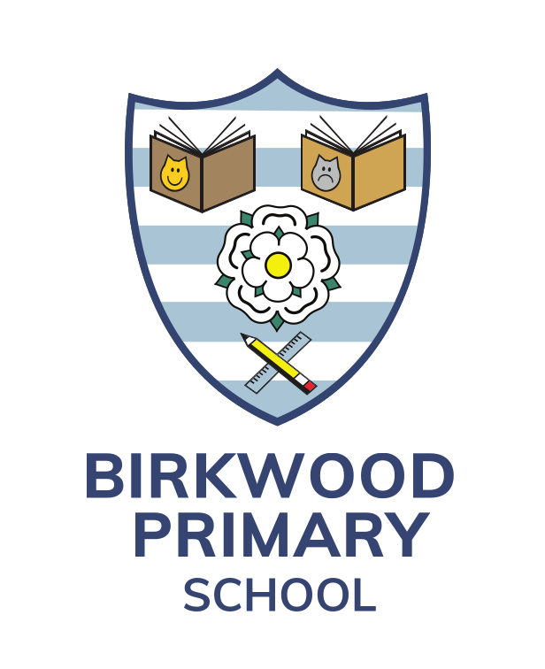 | Birkwood Primary School  Darfield Road  Cudworth  Barnsley  S72 8HG  Telephone: Barnsley (01226) 710447  Email: r.cocking@birkwood.org.uk    www.birkwood.org.uk  twitter.com/BirkwoodPrimary
EYFS Leader

Permanent Contract commencing Easter 2024
MPR to UPR will be considered with TLR 2 for Leadership

We are looking to appoint an ambitious and inspirational EYFS teacher to work as Phase Leader.

We are looking for someone who can actively support our vision and ethos – ‘The Birkwood Way’ where children will
- Do the Right Thing
- Acquire a depth of knowledge
- Experience Leadership, Collaboration and develop independence

The role offers an exciting opportunity for a nurturing, passionate and motivated person. The successful candidate will be creative, enthusiastic and able to work well as a leader and part of a team and crucially to use their initiative.
Our Early Years environment has the potential to be exceptional. This consists of three classrooms, a shared area for resources and cloakroom space, an EYFS staffroom/kitchen area and outdoor spaces.
Starting in 2024, the successful candidate will lead our Early Years Team to ensure high quality provision in this vital age phase. They will create a vibrant learning environment that enables children to reach their full potential. They will have responsibility for developing learning and teaching across the Early Years Curriculum and have an understanding of the impact a highly effective Early Years education has on the progress of learning across the whole school.

At Birkwood, our EYFS comprises a 78 place nursery (39am and 39pm) and 2 reception classes. Some of the Nursery places are 30 hours.
We are looking for a candidate who:
- is an excellent practitioner
- is a great communicator who develops positive relationships with children, staff and parents.
- is able to develop and maintain an imaginative and inclusive learning environment
- is able to lead, develop and motivate other colleagues in Early Years

We can offer:
- A happy caring school where you will be supported and valued
- A dedicated and supportive staff team and Governors
- A strong, nurturing community ethos
- A high quality learning environment

Please see our school’s website – www.birkwood.org.uk

Visits to school with the Headteacher are warmly welcomed.

All Applications to be completed via the BMBC Online Recruitment Page. Closing date for receipt of applications is 12 noon on Monday 11th December 2023. Interview date to be confirmed.

Birkwood Primary School is committed to safeguarding and promoting the welfare of children and expects all staff and volunteers to share this commitment. This post involves working with children and therefore if successful you will be required to apply for a disclosure of criminal records at an enhanced level. Birkwood Primary School is an equal opportunities employer.

