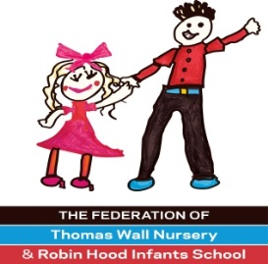
Headteacher: Mrs M Bracey
Deputy Headteacher: Mrs C Harrison

Robin Hood Lane
Sutton
Surrey SM1 2SF
Telephone: (020) 8643 3688/8642 5666
Fax: (020) 8661 1200/8643 2578
www.twn-rhi.org.uk

Teacher for September 2023
Suitable for ECT's or experienced teachers
Salary: Main Scale (Outer London Allowance)
We are looking for an inspiring and enthusiastic teacher to teach an Infant class. Our Federation contains a maintained nursery school with four part-time classes and a three-form entry Infants school. We are a happy school, we aim high and ensure our children leave us with lasting memories.
The successful candidate needs to:  - Be passionate about quality teaching and learning  - Have an outstanding record in Performance Management or ITT with successful experience of raising achievement  - Be reflective, creative and innovative  - Have excellent interpersonal skills – a ‘can-do’ attitude | We can offer you:  - Dedicated, hardworking teachers and support staff  - A caring and supportive team  - Support with continued professional development  - Enthusiastic, well behaved children with outstanding attainment  - Generous PPA time
For further details or an informal chat please contact the school office at office@robinhoodinfants.org.uk and a member of the Senior Leadership team will contact you.
You can visit our website to find out about our schools at: www.twn-rhi.org.uk

Closing date for applications: Monday 12th June 2023 at midday or earlier for enough suitable candidates.

Short listing date: Monday 12th June 2023

Interview during week commencing 12th June.

We reserve the right to close early if we receive enough suitable candidates.

The Federation of Thomas Wall Nursery and Robin Hood Infants School takes notice of and adheres to all national and local policies and guidance in regard to Safeguarding Children and Young People.

