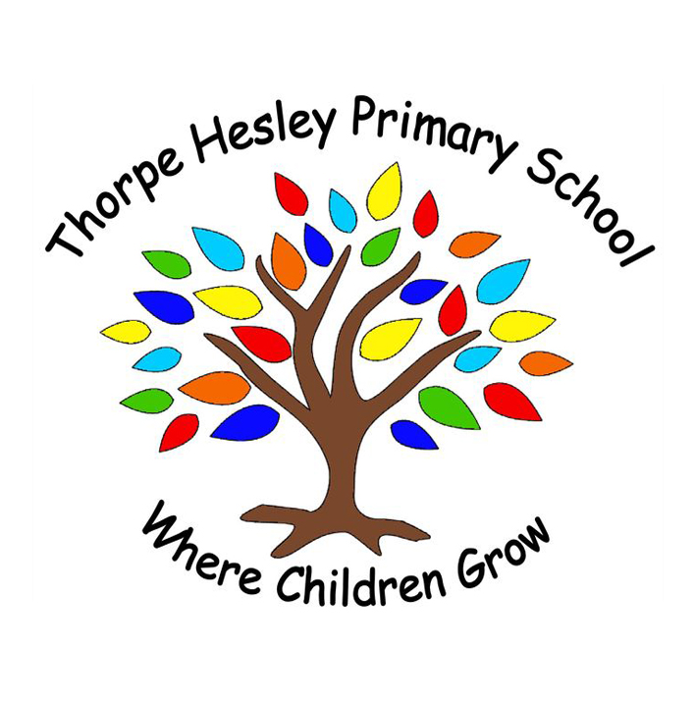
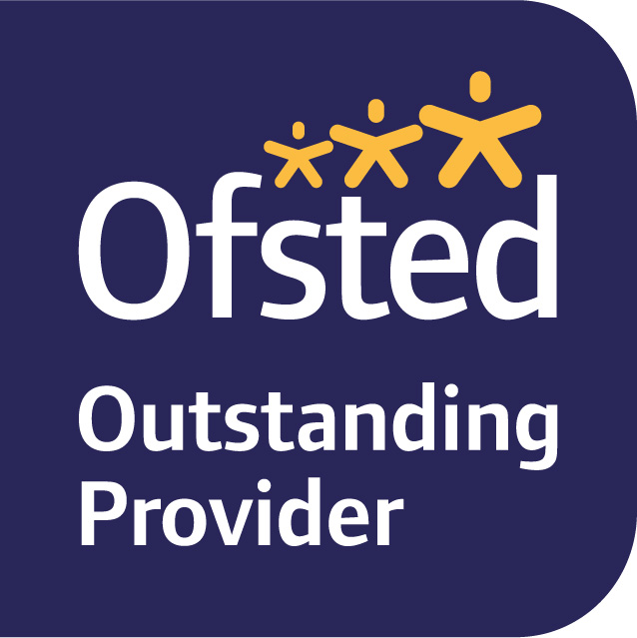
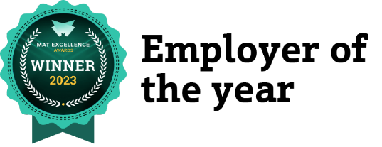

Working in partnership with New Collaborative Learning Trust (NCLT)

Upper Wortley Road, Thorpe Hesley, Rotherham, South Yorkshire, S61 2PL
Email: THP-recruitment@nclt.ac.uk Website:www.thorpehesleyprimary.rotherham.sch.uk Telephone: 01977 802 783

Early Years Practitioner (3 roles)

Salary: Salary Band C Point 4 of the Support Staff Spine, (£26,016 FTE)

Contract Details: 3 roles available with some flexibility regarding working hours and working pattern for the right candidate.

Role 1 – Monday to Friday, 35.83 hours per week. Varied hours between the times of 8am and 4.30pm.
Role 2 – Monday, Wednesday, Thursday & Friday, 8.45am to 3.10pm. 23.67 hours per week.
Role 3 – Wednesday, Thursday, Friday,8.45am to 3.10pm. 17.75 hours per week.

All roles are term time only, 38 weeks per year + 2 Inset Days and are temporary until 31st August 2027.

Start Date: Monday 4th January 2027
Closing Date: 9am on Friday 20th November 2026
Interview Date: Friday 27th November 2026

An exciting opportunity to join an Outstanding team!

We are seeking caring, enthusiastic and dedicated Early Years Practitioners to join our outstanding school-based nursery. Working under the guidance of the Room Lead and EYFS Lead, you will play a vital role in delivering a high-quality, play-based curriculum that supports the individual needs of our youngest learners. You’ll help create a safe, stimulating environment where children can thrive emotionally, socially and academically.

We are looking for someone with experience in early years settings and a strong understanding of the EYFS framework. The ideal candidate will bring a warm, nurturing approach and a genuine love for working with young children. Excellent communication and teamwork skills are essential, along with a clear commitment to safeguarding and promoting the welfare of all children. Join our supportive and forward-thinking team and make a real difference in the lives of children and families.

Thorpe Hesley Primary School is a happy, welcoming and vibrant place full of children and staff who have a real enthusiasm for learning. We constantly strive to be the best that we can be and give our children the best opportunities and experiences that we can. We are a creative school and believe that every child should be prepared for an ever-changing world through an inspiring, bespoke and creative curriculum. We are very proud of our creative curriculum which our staff have carefully developed with our children and our context in mind. Our pupils are incredible citizens who are taught and encouraged to care about each other and about their education. We are very proud of the lovely work they create and of their outstanding attainment which is consistently well above local and national averages.

We are a friendly, larger than average, Outstanding school, catering for around 550 pupils from Early Years Foundation Stage to Year 6. We have our own Nursery as well as comprehensive wrap around care provision, including a breakfast and after school club. Every member of staff in school, as well as our Advisory Group, are fully committed to giving the school and our pupils their best.

New Collaborative Learning Trust (NCLT) has a dynamic, positive and supportive culture for staff and students, with an enviable reputation for staff career progression and development. You will join a focused and driven team, committed to providing the highest standards of education and service. The Trust currently comprises of three 16-19 Colleges, three Secondary Schools and three Primary Schools, plus the Central Team.

Why Work for Us?
- Access to high-quality professional training, in-house and externally, to support your professional development.
- Attractive pension scheme.
- Access to a range of employee benefits, including a cycle to work scheme, technology scheme and an Employee Assistant Programme which includes such as GP appointments, counselling and physiotherapy.
- A strong commitment to staff wellbeing as outlined in our Staff Wellbeing Charter, including an annual Golden Ticket day.
- NCLT was crowned ‘Employer of the Year’ at the 2023 MAT Excellence Awards - these national awards celebrate the very best performers from over one thousand MATs across the country.

If you believe that you have the skills and abilities to take on this role, we’d love to hear from you.

To see the full job description, person specification and to apply please visit https://nclt.ac.uk/vacancies/.
Applications should be submitted to THP-recruitment@nclt.ac.uk.

