
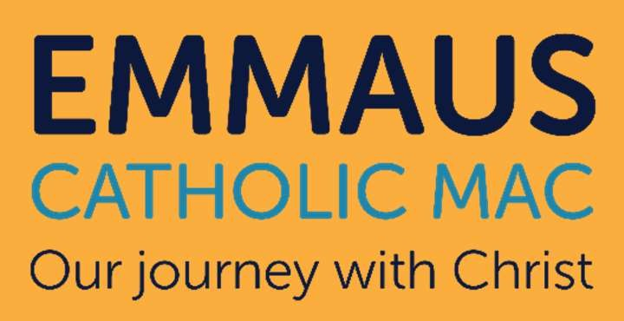





We are recruiting for an Early Years Pre-School Manager

Required for a start as soon as possible/September 2026
Salary: UQTS Level 6
Our Lady & St Hubert’s Catholic Primary School is seeking to appoint a full time Early Years Pre-School Manager. This is a fantastic opportunity for an experienced pre-school manager who is creative, innovative and has a willingness to continue their professional development.

Contact Us
A full application pack is available from our website. All completed applications are to be sent to enquiry_olh@emmausmac.com

We warmly welcome visits to the school.
For specific questions about the role and/or to request a visit, please contact the school office.
Phone – 0121 422 2629
Online - www.emmausmac.com Email – enquiry_olh@emmausmac.com
We offer a supportive and welcoming team environment, opportunities for continued professional development, a well-resourced and inclusive school setting, children who are enthusiastic and keen to learn and a leadership team committed to staff wellbeing
and development.

Putting our children and young people first, always.
“Excellent Catholic education for all, in the heart of our communities: nourishing faith, nurturing talent and fostering aspiration”
The successful candidate will play a key role in our school vision by delivering high quality teaching and learning. Our teachers and support staff are talented, professional, supportive, caring and ambitious to achieve success.
We welcome applications from both Catholics and non-Catholics but expect all employees to support the Catholic ethos and values of the school. If you meet the requirements of the job description and person specification and feel that you could make a positive difference to our school, then we can’t wait to receive your application.

Closing Date: Monday 18th May 2026 at 4pm (we may bring forward the application closing date, depending on volume of applicants, therefore please apply ASAP)
Shortlisting: w/c 18th May 2026
Interview Date: w/c 18th May 2026
Emmaus Catholic MAC is committed to safeguarding and promoting the welfare of children and young people. This position is subject to an Enhanced Disclosure check under the Rehabilitation of Offenders Act 1974.
All applicants must be able to provide documentation to prove their right to work in the UK.
Effective from September 2022, KCSIE states as part of the shortlisting process school and colleges should consider carrying out on-line searches, as part of the due diligence on shortlisted candidates. This is to determine suitability to work with children and keep them safe. All shortlisted candidates are now subject to an on-line check and if there is anything concerning, then the shortlisted candidate will be asked to comment on it either prior to or during the interview.

