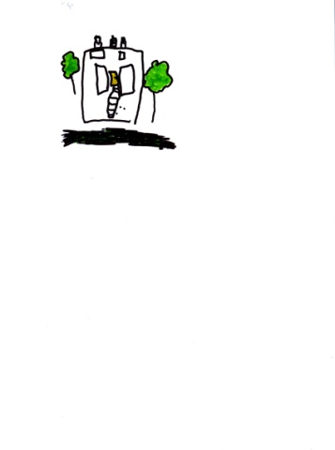

**MOSS HALL**

**NURSERY SCHOOL**

|  |
| --- |
| **Post:** Early Years Professional  **Address:** Moss Hall Nursery School, 189 Nether Street, London, N3 1NR  **Salary:** £38,058 - £41,442 (FTE), £34,405 - £37,464 (Actual)  **Hours of work:** 8:15-16:15 Monday, Tuesday, Thursday & Friday and 8:15 – 17:00 on a Wednesday  **Contract**: Term Time Only, Fixed Term Contract ( Maternity cover - 12 months)  **Deadline for applications:** 12.00 noon on Monday 6th January 2025  **Shortlisting:** Tuesday 7th January 2025  **Interviews:** Monday 13th January 2025  **Start date:** Monday 20th January 2025  PAC-UK | Ofsted Outstanding Logo |

We are looking for a dynamic, calm and caring Early Years Professional with a qualification in early years education (level 6 or above) to join our outstanding staff for a maternity cover.

This post will involve being the class lead for the 2 year olds class and ensuring high quality provision is made for FEE2 pupils and other 2yr olds attending Moss Hall Nursery School. The role also involves being a key person for a group of children ensuring children are engaged in highly motivating learning experiences in partnership with parents/carers.

Moss Hall Nursery School is an outstanding and popular school for children aged 2 years to rising 5 years of age. The children come from a rich variety of cultural backgrounds and they love to learn. The school is set in a spacious Victorian building with an extensive outdoor learning environment. The staff team are wonderful, experienced, enthusiastic and committed to providing an environment which supports active and independent learning.

**We can offer you:**

* A happy working environment with a supportive and hardworking team of staff
* An opportunity to develop professionally.
* A school that values creative individuals and supports a cross curricular and creative learning approach.
* A school which puts the interests of the children and their families first in all that we do.
* A supportive governing body
* A community of learners including links with our local infant and junior schools.
* Weekly WFH morning as part of PPA for the class lead

**Start date:** Monday 20th January 2025

Informal visits are strongly encouraged. We are open between 8:00 and 18:00 Monday to Friday.

For more information, contact the school office on 020 8445 2518

Completed application forms should be emailed to office@mosshallnursery.barnetmail.net

We are committed to promoting equality and challenging discrimination. Barnet is committed to safeguarding and promoting the welfare of children, young people, and vulnerable adults and expects all staff and volunteers to share this commitment. This post will be subject to an Enhanced CRB Clearance.  
  
Barnet operates stringent safer recruitment procedures.