INFORMATION PACK
Early Years Stronger Practice Hub: Digital Marketing Assistant – 2 year fixed term contract
Opportunity for flexible working and fully funded qualifications
Based at The Lodge (Altrincham Grammar School for Girls) – hybrid working available
Overview of the Role
We are seeking a digital marketing assistant to support marketing activities for our Early Years Stronger Practice Hub with direction from our Trust Marketing and Communications team. The postholder will have experience in digital marketing and be responsible for defining, designing , building and implementing digital campaigns across a variety of online and social media platforms to drive acquisition, engagement, and retention. The successful candidate will have experience of using a range of platforms including social media, WordPress, hoot suite, google classrooms, Teams/Zoom and of creating compelling content. Reporting to the Early Stronger Practice Hub Project Manager the role offers much variety covering everything from responsibility for elements of the overall Hub marketing plan to performing administrative tasks.
The full job description and person specification are at the end of this pack.

Bright Futures Educational Trust

Bright Futures Educational Trust (The Trust) is a multi-academy trust (MAT) set up in 2011. The Trust is made up of a richly diverse group of schools in Greater Manchester and Blackpool. We are passionate about working together within and beyond the Trust to achieve our aspirational vision: the best for everyone, the best from everyone. We are an organisation that is underpinned by values of: community, integrity, and passion. In everything we do, we remember that we are accountable to the children, families, and communities that we serve.

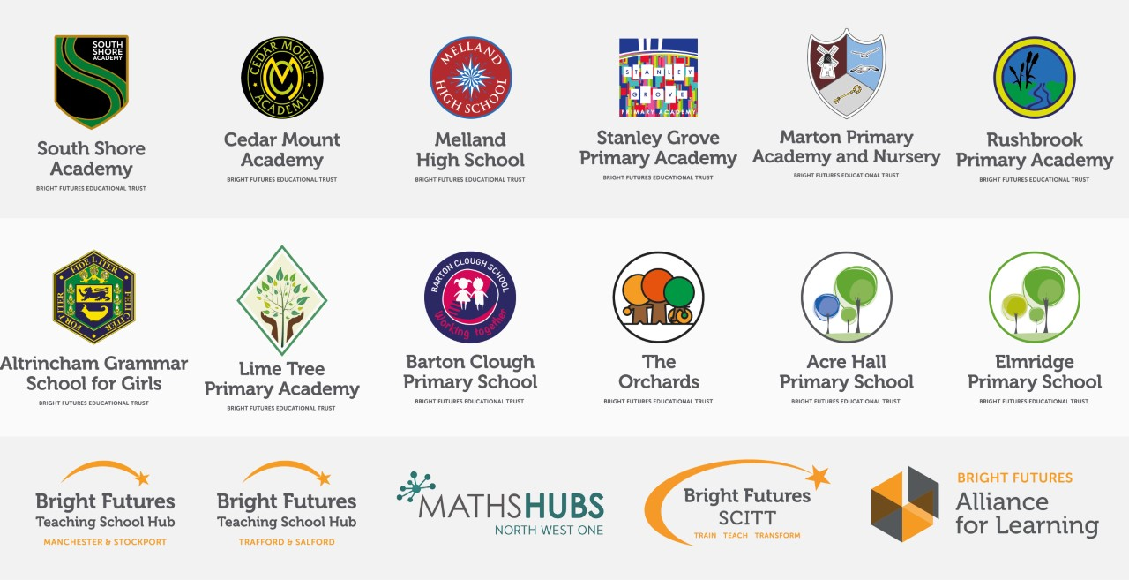

Our schools have their own identities and form one organisation and one employer, Bright Futures Educational Trust. Bright Futures’ Board of Trustees maintains strategic oversight of the Trust and delegates some of its responsibilities to the Executive Team, Principals, and local governing bodies. We place a high value on integrity and probity and take seriously our accountabilities for making the best use of public money. How decisions are made is described in our delegation framework. You can find out more about the Trustees and the Executive Team on our website: About Us

The central team comprises the Executive Team: John Stephens, CEO; Edward Vitalis, Chief Operating Officer; Gary Handforth, Director of Education; Lisa Fathers, Director of Development, Partnerships and Teaching School Hubs; Lynette Beckett, Director of HR & Strategy. The focus of these roles is to work with schools, providing high quality and timely guidance, leadership, challenge, and support. In addition to the Executive Team, we have central operations for Finance, HR, Educational Psychology, Marketing and Communications, and Digital Technologies. Please see our website brochure which explains our central operations: Working together for a Bright Future.

Bright Futures Development Network is another important outward facing component of our organisation made up of a number of hubs and networks at the heart the Trust. In January 2021, after significant national reforms to the teaching school policy Bright Futures was designated with two new large-scale Teaching School Hubs, which replace the Alliance for Learning Teaching School. This growth and expansion in our outward facing work brings about a significant increase in accountability and reach. The two Bright Futures Teaching School Hubs are designed to provide strong strategic regional leadership to build robust partnerships to support teachers and leaders in every phase and type of school, at each stage of their development. A crucial part of the hub remit is carefully ensuring structured collaboration. The Teaching School Hubs are at the forefront of providing high quality professional development, playing a significant role in the implementation and delivery of: The Early Career Framework, National Professional Qualifications (NPQ), Initial Teacher Training and Continuous Professional Development (CPD). The Hubs work directly with the Department for Education and national NPQ/ECT providers. In addition to this, the Hubs enhance the professional development needs of Bright Futures schools and academies. Within this outward facing area of Bright Futures Educational Trust, we have a commercial offer run through the Alliance for Learning which provides first-class school improvement services and CPD to over 700 schools, further complementing the work of our Teaching School Hubs. Our School-Centred Initial Teacher Training (SCITT) Bright Futures SCITT is also an integral part of the Teaching School Hubs, with over 10 years’ experience and judged Good by Ofsted, we offer Early Years, Primary and Secondary teacher training programmes. Within the Bright Futures Development Network, we are also proud to have a Maths Hub: NW1 Maths Hub offering a wide range of maths specific high-quality professional development opportunities and training/coaching to 500 schools.

Early Years Stronger Practice Hub
Throughout the pandemic, the youngest children in the most disadvantaged areas of England were among the hardest hit by lockdowns and social distancing. A responsive programme of support for staff and children has been developed by the Government to assist recovery and address the disruption of Covid-19. This includes new funding to support settings to address the impact of the pandemic on young children by sharing effective evidence-informed practice and building lasting local networks via the Stronger Practice Hubs programme.
The Stronger Practice Hub model works directly with the sector on a system leadership approach, with strong settings becoming a base for support, collaboration and practice sharing for and with other parts of the sector. The DFE has commissioned the National Children’s Bureau (NCB) to manage the relationships with Early Years Stronger Practice Hubs, including providing support, oversight and quality assurance, as well as running the selection process.

Our Early Years Stronger Practice Hub (EYSPH) will support settings to adopt evidence-informed practice improvements – in line with the framework developed for the programme by the Education Endowment Foundation, as well as with the reformed Early Years Foundation Stage, Development Matters.

Collaboration and strong relationships form one of the ‘commitments’ in our Strategy and all components of the Bright Futures’ family work closely together. Our Strategy was developed collaboratively and can be found on our website: Our Strategy

WHY WORK FOR US?
We offer a great opportunity to join an organisation which really lives its values. Our working environment is very inclusive and whilst you can expect to be challenged in your role, you will be supported through professional learning, treated fairly and with dignity and respect. Please see the Equality,
Diversity, an Inclusion statement on our website.

Terms and Conditions
Salary: NJC scale points 7- 11 to (Bright Futures scale Grade 4). The full time equivalent pay is
£22,369 rising to £24,054 p.a. Pay progression is linked to performance.

Working weeks: This is an all year round contract.

Hours: 36.25 hours per week over 5 days. Flexible working will be considered, please discuss at
interview if you wish this to be considered.

Holidays: You will be paid for the prorate equivalent of 25 days, plus 8 public holidays. This increases
to 30 days plus 8 public holidays after 5 years’ service.

Pension: Local government pension scheme. Please take a look at the website:
https://www.gmpf.org.uk/

Other: We offer salary sacrifice schemes for purchasing bikes used for travel to work and technology
for personal use, through monthly interest free salary deductions.
We also offer opportunities for professional development and funded offer a fully funded
apprenticeship with time off for study
For a full explanation of our employment offer please see the booklet on our website:
Great-Place-booklet.pdf (bfet.co.uk)
How to Apply
We can only accept completed application forms, rather than CVs. This is because the regulatory guidelines of
Keeping Children Safe in Education (2021), require us to check various details of job applicants and an identical
application format for each candidate enables us to do this. We use a process that does not identify personal
characteristics to the shortlisting panel. This is part of our commitment to equalities and diversity.
NO AGENCIES PLEASE.

Our application form is available online, along with the disclosure of criminal background form. The portal link is Digital Marketing Assistant Early Years Hub (jotform.com). Alternatively, you can click Apply Now on this role via the current vacancies page of our website. http://bfet.co.uk/vacancies/. Please upload the forms by midday Friday 6 January 2023.

The selection process may be conducted virtually, so candidates will need access to a device with a camera and a microphone to participate. However, we will confirm this following the closing date. The selection will take place on Thursday 12 January 2023. You will be notified after the closing date whether you have been shortlisted.
Keeping Children Safe in Education
Bright Futures Educational Trust is committed to safeguarding and promoting the welfare of children and young people and we expect all staff and volunteers to share this commitment. This post is exempt from the Rehabilitation of Offenders Act 1974; pre-employment checks will be carried out and references will be sought for shortlisted candidates and successful candidates will be subject to an enhanced DBS check and other relevant checks with statutory bodies.
Data Privacy
You can read the details of how we use the personal data that you provide us with in our Job Applicants’ privacy notice on our website: Applicant Privacy Notice
JOB DESCRIPTION
Early Years Stronger Practice Hub: Digital Marketing Assistant

JOB SUMMARY
The Digital Marketing Assistant will support marketing activities for our Early Years Stronger Practice Hub with direction from our Trust Marketing and Communications team. The primary role of any digital marketer is to define, design, build and implement digital campaigns across a variety of online and social media platforms to drive acquisition, engagement, and retention. This role is varied too, covering everything from responsibility for elements of the overall Hub marketing plan to performing administrative tasks, and is line managed by the Early Stronger Practice Hub Project Manager.

Early Years Stronger Practice Hub: Context
Throughout the pandemic, the youngest children in the most disadvantaged areas of England were among the hardest hit by lockdowns and social distancing. A responsive programme of support for staff and children has been developed by the Government to assist recovery and address the disruption of Covid-19. This includes new funding to support settings to address the impact of the pandemic on young children by sharing effective evidence-informed practice and building lasting local networks via the Stronger Practice Hubs programme.

The Stronger Practice Hub model works directly with the sector on a system leadership approach, with strong settings becoming a base for support, collaboration and practice sharing for and with other parts of the sector. The DfE has commissioned the National Children’s Bureau (NCB) to manage the relationships with Early Years Stronger Practice Hubs, including providing support, oversight and quality assurance, as well as running the selection process.

Our Early Years Stronger Practice Hub (EYSPH) will support settings to adopt evidence-informed practice improvements – in line with the framework developed for the programme by the Education Endowment Foundation (EEF), as well as with the reformed Early Years Foundation Stage, Development Matters.

KEY RESPONSIBILITIES AND ACCOUNTABILITIES

Main Responsibilities
- To manage all digital functions, platforms and the website for the Early Years Stronger Practice Hub. To include:
- Managing social media channels, engaging with stakeholders and creating relevant content e.g. graphics and testimonials
- Putting in place digital campaigns to support relevant marketing and recruitment activities
- Ensuring that all platforms used are effective, increase engagement and are reviewed using analytics to increase performance, with regular reporting
- To work with the Trust Marketing & Communications team to undertake and support the required digital marketing and general marketing and communications activities for the Hub
- Prepare online newsletters and promotional emails and organise their distribution through various channels
- Prepare, format and edit a range of documents and presentations
- Apply best practice and trends in digital work and learnings
- Ensure that all data capture meets GDPR and Data Protection requirements

Partners
- Collaborate with our partners to support the promotion of our Hub
- Work closely with the external website developer to complete ongoing development work, and manage any technical issues

Other
- Any other reasonable duties requested by the Director, Head of EYSPH, EYSPH (Project Manager) Commercial Manager and Marketing & Communications team

PERSON SPECIFICATION
Category | Essential | Desirable | Method of assessment
Qualifications, Education, Training | - 5 GCSEs grade A*- C/9 - 4 or equivalent (including English and Maths) | - A Level 2 qualification in digital marketing or a related subject  - Experience in a digital marketing role (1 year)  - Experience of using design programs to create marketing collateral | - Application form  - Certificates
Relevant Experience | - Experience of using a range of platforms including social media, WordPress, hoot suite, google classrooms, Teams/Zoom  - Experience of creating compelling content (video desirable) | - Experience in a digital marketing role  - Experience of developing online training programmes  - Experience of website management  - Experience of implementing paid for digital campaigns  - Experience of creating compelling content (video desirable) | - Application form  - Interview  - Tasks
Knowledge, Skills and Abilities | - Excellent communication skills; both oral and written and excellent interpersonal skills  - Ability to be an effective and supportive team member but also able to work alone with a high level of self-direction and self-motivation  - Ability to prioritise conflicting demands and thrive under pressure, excellent time management skills  - Excellent IT & proven digital skills  - Ability to take a problem-solving approach to tasks, and develop well thought through, valid solutions  - Ability to build and maintain effective working relationships with a wide variety of people and liaise with colleagues | - Ability to provide solutions based on needs of staff within the team  - Experience and understanding of the whole marketing mix  - Ability to encourage less digitally able staff to take on new skills and support them in the process | - Application form  - References  - Interview  - Tasks
Personal Qualities/Others | - Personal integrity and confidentiality  - Tact and discretion  - A positive approach to challenges, which seeks solutions to problems and addresses difficulties with cheerfulness and good humour  - Flexibility and adaptability  - Initiative and confidence when dealing with difficult situations  - Commitment to further training and development  - Smart, professional appearance |  | - Application form  - References  - Interview
Safeguarding | Commitment to demonstrating a responsibility for safeguarding and promoting the welfare of young people |  | - Application form  - Interview  - Task
Our Values | Community: Evidence of working together for a common purpose and encouraging diversity |  | - Interview  - Tasks
 | Integrity: Evidence of doing the right things for the right reason |  | - Interview  - Tasks
 | Passion: Evidence of taking personal responsibility, working hard and having high aspirations |  | - Interview  - Tasks

