INFORMATION PACK
Early Years Stronger Practice Hub: Head of Hub: 2 year fixed term contract
Based at The Lodge (Altrincham Grammar School for Girls) – hybrid working available

Overview of the Role
We are seeking an excellent senior leader to lead and manage the Early Years Stronger Practice Hub and improve Early Years Provision, creating and leading Early Years partnerships at a local, regional and national level and ensuring the delivery of our Early Years Stronger Practice Hub KPIs. Reporting to Director of Development, Partnerships & Teaching School Hubs this role is pivotal to the success of our Early Years Stronger Practice Hub and will have strong experience in providing outstanding strategic leadership within the Early Years sector and have a passion for development of the profession and research led opportunities.

The full job description and person specification are at the end of this pack.

Bright Futures Educational Trust

Bright Futures Educational Trust (The Trust) is a multi-academy trust (MAT) set up in 2011. The Trust is made up of a richly diverse group of schools in Greater Manchester and Blackpool. We are passionate about working together within and beyond the Trust to achieve our aspirational vision: the best for everyone, the best from everyone. We are an organisation that is underpinned by values of: community, integrity, and passion. In everything we do, we remember that we are accountable to the children, families, and communities that we serve.

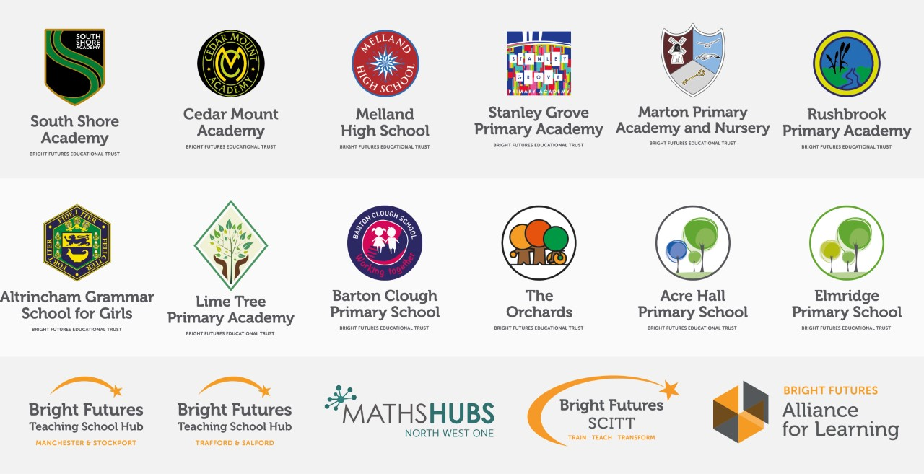

Our schools have their own identities and form one organisation and one employer, Bright Futures Educational Trust. Bright Futures’ Board of Trustees maintains strategic oversight of the Trust and delegates some of its responsibilities to the Executive Team, Principals, and local governing bodies. We place a high value on integrity and probity and take seriously our accountabilities for making the best use of public money. How decisions are made is described in our delegation framework. You can find out more about the Trustees and the Executive Team on our website: About Us

The central team comprises the Executive Team: John Stephens, CEO; Edward Vitalis, Chief Operating Officer; Gary Handforth, Director of Education; Lisa Fathers, Director of Development, Partnerships and Teaching School Hubs; Lynette Beckett, Director of HR & Strategy. The focus of these roles is to work with schools, providing high quality and timely guidance, leadership, challenge, and support. In addition to the Executive Team, we have central operations for Finance, HR, Educational Psychology, Marketing and Communications, and Digital Technologies. Please see our website brochure which explains our central operations: Working together for a Bright Future.

Bright Futures Development Network is another important outward facing component of our organisation made up of a number of hubs and networks at the heart the Trust. In January 2021, after significant national reforms to the teaching school policy Bright Futures was designated with two new large-scale Teaching School Hubs, which replace the Alliance for Learning Teaching School. This growth and expansion in our outward facing work brings about a significant increase in accountability and reach. The two Bright Futures Teaching School Hubs are designed to provide strong strategic regional leadership to build robust partnerships to support teachers and leaders in every phase and type of school, at each stage of their development. A crucial part of the hub remit is carefully ensuring structured collaboration. The Teaching School Hubs are at the forefront of providing high quality professional development, playing a significant role in the implementation and delivery of: The Early Career Framework, National Professional Qualifications (NPQ), Initial Teacher Training and Continuous Professional Development (CPD). The Hubs work directly with the Department for Education and national NPQ/ECT providers. In addition to this, the Hubs enhance the professional development needs of Bright Futures schools and academies. Within this outward facing area of Bright Futures Educational Trust, we have a commercial offer run through the Alliance for Learning which provides first-class school improvement services and CPD to over 700 schools, further complementing the work of our Teaching School Hubs. Our School-Centred Initial Teacher Training (SCITT) Bright Futures SCITT is also an integral part of the Teaching School Hubs, with over 10 years’ experience and judged Good by Ofsted, we offer Early Years, Primary and Secondary teacher training programmes. Within the Bright Futures Development Network, we are also proud to have a Maths Hub: NW1 Maths Hub offering a wide range of maths specific high-quality professional development opportunities and training/coaching to 500 schools.

Early Years Stronger Practice Hub: Context
Throughout the pandemic, the youngest children in the most disadvantaged areas of England were among the hardest hit by lockdowns and social distancing. A responsive programme of support for staff and children has been developed by the Government to assist recovery and address the disruption of Covid-19. This includes new funding to support settings to address the impact of the pandemic on young children by sharing effective evidence-informed practice and building lasting local networks via the Stronger Practice Hubs programme.
The Stronger Practice Hub model works directly with the sector on a system leadership approach, with strong settings becoming a base for support, collaboration and practice sharing for and with other parts of the sector. The DFE has commissioned the National Children’s Bureau (NCB) to manage the relationships with Early Years Stronger Practice Hubs, including providing support, oversight and quality assurance, as well as running the selection process.

Our Early Years Stronger Practice Hub (EYSPH) will support settings to adopt evidence-informed practice improvements – in line with the framework developed for the programme by the Education Endowment Foundation, as well as with the reformed Early Years Foundation Stage, Development Matters.

Collaboration and strong relationships form one of the ‘commitments’ in our Strategy and all components of the Bright Futures’ family work closely together. Our Strategy was developed collaboratively and can be found on our website: Our Strategy

WHY WORK FOR US?
We offer a great opportunity to join an organisation which really lives its values. Our working environment is very inclusive and whilst you can expect to be challenged in your role, you will be supported through professional learning, treated fairly and with dignity and respect. Please see the Equality,
Diversity, an Inclusion statement on our website.
Terms and Conditions
Salary: School Leadership scale pay range L8 – L12, dependent upon experience. Actual pay for the working pattern below is £21,166- £23,355 p.a.

Working weeks: This is a great opportunity for flexible working as the role will work 38 weeks during school term time and an additional 1 week to be agreed. A total of 39 weeks.
Hours: 2 days per week.

Pension: Teachers Pension Scheme: https://www.teacherspensions.co.uk/

Other: We offer salary sacrifice schemes for purchasing bikes used for travel to work and technology for personal use, through monthly interest free salary deductions.
We also offer opportunities for professional development.
For a full explanation of our employment offer please see the booklet on our website:
Great-Place-booklet.pdf (bfet.co.uk)

How to Apply
We can only accept completed application forms, rather than CVs. This is because the regulatory guidelines of
Keeping Children Safe in Education (2021), require us to check various details of job applicants and an identical
application format for each candidate enables us to do this. We use a process that does not identify personal
characteristics to the shortlisting panel. This is part of our commitment to equality and diversity.
NO AGENCIES PLEASE.

Our application form is available online, along with the disclosure of criminal background form. The portal link is Head of Early Years Stronger Practice Hub (jotform.com). Alternatively, you can click Apply Now on this role via the current vacancies page of our website: http://bfet.co.uk/vacancies/. Please upload the forms by Friday 9th December 2022.

The selection process may be conducted virtually, so candidates will need access to a device with a camera and a microphone to participate. However, we will confirm this following the closing date. The selection will take place on Wednesday 14th December 2022. You will be notified after the closing date whether you have been shortlisted.
Keeping Children Safe in Education
Bright Futures Educational Trust is committed to safeguarding and promoting the welfare of children and young people and we expect all staff and volunteers to share this commitment. This post is exempt from the Rehabilitation of Offenders Act 1974; pre-employment checks will be carried out and references will be sought for shortlisted candidates and successful candidates will be subject to an enhanced DBS check and other relevant checks with statutory bodies.
Data Privacy
You can read the details of how we use the personal data that you provide us with in our Job Applicants’ privacy notice on our website: Applicant Privacy Notice
JOB DESCRIPTION
Early Years Stronger Practice Hub: Head of Hub

JOB SUMMARY
The Head of Hub fulfils a senior leadership role leading and managing the Early Years Stronger Practice Hub. The role has a clear focus on improving Early Years Provision and leading Early Years partnerships at a local, regional and national level. This role is pivotal to the success of our Early Years Stronger Practice Hub. The Head of Hub will have a strong Early Years background and understand the Early Years sector. identify and create early years partnerships and will ensure delivery of our Early Years Stronger Practice Hub KPIs. The role is accountable directly to the Director across Bright Futures Development Network. This role will ensure early years good practice is shared and the profile of early years is amplified across the region working to ensure: ‘the best for everyone, the best from everyone’.

KEY RESPONSIBILITIES AND ACCOUNTABILITIES

Main Responsibilities
To have strategic overview of the Early Years Stronger practice hub and ensure the KPI’s set out by the Department for Education and National Children’s Bureau are achieved. The objectives include:

- Establishing local networks of settings to share knowledge and effective practice
- Proactively sharing information and advice on evidence-informed approaches, for example, through newsletters, blogs, events, network webinars and social media
- Acting as a point of contact for bespoke advice, and signposting/ referring to other funded support
- Working with the Education Endowment Foundation to select evidence-based programmes to fund and make available to settings

Leadership

- Develop and implement short, medium and long-term clear strategies to deliver the vision of the Early Years Stronger Practice Hub.
- To work with strategic partners to improve the quality of Early Years provision across all networks and to use technology to drive efficiency and improve overall outcomes
- To act as an advocate for Early Years to facilitate effective partnerships
- To report to the DFE and the Director of Development, Partnerships & Teaching School Hubs on progress in implementing the agreed strategies relating to areas of leadership and key milestones
- With support from our Commercial Manager ensure compliance to grants and DFE contracts and the commercial aspects of our organisation
- Support the Director with ensuing the Early Years Hub adds value across Bright Futures and beyond and has a sustainable legacy.
- To develop, articulate and uphold the vision, values, ethos and expectations of the trust

Stakeholder Engagement & Profile

- Being responsible for establishing and leading an engagement strategy for Early Years
- Facilitate the development and maintenance of formal and informal collaborative working partnerships for the Early Years Hub
- To work in partnership with the Deputy Directors of Teaching School Hubs
- To build on and strengthen partnerships with Early Years ITT provision and our own EYTS SCITT
- To represent the EYSPH at events, regional and local networks integral to the success of the Hub
- Responsibility for contributing to reports to governors, strategic partners and external agencies about activity against targets
- To maintain an up-to date knowledge of national developments in Early Years

Review, Evaluation, Improvement and Innovation
- Evaluation and review of the EYSPH KPIs completing Monthly reports as directed by the DfE and NCB
- Provide Risk Register to ensure all appropriate issues are risk assessed and mitigations put in place
- Production of self-evaluation document, to check and challenge progress on KPI’s
- Reporting to the board of Trustees, the Executive team and the Partnership Advisory Group which includes key stakeholders

Management

- To develop a strategic operating model for the Early Years Hub and its partners
- Mitigate financial risks through thorough strategic planning and
- Line manage specific and identified staff and oversee the performance management of all relevant colleagues
- Recruit and deploy a team of Early Years experts, mentors and SLEs
- As a member of the Development Network Leadership Team maximise the capacity, performance and effectiveness of our team
- Management of the team of Early Years Experts/SLEs

Bright Futures Development
- Contribute to the development of Early Years expertise in our workforce, drawing upon opportunities and intelligence of the early Years Hub to support all Trust schools
- Act as a positive advocate for Bright Futures
- Support the growth and development of the Trust
- Proactively engage with the mission, vision and values of the Trust

PERSON SPECIFICATION
Category | Essential | Desirable | Method of assessment
Qualifications, Education, training | - Degree  - Recent relevant in-service training  - No less than 2 years leadership experience in a Early Years Setting or School | - Post-graduate qualification  - Relevant Early Years Qualification – eg. QTS or EYTS | - Application form  - Certificates
Relevant Experience | - Successful leadership within a substantial middle or senior management role  - Experience of the teaching/working in the Early Years Sector (Schools, PVI & Childminders)  - Experience in school self-evaluation and development planning  - Substantial and successful work within professional development  - Evidence of a contribution to wider educational issues  - Experience of collaborating with/supporting the Early Years Sector | - Engagement in research  - Experience managing Government grants and associated monitoring and evaluation  - Experience and understanding of managing strategic communications and marketing | - Application form  - Interview
Knowledge, skills and abilities | - Understanding of the wider education landscape and the opportunities and challenges it brings  - Understanding of what constitutes high quality teaching professional development  - Very good oral and written communication skills  - Excellent ICT skills  - Ability to generate enthusiasm for teaching and for learning in general  - Ability to work as part of a team  - Ability to lead and motivate others  - Ability to plan, organise, review and adapt | - Experience of working with the DFE  - Experience of working in/with a range of Early Years Setting  - Experience of strategic boards and governance | - Application form  - References  - Interview  - Task
Leadership and Management | - Understanding of the importance of governance and strategic partnerships  - Ability to innovate, manage change and lead growth  - Ability to motivate, support and inspire trust in others  - Ability to confront and resolve problems  - Ability to work well under pressure  - Ability to formulate, monitor, evaluate and review plans and policies |  | - Application form  - References  - Interview  - Task
Early Years Hub | - Understanding of how to manage large budgets and staff  - Commitment to further training and a willingness to participate in relevant CPD e.g. facilitation  - Willingness to contribute to all to all Early Years Hub activities |  | - Application form  - Interview  - Task
Our Values | Community: Evidence of working together for a common purpose and encouraging diversity |  | - Interview  - Tasks
 | Integrity: Evidence of doing the right things for the right reason |  | - Interview  - Tasks
 | Passion: Evidence of taking personal responsibility, working hard and having high aspirations |  | - Interview  - Tasks

