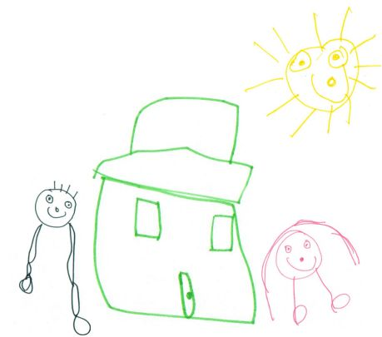 Hoyle Nursery School
Person Specification – Early Years Class Teacher/SENCo
AF = Application Form; I = Interview; LO = Lesson Observation
Qualifications and Training | Essential | Desirable | Evidence
Qualified Teacher Status | √ |  | AF/I
Eligible to work in the UK | √ |  | AF/I
Minimum of 3 years of successful teaching experience | √ |  | AF/I
Further qualification in Special Educational Needs (NASENCO) | √ |  | AF/I
Safeguarding Training and an excellent understanding of child protection policies | √ |  | AF/I
Experience and Professional Development | Essential | Desirable | Evidence
Evidence of teaching early years children, including disadvantaged children, children for whom English is an additional language and children with special educational needs | √ |  | AF/I/LO
Experience of Sensory Integration; Picture Exchange Communication System (PECS); Multi-Sensory Impairment; Team Teach or Sign Language |  | √ | AF/I/LO
Evidence of successful collaboration or partnership working with a multi-professional team to raise pupil achievement by removing or reducing barriers to learning for pupils with special educational needs or disabilities |  | √ | AF/I
Evidence of contribution to a pupils APDR cycles, EHCP and/or Annual Review | √ |  | AF/I
Recent experience of working successfully as a SENCO across the school |  | √ | AF/I
Knowledge, Skills and Ability | Essential | Desirable | Evidence
Knowledge of SEND assessment systems, interventions and strategies to support learning and progress | √ |  | AF/I
The ability to prioritise your own time, work under pressure and to set and meet deadlines | √ |  | AF/I
Evidence of successful and sustained teaching in challenging settings or situations |  | √ | AF/I
Excellent knowledge and understanding of the Early Years Foundation Stage Framework, its principles and practice | √ |  | AF/I
Familiar with current evidence based research pertaining to Education in the Early Years |  | √ | AF/I
Understanding of the philosophy of the benefits of outdoor learning and Forest School |  | √ | AF/I
Excellent knowledge and understanding of the educational, developmental and health needs of children under 5yrs including those with SEND and how to implement the statutory learning, assessment, welfare and safeguarding | √ |  | AF/I
Ability to use ICT to support children’s learning and school development | √ |  | AF/I
Decision making skills – the ability to investigate, solve problems, use own initiative and make decisions | √ |  | AF/I
Evidence of knowledge of Trauma Informed Practice and supporting children with ACES |  | √ | AF/I
Personal Attributes | Essential | Desirable | Evidence
A passion for Early Years and achieving the best possible outcomes for all children. | √ |  | AF/I
A passion for working with children with additional needs, offering quality inclusive early years education | √ |  | AF/I
An ability to be a positive role model for staff, form good relationships with the team and deal sensitively with and resolve conflicts | √ |  | AF/I
Establish and develop relationships with parents, governors and the community | √ |  | AF/I
Display warmth, care and sensitivity when dealing with children, parents and colleagues | √ |  | AF/I
Open minded, self-evaluative and adaptable to new developments | √ |  | AF/I
Professional, confidential, reliable, good sense of humour and a flexible approach | √ |  | AF/I
Requirements of the Early Years | Essential | Desirable | Evidence
Ability to foster equality and promote the richness of diversity through the curriculum, in relationships with parents, and in the supervision, support and leadership of staff | √ |  | AF/I
Ability to be reflective and evaluate provision through insightful analysis of qualitative and quantitative data and initiate appropriate changes | √ |  | AF/I
Knowledge and understanding of, the importance of mainstream inclusion for children with special educational needs | √ |  | AF/I/LO
Ability to lead and motivate staff in the development of quality education and care and to work towards common goals | √ |  | AF/I
Commitment to maintaining and developing the ethos of the EYFS provision as a partnership of children, staff, Governors and stakeholders, parents/carers and the community | √ |  | AF/I
Highly effective communication, interpersonal and emotional intelligence skills which support, facilitate trust and positive relationships with staff, parents, children and partners | √ |  | AF/I/LO
Understanding the importance of appropriate information sharing and confidentiality in accordance with the GDPR legislation | √ |  | AF/I
Commitment to Equal Opportunities | Essential | Desirable | Evidence
Demonstrate a commitment to and carry out duties with regards to the principles of the school’s Equal Opportunities Policy and a thorough knowledge of best practice and procedures for Safeguarding children. | √ |  | AF/I
An understanding of the appropriate strategies for managing pupils behaviour | √ |  | AF/I
Special requirements of the post | Essential | Desirable | Evidence
This role will require you to obtain an Enhanced satisfactory clearance from the Disclosure and Barring Service | √ |  | AF/I

