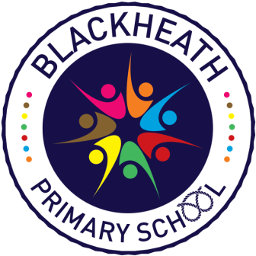
Job Description for Teacher

Core Purpose

The Teacher will:

- Provide a high quality educational experience for all children;
- Teach a class of pupils and ensure that planning, preparation, recording, assessment and Reporting meet their varying learning and social needs;
- Maintain and foster the positive ethos and core values of the school, both inside and outside the classroom;
- Contribute to constructive team building amongst teaching and non- teaching staff, parents and governors.

Have a working knowledge of:

- The national conditions of employment for school teachers as set out in the current copy of the School Teachers’ Pay and Conditions Document;
- The national standards for Qualified Teacher Status.

General Duties and Responsibilities

The Class Teacher will:

- Meet all teacher standards
- Implement agreed school policies and guidelines, including the Health and Safety and Child Protection Policies.
- Support initiatives
- Plan appropriately to meet the needs of all pupils, through differentiated tasks
- Be able to set clear targets, based on prior attainment, for pupils’ learning;
- Provide a stimulating classroom environment, where resources can be easily accessed by all pupils;
- Keep appropriate and efficient records, integrating assessment into planning
- Report to parents on the development, progress and attainment of pupils;
- Maintain good order according to the school’s behaviour policy
- Make part in and contribute to meetings that relate to teaching /curriculum
- When appropriate advise the head teacher and other colleagues in the development of subjects within school;
- Communicate and cooperate with specialists from outside agencies
- Plan for, organise and direct the work of support staff
- Participate in the performance management system for the appraisal of their own performance

Knowledge and Understanding

The Class Teacher will:

- Have knowledge of, and keep up to date with, the National Curriculum, the Agreed Syllabus for Religious Education and the new EYFS Framework.

- Understand how pupils’ learning is affected by their physical, intellectual, emotional and social development and to understand the stages of child development;

- Select and make good use of IT skills for classroom and management support;

- Understand and know how national, local comparative and school data, including National Curriculum test data, can be used to set clear targets for pupils’ achievement.

Planning, Teaching and Class Management

- Plan and deliver in relation to the National Curriculum etc the teaching programme for all children within the class.

- Make effective use of assessment information on pupils’ attainment and progress and in planning future lessons.

- Ensure effective teaching of whole classes, groups and individuals, establishing high expectations of behaviour and attainment, so that teaching objectives are met.

- Monitor and intervene when teaching to ensure sound learning and discipline and maintain a safe environment in which pupils feel confident.

- Use a variety of teaching and learning styles to keep all pupils engaged.

- Be familiar with the Code of Practice and identification, assessment and support of pupils with special educational needs.

- Evaluate their own teaching critically to improve effectiveness.

- Manage additional adults effectively.

Monitoring, Assessment, Recording, Reporting and Accountability

- Assess and record each pupil’s progress systematically with reference to the school’s current practice, including the social progress of each child, and use the results to inform planning.

- Mark and monitor children’s work appropriately, providing constructive feedback and setting targets for future progress.

- Provide reports on individual progress to the Head Teacher and parents as required.

