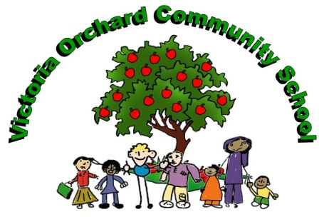

Victoria Community School, Victoria Road,
Burton upon Trent, Staffordshire. DE14 2LU
Victoria Orchard Site, Belvoir Road,
Burton upon Trent, Staffordshire. DE13 0RA

Head Teacher: Mrs Elizabeth Laughlin
Tel: 01283 247432 E-mail: headteacher@victoria.staffs.sch.uk

January 2021

EARLY YEARS CLASS TEACHER (RECEPTION)
Temporary/Part time
MS1-MS6 £25,714 - £36,961 pa (pro rata)

Dear Colleague

Thank you for your interest in our temporary part time teaching post as a Reception Class Teacher which is available as soon as possible after 22nd February 2021. Please find enclosed a job description, application form and information about our school. The post is for 19.5 hours a week, Monday to Wednesday.

Our two site school serves a majority minority ethnic community which is unique within Staffordshire, as we are the only school where over 90% of our pupils speak English as an additional language. However, more recently we have admitted a number of pupils with a variety of cultural and linguistic backgrounds including those from Eastern Europe.

We require an enthusiastic teacher to join our Early Years team teaching pupils in one of our Reception Classes as soon as possible from February 2021 until 31st August 2021 based at the Victoria Road site. The start date would be negotiable according to the situation of the successful candidate.

It is important that you have a genuine interest and desire to learn in this area of education and share in the real challenges and rewards of raising the achievement of our pupils. As a school we can offer you:

- The support of an excellent team of colleagues.
- An experienced and dedicated team of support staff.
- Established curriculum plans and schemes of work and agreed planning formats.
- A well-resourced curriculum including an ICT suite and interactive whiteboards.
- An attractive, caring and supportive learning environment.
- Opportunity to work in a multi-disciplinary environment.
- Access to professional development and a comprehensive programme of staff training including an induction programme with a personal mentor for every new member of staff.
- An active partnership with our parents and local community.

If you are keen to join a team committed to working together to raise the aspiration and attainment of all our pupils you are strongly encouraged to consider this vacancy. You are encouraged to outline in your application form-

- The skills, talents and experience you could bring to our school.
- Information concerning recent and relevant teaching experience.
- Strategies you have found successful in supporting all pupils to achieve high standards.

This School is committed to safeguarding and promoting the welfare of children and young people/vulnerable adults and expect all staff and volunteers to share this commitment.
This position is subject to a “disclosure” check under the “Rehabilitation of Offenders Act 1974”. Further details regarding this check and Staffordshire County Council’s employment policy will be found within the guidance notes.

Please note that completed applications should be returned to school no later than 9am on
Monday 18th January 2021. Interviews are planned for Friday 22nd January 2021. Applications should be sent by email to office@victoria.staffs.sch.uk.

We look forward to hearing from you.

Yours sincerely

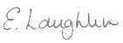

Mrs E Laughlin
Headteacher

Where everyone is important

