





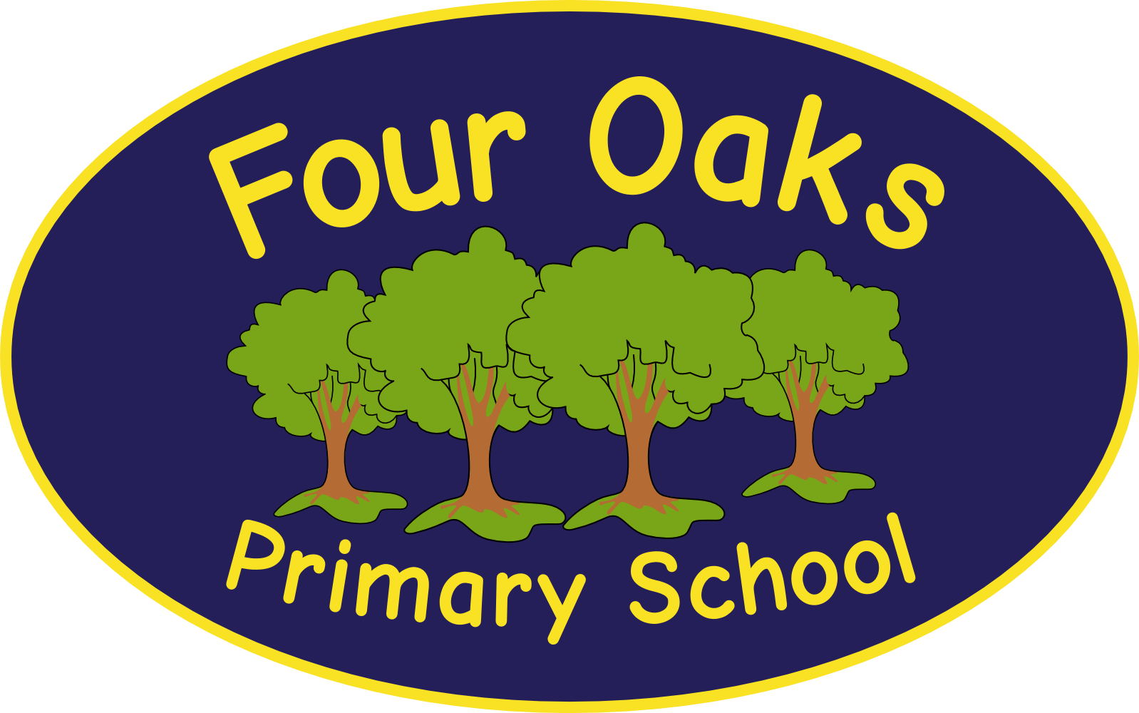

Headteacher: Mrs S Robinson B.A.(Ed) M.Ed. NPQH

39 Davy Street
Liverpool L5 1XP
Telephone: (0151) 263 4038
Fax: (0151) 260 7257
Email: office@fouroaksprimary.com
Website: www.fouroaksprimary.co.uk


Job Description

Job Title – Early Years Teacher Status
Grade 9 to 13 (26,409 - £28,163)

Purpose of the position

The EYTS will oversee the operation of the day nursery to the highest quality standard, ensuring that the best possible environment and care are provided for young children to learn and develop and will supervise the work of subordinate staff.

The EYTS will be expected to provide high quality, flexible childcare for families from the local communities. To support the marketing and promotion of the Nursery to enable it to be a sustainable childcare business.

Main Responsibilities

- The EYTS will work closely with the EYFS Leader and will be expected to work autonomously in relation to the day-to-day management, organisation and smooth running of the Nursery. The role requires the confidence to make day-to-day decisions thoughtfully and with a high degree of sensitivity to the needs of children and families.
- The EYTS will supervise all nursery staff including induction, mentoring, and professional development and operational issues e.g. maintaining staffing levels if staff are absent.
- The EYTS will be expected to make recommendations and proposals about service developments and changes, but not to make decisions about substantive changes to the Nursery.
- To ensure the EYFS is promoted and delivered within the setting and the principles adhered to. To keep a register and up to date records of all children using the nursery provision and to give regular feedback to parents about their child’s development and progress.
- The EYTS will have a key role in planning and monitoring of the nursery and implementing essential policies and procedures. This will require creative thought together with an informed understanding of KCSiE, statutory requirements and best practice for childcare.
- To promote inclusion and equality in all aspects of service delivery
- The EYTS will need to demonstrate effective time and resource management to meet the planned needs of children and families and any anticipated demands that might be reasonably foreseen. The EYTS will need to make judgments about the delegation of tasks and responsibilities to other staff in the Nursery.
- The EYTS will have day to day responsibility for the planning in the Nursery and for the use of other resources. Also for ensuring that the nursery provision is clean, safe and welcoming for children, their families, staff and the wider community.
- To order and maintain equipment and resources in the Nursery
- To ensure the nursery meets Ofsted Early Years Foundation Stage Requirements and provides a high-quality inclusive childcare service for children.
- The EYTS will be expected to build good working relationships at every level. Working in partnership with parents and families is highly valued and the EYTS must be approachable, friendly and able to communicate effectively at all times.
- To provide information for and consult with parents on the development of their child (ren) and the wider service delivery of the nursery.
- To provide data/monitoring information and reports as requested.
- To attend meetings with other relevant professionals and organisations as required. To ensure effective communication between the nursery staff and with all partner organisations including the Social Services, Health, Local Authority and a range of voluntary /private sector organisations and Day Care providers.
- The EYTS will need to understand and implement policies and procedures
- To carry out any reasonable task as requested by the EYFS Leader or Headteacher.

This job description is not intended to be either prescriptive or exhaustive; it is issued as a framework to outline the main areas of responsibility at the time of writing.

