

Enquire Learning Trust Application Pack

Teaching Assistant (Level 2)

Reference Number: ELTNOV2025

Buckingham Primary Academy
Buckingham Street
Hull
HU8 8UG



Contents:



2. Academy Information


3. EAP Programme


4. Job Advert


5. Job Description


6. Person Specification

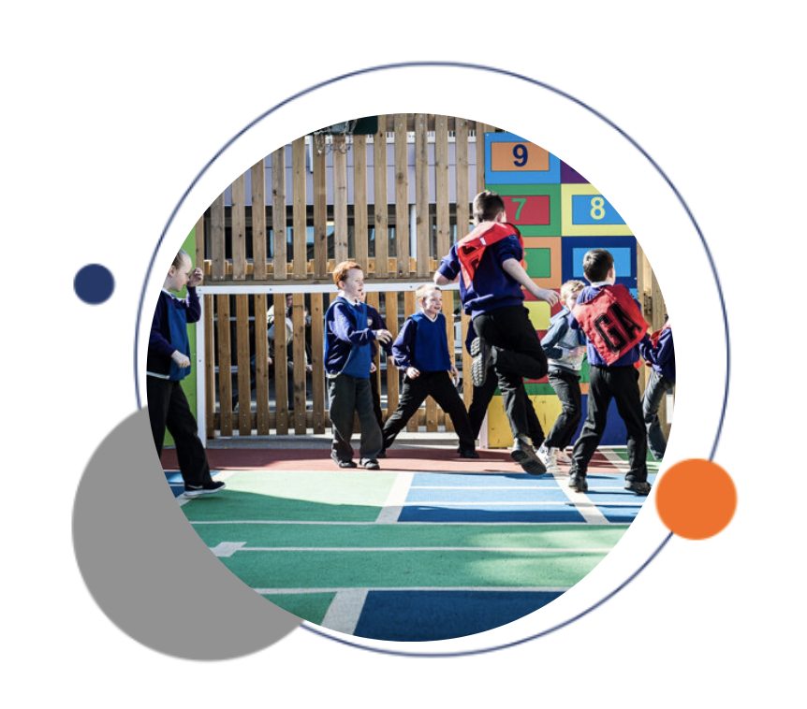


The Enquire Learning Trust

We are a multi-academy trust currently responsible for 32 academies in four clusters across the North of England; North East Lincolnshire, Hull, Manchester, Teesside and North Yorkshire.

We work in complete collaboration with each of our academies and place a strong emphasis on school-to-school support and learning. Our academies work in collaboration with one another, sharing both their talent and ideas with others, giving employees the opportunity to learn from individuals within our other academies.

We recognise that the most important assets we have are our employees, and for our academies to succeed we need to ensure we employ the very best people in every single role. Our core values and beliefs are consistent throughout all of our academies, and our keys to success are at the heart of everything we do.

Every role across the Trust is valued, appreciated and purposeful. We believe that the outcome of every role across the Trust should improve the education each of our learners receive. Whether teaching, support or leadership, every single role is vital to the success of our academies.

We also recognise that all of our academies are different, and we encourage individuality. Whilst we believe our academies should work together to support best practice and to share ideas, we don’t believe that implementing blanket priorities and objectives is pertinent to a successful academy, and we encourage autonomy for academy leaders wherever possible.

Values

- We believe that all learners can be powerful learners given access to extraordinary learning experiences. We want children and the academies they attend to be confident, successful and ambitious.
- We envisage a Trust where well led, highly skilled and committed professionals collaborate, learn and innovate together to ensure that all academies are successful and where all learners have access to effective and innovative provision that meets their needs and aspirations.
- We want to add value to achievement and raise standards. We also want to change lives. We know this requires our provision and our practice to be world-class – because of the distance we have to travel, we understand that good will not be good enough and that we need to develop a shared appreciation of excellence and then strive to enact this every day.
- We take learning seriously and work together to create a vibrant culture in which this can happen. We know that it’s what we do that counts and that our thinking must be visible in classrooms if it is to have leverage. Children are at the forefront of all that we do and aspire to do. We take serious steps to engage them, to hear their voice in authentic ways and then to use their insight and expertise to develop radical pedagogies that tap into their passions and interests and use the potential of emergent technologies.



About the Academy

Buckingham Primary Academy converted to academy status in June 2014, however children from East Hull have been educated on the same site since 1883. The current building dates back to 1988 and we are fortunate enough to have ample outdoor learning space including 3 playgrounds, a sports field and gardens. The academy has undergone extensive refurbishment in recent years and this is expected to continue on a rolling programme.

Values and Ethos

At Buckingham Primary Academy we believe, persevere and achieve.
Our mission is to ensure that our young people leave us as confident and adaptable learners who are imaginative, intelligent and independent ready to be responsible, respectful and aspirational members of their community and the wider world.
We are proud to offer a purposeful, inspiring, broad and aspirational curriculum which is accessible and inclusive for ALL with a wide range of enquiry questions, high aspirations and a belief to achieve through collaboration. There is a clear progression of skills from when a child starts to when a child leaves at the end of primary in readiness for secondary education. Our curriculum provides connections and webs of knowledge through careful task design.
Our children’s cultural capital is varied as our children come from a wide range of backgrounds. Our curriculum aims to close the cultural capital gap for the most disadvantaged children in our community. This will enable ALL our children to actively contribute to the community and their wider society in a positive way.
Staff work hard to enable pupils to become confident, responsible and successful learners and we believe working with parents and carers ensures the best outcome for everyone. Through collaboration, our children will leave Buckingham Primary Academy with personal pride and respect for one another and have a deepened understanding and the emotional intelligence to keep themselves and their community safe in an ever-changing society.

‘Pupils are polite and friendly.
They interact well with one another and are welcoming to visitors’.

‘The school is ambitious for what pupils can achieve.
Pupils respond well to these high expectations’.
OFSTED January 2025

EAP Programme



The Trust offers a plan through Health Assured which provides access to valuable health and wellbeing services.​

Key Features:

- Unlimited access to 24/7 confidential telephone helpline
- Up to 10 sessions of face to face, telephone and online counselling
- Access to the portal and wisdom app
- Coverage for spouse/partner and dependants
- Medical information line including articles, webinars and podcasts
- Menopause Support access to other resources such as 'Menopause Matters'
- Access to Perks and Discounts
- Online and mobile access, anywhere and anytime
- Self-help guides, mood and wellness trackers

Job Title: Teaching Assistant (Level 2)
Reference Number: ELTNOV2025

Working Hours: 33.75 hours per week. Additional hours may become available to support children in wrap around provision if there is the demand
Working Weeks: 39 Weeks
Salary Scale Range: NJC 5-7
Contract Type: Permanent
Start Date: 05/01/2026
Location: Buckingham Primary Academy, Buckingham Street, Hull, HU8 8UG

About us

We are proud to offer a purposeful, inspiring, broad and aspirational curriculum which is accessible and inclusive for ALL with a wide range of enquiry questions, high aspirations and a belief to achieve through collaboration. There is a clear progression of skills from when a child starts to when a child leaves at the end of primary in readiness for secondary education. Our curriculum provides connections and webs of knowledge through careful task design. .

About the role
We are seeking to appoint an experienced Early Years Teaching Assistant/ Early Years Educator who understands the stages of child development and how to support children’s learning and growth. This role is primarily for Early Years but from time to time, the successful candidate may support with child development in KS1.

What we are looking for
Someone who has a full and relevant Early Years Educator qualification. Before you apply, please check your qualification by following this link:
https://www.gov.uk/guidance/check-an-early-years-qualification

- Excellent English and Maths skills
- Someone who is imaginative, creative, flexible and open to change with a caring and kind nature
- Willingness to attend a Paediatric First Aid course (if not already in possession of this qualification)
- Willingness to undertake professional and personal development

What we can offer
Membership of the East Riding Pension Scheme
Opportunities for development and progression
Employee Assistance Programme provided by Health Assured
Cycle to Work Scheme
Octopus EV Scheme
Lifestyle savings

Working arrangements
08.30AM – 15.45PM
Monday – Friday term time plus 5 days

For more information, please contact Paula Hillman, Principal, 01482 328661, admin@buckingham.hull.sch.uk

Visits to school are welcomed and encouraged, please contact the school office on 01482 328661 or email admin@buckingham.hull.sch.uk to arrange.

How to apply
You can apply for this position by visiting:
The Enquire Learning Trust
Eteach
DfE Vacancies

Closing date and time: 25/11/25 5:00PM

Interview Date:02/12/2025

DBS/Safeguarding Statement
The Enquire Learning Trust is committed to safeguarding and promoting the welfare of children, young people and vulnerable adults and expects all staff and volunteers to share this commitment. As this post involves access to children or vulnerable adults, the successful applicant will be required to obtain an Enhanced Disclosure from the DBS.

Job Description

Reporting to: Principal and EYFS Lead

- Job Purpose
Whilst working under supervision, the purpose of the job is to focus on supporting the holistic development of young children through care, play, and learning activities, while ensuring a safe and stimulating environment.

- Relationships
- The post holder reports to the Principal and EYFS Lead
- The post holder is also accountable to the EYFS Lead and Principal.
- Develop and maintain positive relationships with children, colleagues and parents/carers.

- Main Duties

Childcare and Well-being:
- Provide daily care, including feeding, nappy changing, and assisting with personal hygiene.
- Ensure the safety and well-being of children, both indoors and outdoors.
- Recognise and respond to children's individual needs and emotional needs.
- Promote positive behaviour and encourage children's social interaction.
- Support children through transitions, such as settling in.
- Administer first aid and follow procedures for accidents and emergencies.
Learning and Development:
- Support children's learning and development through play-based activities and educational programs.
- Plan and implement age-appropriate activities that encourage creativity, social skills, and cognitive development.
- Observe children's progress and keep records of their learning and development.
- Contribute to the development of learning journals and assessments.
Communication and Collaboration:
- Liaise regularly with parents and carers to share information about their child's progress and needs.
- Work collaboratively with other staff members to plan and deliver activities.
- Contribute to policies and procedures.
- Attend staff meetings and training events.
Safeguarding:
- Recognise and report any concerns about a child's safety or well-being.
- Follow safeguarding procedures.
- Be aware of child protection issues and how to respond to incidents, accidents, and emergencies.
Other Duties:
- Maintain a clean, safe, and stimulating learning environment.
- Follow policies and procedures.
- Undertake any other reasonable duties as directed

Person Specification
 | Essential | Desirable | Method of assessment
Qualifications | - Full and Relevant Early Years Educator Level 2 qualification.  https://www.gov.uk/guidance/check-an-early-years-qualification  - Excellent English and Maths skills.  - Willingness to attend Paediatric First Aid course (if not already in possession of this qualification).  - Willingness to undertake professional and personal development. | - Full First Aid qualification  - Early Years CPD | Application  Certificates  Interview
Skills and Experience | - Experience of working in a private or school based early years setting.  - Knowledge of Child Development: Understanding the stages of child development and how to support children's learning and growth.  - Safeguarding: Recognising and responding to child protection concerns, including abuse and neglect.  - Health and Safety: Ensuring a safe and healthy environment for children, including understanding and implementing relevant policies and procedures.  - Communication: Effectively communicating with children, parents, and colleagues.  - Planning and Delivery of Activities: Supporting the planning and delivery of activities, purposeful play opportunities, and educational programs.  - Supporting Children with Special Educational Needs and Disabilities: Understanding and supporting children with diverse needs.  - Working with Others: Collaborating effectively with parents, colleagues, and other professionals.  - Following Procedures: Adhering to policies and procedures within the setting.  - Recording Observations: Keeping accurate records of children's progress and development | - Experience of KS1  - Patience and Enthusiasm: Maintaining a positive and engaging attitude when working with young children.  - Imagination and Creativity: Developing and implementing engaging and stimulating activities.  - A Caring and Kind Nature: Treating children with respect and understanding.  - Willingness to be Part of a Team: Collaborating effectively with colleagues to provide the best possible care for children.  - Sensitivity and Understanding: Recognizing and responding to children's individual needs and emotions.  - Flexibility and Openness to Change: Adapting to different situations and learning new skills.  - Active Listening Skills: Paying attention to children's communication and responding appropriately.  - Customer Service Skills: Communicating effectively with parents and other stakeholders.  - An interest in child development: Showing genuine enthusiasm for working with young children and understanding their needs. | Application  Interview  References

Buckingham Primary Academy
Buckingham Street
Hull
HU8 8UG

Principal: Paula Hillman

Telephone: 01482 328661
Email: admin@buckingham.hull.sch.uk

The Enquire Learning Trust is committed to safeguarding and promoting the welfare of children and young people and expects all staff and volunteers to share this commitment. All ID and qualification checks will be made prior to appointment, as will online searches of candidates (Keeping Children Safe in Education 2023). Any offer of employment will be subject to receipt of a satisfactory Disclosure & Barring Service check and Disqualification by Association Disclosure.

DISCLOSURE AND BARRING AND RECRUITMENT CHECKS
The Trust is legally obligated to process an enhanced Disclosure and Barring Service (DBS) check before making appointments to relevant posts.
The DBS check will reveal both spent and unspent convictions, cautions, reprimands and final warnings, and any other information held by local police that’s considered relevant to the role. Any information that is “protected” under the Rehabilitation of Offenders Act 1974 (Exceptions) Order 1975 will not appear on a DBS certificate.
For posts in regulated activity, the DBS check will include a barred list check.
It is an offence to seek employment in regulated activity if you are on a barred list.
We’ll use the DBS check to ensure we comply with the Childcare Disqualification Regulations. It is an offence to provide or manage childcare covered by these regulations if you are disqualified.
Any data processed as part of the DBS check will be processed in accordance with data protection regulations and the trusts information governance policy which can be found on the website.
Please note this post is in regulated activity and exempt from the rehabilitation of Offenders Act 1974 and subject to satisfactory references and an enhanced DBS criminal records and barred list check for work with children. An online search may be undertaken as part of the recruitment process on information available in the public domain. Candidates should disclose anything that may be relevant in line with Keeping Children Safe in Education.

Any job offer will be conditional on the satisfactory completion of the necessary pre-employment checks. Only applicants who have been shortlisted will be asked for a self-declaration of their criminal record or information that would make them unsuitable for the position. Any convictions that are self-disclosed or listed on a DBS check will be considered on a case-by-case basis.

All documentation will be treated confidentially and processed in accordance with Data Protection regulations

