SANDBACH PRIMARY ACADEMY

Early Years Teaching Assistant
Permanent
30 hours per week 39 weeks per year
Grade 4 pro rata

Sandbach Primary Academy are looking to appoint an Early Years Teaching Assistant to work in our school.

We are looking for a dedicated, passionate and resilient individual who places the best interests of the children in their care at the heart of their work. We are looking for a versatile Teaching Assistant with Early Years qualification Level 3 or above, to work in our Nursery. The successful candidate will also be able to adapt to provide excellent provision in any class when needed.

The successful candidate will ideally understand the Early Years frameworks, have a secure understanding of a range of SEND needs and have experience of supporting children across the whole curriculum. The successful candidate must be able to build positive relationships with the children and their families and build and maintain positive working relationships within the staff team.

We are a member of The Aspire Multi Academy Trust and offer a mutually supportive ethos with excellent opportunities for professional development.

We are proud to be a Disability Confident Committed Employer, we strongly encourage applications from all persons with a known disability. We aim to ensure a fully inclusive and accessible recruitment process.

If you request any support or have any questions, please contact
Name: Claire Caldwell
Phone:01270 918 922
Email: head@sandbach-pri.cheshire.sch.uk

As a Trust we are committed to safeguarding and promoting the welfare of our children. For all shortlisted candidates reference checks and online searches will be completed prior to interview. All successful candidates are subject to satisfactory references, medical checks, right to work in UK and safeguarding checks (including enhanced DBS and a declaration of disqualification (Childcare Disqualification regulations 2009).
If you are committed to helping children thrive and getting the best start in life, then we look forward to hearing from you.

Applicants must write a letter of application detailing suitability for the post and complete an Aspire Educational Trust application form which can be found on the school website:
Sandbach Primary Academy: Current Job Vacancies (sandbach-pri.cheshire.sch.uk)

If you are committed to helping children thrive and getting the best start in life, then we look forward to hearing from you.

Closing Date: Wednesday 19th June 12 noon
Interview: To be confirmed
Start Date: September 2024
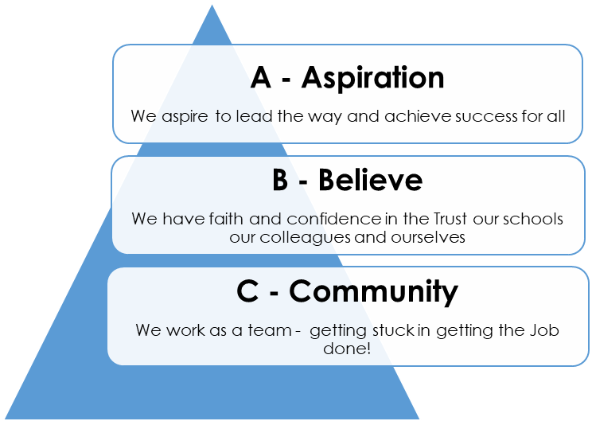
Applications to be sent to: Lesley Greenwood (Bursar): admin@sandbach-pri.cheshire.sch.uk

