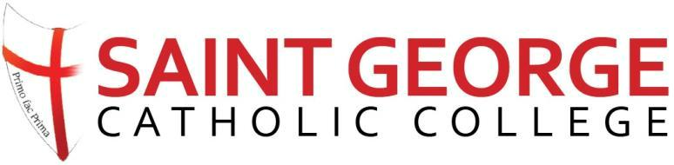

- Education Mental Health Nurse
- Closing Date: 4th October 2021
- Job Start Date: 4th January 2022
- Location: Southampton
- Contract/Hours: Part Time.
- Hours: 3 days (8:30am to 3:30pm) per week term time only
- Salary Type: £25,481 FTE

Job/Person Summary
St George Catholic College is an oversubscribed and growing college, both in terms of the number of students on roll and in terms of the ability of the students who are joining us. We put our pupils at the forefront of all we do and need someone who shares our passion. We enable all children to make the best progress they can through our creative curriculum, we aim to prepare pupils to move confidently and happily, through each stage of their education enabling them to become lifelong learners.
We have a vacancy for a part time experienced and qualified Education Mental Health Nurse. The post holder will:
- Deliver evidence-based intervention for children and young people in education setting with mental health problems.
- Work in partnership to support children and young people experiencing mental health difficulties and their parents/carers, families and educators in the self-management of presenting difficulties.
- Help children and young people within these settings who present with more severe problems to rapidly access more specialist services.
- Support/facilitate staff in school to identify and where appropriate manage issues related to mental health and wellbeing.
- Accept referrals in school according to agreed local and national protocols.
- Complete all requirements relating to data collection.
We are looking for a self-motivated team player with excellent time management skills.
The successful candidate will be part of our Inclusion Team which is led by our Deputy Headteacher (Pastoral) and Assistant Headteacher who is our SENCO alongside our warm and friendly Inclusion Team.
For further details of this exciting opportunity, please see the vacancies section of our website at www.stgcc.co.uk or contact Mrs J Bonavia via email at headpa@stgcc.co.uk Visits to the college are welcomed and can be arranged by contacting Mrs J Bonavia.

St George Catholic College is committed to safeguarding and promoting the welfare of children and young people and expects all staff and volunteers to share this commitment. Any appointment is subject to an enhanced DBS Check. The Governing Body is an Equal Opportunity Employer.
Closing date for applications: 2.30pm on 4th October 2021

