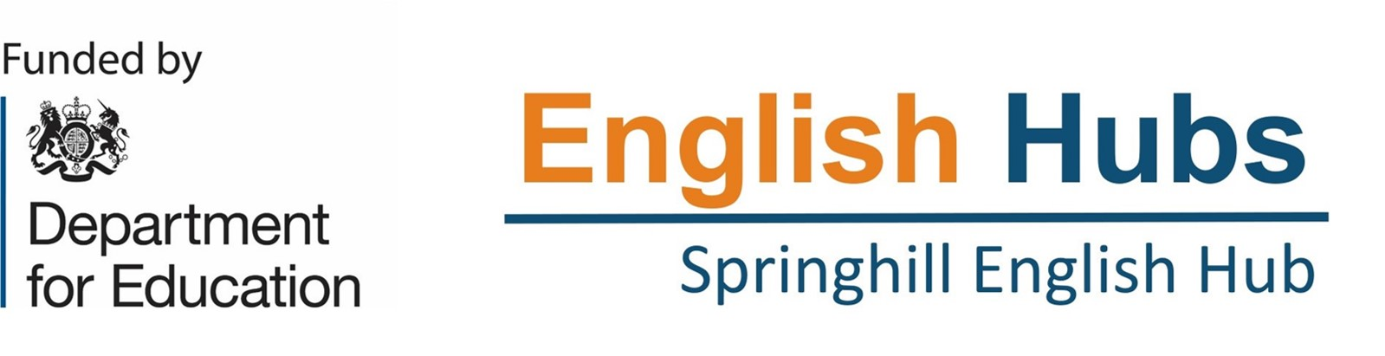

Become an English Hub Literacy Specialists for Springhill English Hub starting January 2026

Springhill English Hub is seeking to recruit an outstanding primary teacher to work as a Literacy Specialist. Literacy Specialists are experienced primary school teachers, who have an excellent knowledge of early reading and phonics.

Role Duties
- To support our Partner School leaders to implement the ‘challenge checklist’ across a specified number of days
- To coach leaders and teachers within their SSP
- To track schools progress in early reading and to support Partner Schools to submit half termly data
- To produce a report after each visit highlighting the progress a Partner School has made and action points for the next half term
- To complete Reading Audits under the guidance of the Hub Lead
- To support the delivery of medium level training to the wider Springhill English Hub network

Employement type: casual arrangement (through payroll).
Salary: £196 - £238 (gross) per day
Closing date for applications: January 4th
Interview date: Week beginning 5th January 2025
Start date: As soon as possible subject to satisfactory completion of DBS and other pre-employment checks

