
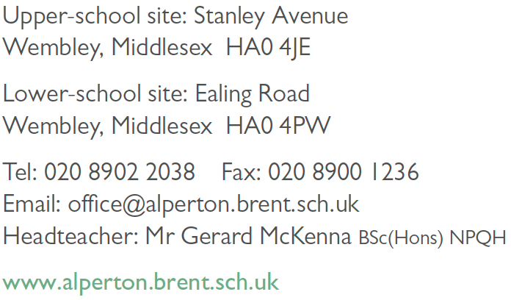

Aspire | Commit | Succeed

CONFIDENTIAL MONITORING DETAILS

Personal Details

All stages of the recruitment process are monitored to check that unfair discrimination is not taking place.
As part of this process your personal information is treated as confidential and is not disclosed to the appointment panel or the line manager for this post.
Please complete the following by ticking the relevant boxes.

Gender Male  Female 

I would describe my race or ethnic origin as:

 White British  White Irish  White other
e.g. Polish – specify

 Mixed White and
Black Caribbean
 Mixed Other – specify
 Mixed White and
Black African
 Mixed White and Asian

 Asian Indian  Asian Pakistani  Asian Bangladeshi

 Asian British  Asian other - specify

 Black Caribbean  Black African  Black British
 Black other - specify
 Chinese
 Chinese British  Chinese other - specify

 Any other group
e.g. Arab – specify

How did you hear of this job? Please state the publication in which you saw it advertised.

Do you have a long standing physical or mental condition or disability? (by long
standing we mean anything that has lasted at least 12 months or that is likely to last at least 12 months).

If yes please state the type of impairment which applies to you, if more than one type of impairment applies, please indicate. If none of the categories applies then please mark other.

Physical impairment, such as using a wheelchair to get around and/or difficulty using your arms.

Sensory impairment, such as being blind / having a serious visual impairment or being deaf / having a serious hearing impairment.

Mental Health condition, such as depression or schizophrenia.

Learning Disability, such as Down’s Syndrome or dyslexia or a cognitive impairment
such as autism or a head injury.

Long standing illness or health condition, such as cancer, HIV, diabetes, chronic heart disease or epilepsy.

Yes  No 

Yes  No 

Yes  No 

Yes  No 

Yes  No 

Yes  No 

 Other, such as disfigurement (please specify)

Please tell us what are the biggest barriers to enable you attend a job interview with us.

▪ Physical access to buildings, streets and transport vehicles
▪ Access to written word or images
▪ Access to speech or sounds
▪ People’s attitudes to you because of your impairments, medical condition or
disability.
▪ Stressful situations
Yes  No 
Yes  No  Yes  No  Yes  No 

Yes  No 

 Other barriers (please specify)

Name
Date of birth
Post applied for

