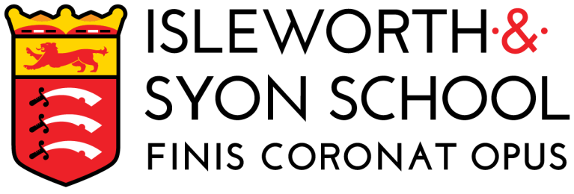 | ADVERT

JOB TITLE | English Teacher
Closing Date: | 09:00 – Monday 20 February
Date posted: | 2 February 2023 | Salary: | MPS/UPS (Outer London)
Start date: | 1 September 2023 | Contract term: | Permanent
Contract type: | Full Time | Suitable for ECTs: | Yes

“The school succeeds in dispelling the myths and stereotypes that are sometimes associated with boys’ schools.”
[Challenge Partners Report]

Our School
Isleworth & Syon School is a great place to work and a place where teachers can develop. Our staff are energetic, dedicated and absolutely committed to working together in order to ensure that our boys (and students in our mixed Sixth Form) remain ambitious and highly successful.
We have a history of excellence, are a high-performing school and are part of the ‘Leading Edge’ network. Our progress measures at GCSE level are significantly above that for boys nationally and at all levels progress and attainment scores are well above national scores.

Our Ethos
Relationships are critical to our success and to our future. We empower our staff and encourage everyone to work collegially in departments to create shared resources so that planning time can be spent refining rather than re-inventing lessons. Good practice is shared and all staff contribute ideas to further enhance the curriculum. Our school is systematically organised and pastoral processes are tightly managed to allow staff to build professional relationships with students in order to create excellent learning environments.

Across the school, students benefit from our insistence on high standards and achievement, an exceptional range of extra-curricular activities, and a focus on traditional values. We are looking for a colleague that aspires to be part of a great team of staff and who will enjoy contributing to the successes of all our students.

Our English Department
Boys at Isleworth & Syon School buck the national gender trends for success in English. Our progress measures at GCSE (compared to boys and girls) are exceptional for both English language and English literature and outstrip national data sets. Many students continue their studies at Advanced level in our mixed Sixth Form. Our recent independent review by ‘Challenge Partners’ classified the English department as a national “area of excellence” with a specific expertise in teaching boys.

We offer a supportive and invigorating environment which is brilliantly led and in which the current staff are passionate about delivering a creative and engaging curriculum offer. You will be working with an excellent team of practitioners with a passion for ensuring that our students achieve and attain their very best. In 2018, the department benefited from a new £6.5 million build which houses a suite of nine specialist English classrooms.

Our Staff
We recognise that our staff are our greatest resource. Therefore, we are ambitious for our staff and invest heavily in their development. We offer an extensive programme of professional development with a range of opportunities for training, including internally and through local and national programmes. We have strong partnerships with universities and higher education institutions and actively support staff pursuing heavily subsidised Masters degrees and other higher qualifications. There will also be opportunities for internal promotion and to chances to collaborate within our local partnership of schools.

Our Location
We are situated in a tree-lined neighbourhood of Isleworth, a vibrant area of West London. The school is close to Osterley Park and a short hop from central London by tube (Osterley is a 10-minute walk) or rail (Isleworth is a 7-minute walk). There is easy access to the M3, M4 and Heathrow Airport.

Visit Us
We welcome enquiries from everyone and value diversity in our workforce. We want to make sure we are attracting the widest possible range of people and ensure that they are accepted, understood and treated equally when they work here. This means we will work hard to understand that each employee is unique and ensuring that individuals or groups are not treated differently or less favourably on the basis of specific characteristics. Such characteristics include (but are not limited to) age, disability, gender including transgender, race, religion, sexual orientation, marital status, and how the school supports pregnant women and new parents.

You are very welcome to arrange to visit us and to experience why we are such a successful school and a fantastic place to develop your career.

Amongst other benefits, we offer:
- Working with dynamic, innovative and supportive colleagues, and in a school where student behaviour is described as “outstanding”.
- Induction into the school, a continuing professional development schemes and carefully considered succession planning.
- Superb ICT facilities and the free use of a laptop.
- Investment in staff physical and mental health through a subscription to APL Health.
- The opportunity to work with colleagues from a range of external partnerships.
- A chef-led canteen service.
- Access to schemes such as: childcare vouchers; cycle to work and free flu jabs.

Click here for a full list of Our Benefits.

“Staff are proud of the work they do. Building on the long-standing traditions of the school, staff support the development of ‘courteous, respectful and calm’ young men, reflecting the school’s well-established values.”
[Ofsted Report]

Application details
Further recruitment details, including a School Information Pack and a role information document (with curriculum and facilities details) and an application form are on our website www.isleworthsyon.org under ‘Staff Recruitment’.
Alternatively visit the Teaching Vacancies site at GOV.UK or click on TES ‘Quick Apply’.
Please ensure that all sections of the form are completed. Early application is encouraged, as suitable candidates will be interviewed promptly on receipt of completed forms. If we fill the post, we will bring forward the closing date.
Isleworth & Syon School is committed to safeguarding and promoting the welfare of children and young people and expect all staff and volunteers to share this commitment. The successful applicant will be subject to an Enhanced DBS check, references and other pre and post-employment checks, including, where appropriate police checks from other countries.
Our Data Protection Policy and our Privacy Notice for applicants, can also be found on the website.

More about Isleworth & Syon School
Type: Mainstream School Address: Ridgeway Road, Isleworth, Middlesex, TW7 5LJ
Phase: Secondary with Sixth Form Telephone: +44 20 8568 5791
Funding status: State – Academy http://www.isleworthsyon.org
Gender: Boys and mixed Sixth Form email: school@islewothsyon.org
Age range: 11-19 years

Placement : DfE Teaching Vacancies ; TES online

Banner for web site :
We have an exciting opportunity for an English teacher to join our highly successful school and to work in an outstanding team.

