
Designated Provision – English Teacher

Information for Applicants









April 2026

Dear applicant,

Thank you for your interest in joining our Designated Provisions. We are delighted that you are considering becoming part of what is an exciting and deeply purposeful journey.

These provisions have been created in response to a clear and growing need: to offer children and young people with autism and/or social, emotional and mental health needs a setting where they feel safe, understood and genuinely believed in. Our vision is simple but ambitious — to create a calm, relational and aspirational environment in which every pupil is supported to re-engage with learning, develop confidence, and build the skills they need for a successful future.

At the heart of our work is the belief that behaviour is communication, relationships are fundamental, and consistency changes lives. We are committed to trauma-informed practice, high expectations with high support, and a curriculum that is flexible, relevant and rooted in the needs of each individual learner. These are provisions where adults matter — where your presence, patience and professionalism will have a direct and lasting impact.

As a member of our team, you will be part of a small, highly skilled and reflective staff group who work collaboratively, support one another and share a relentless commitment to doing what is right for our pupils. We value curiosity, compassion and courage: the courage to try new approaches, to remain hopeful when progress is slow, and to see potential where others may have given up.

This is not always easy work, but it is profoundly rewarding. You will be supported through high-quality professional development, strong leadership and a culture that prioritises staff wellbeing alongside pupil success. We are building something special — provisions shaped by shared values, trust and a belief that every young person deserves another chance to thrive.

If you share our vision and are motivated by the opportunity to make a genuine difference, we would be delighted to receive your application.

Our website and this application summary can only give you a flavour of who we are, but I hope that it will inspire you to apply for the Designated Provision Teacher vacancy. If you have any questions or need any further information about this fantastic opportunity, please do not hesitate to contact Tina Wiegand via email at twiegand@birchwoodhigh.org

Vacancy details:

Salary Scale
Teachers Pay Scale plus SEND allowance (To be negotiated depending on experience)

Start Date:
September 2026

Contract
Permanent.

Method of Application
Applications to be made through the SAM People Recruit Portal. Applications will be shortlisted for interview and the HR Manager will contact those selected regarding the time and venue. Applicants who have not been contacted within two weeks of the closing date can assume that on this occasion their application was unsuccessful.

Closing Date
Applications received after the closing time of 9am Wednesday 6th May 2026 will not be considered.

Interview Dates
Week commencing 11th May 2026.

Safeguarding

All staff who teach, train or work regularly with children aged up to 18 and vulnerable adults are required to comply fully with legislation and One Community Trust and Birchwood Community High School policies and practices to ensure learners are safeguarded and protected. The school is committed to safeguarding and promoting the welfare of children. (Rehabilitation of Offenders Act 1974).

Please feel welcome to come and have a visit before applying, but be assured that whether you visit or not, it will not affect the short-listing process. If you would like to have a look round, please email our HR Manager, Tina Wiegand (twiegand@birchwoodhigh.org) to arrange.

Thank you for considering our truly amazing school as the next chapter in your career, and hopefully I will be reading your application soon.

Yours sincerely,



Emma Mills
Headteacher




‘There is a ‘buzz’ of energy in classes, reflecting student’s positive attitudes to their learning.’

Our Vision

Our provisions provide a safe, relational environment where behaviour is understood, emotional needs are met, and every young person is supported to re-engage, grow and succeed.

Our Ethos

Our ethos is rooted in care, consistency and high expectations. We believe that behaviour is communication and that positive change happens through strong, trusting relationships.
We are committed to trauma-informed practice, emotional safety and personalised support, ensuring every young person feels valued, understood and able to succeed. We create calm, structured environments where pupils are supported to regulate, reflect and re-engage with learning.

We work in close partnership with families, schools and professionals, holding a shared responsibility for each child’s wellbeing, progress and future. Above all, we are relentless in our belief that every young person can grow, achieve and thrive when given the right support at the right time.
their school life.

Our Mission

Our mission is to provide a safe, structured and nurturing environment where children and young people with autism and/or social, emotional and mental health needs are supported to understand their emotions, develop positive behaviours and engage with learning.

Through trauma-informed practice, consistent relationships and personalised provision, we work to remove barriers, build resilience and enable every pupil to make progress — academically, socially and emotionally — so they are prepared for their next steps in education and life.

Our Aims

We wish for our students to be:
- Emotional Wellbeing – To feel safe, supported, and understood, and to develop strategies to manage emotions effectively.
- Positive Relationships – To build trust with staff and peers, fostering respectful, collaborative, and supportive interactions.
- Behaviour for Learning – To understand and regulate behaviour, developing self-control, resilience, and confidence in decision-making.
- Academic Engagement – To re-engage with learning, experience success in the curriculum, and make measurable progress.
- Personal Development – To develop life skills, self-esteem, and a sense of responsibility for themselves and their community.
- Preparation for the Future – To equip students with the skills, knowledge, and resilience needed for reintegration into mainstream education or transition to further education, training, or employment.

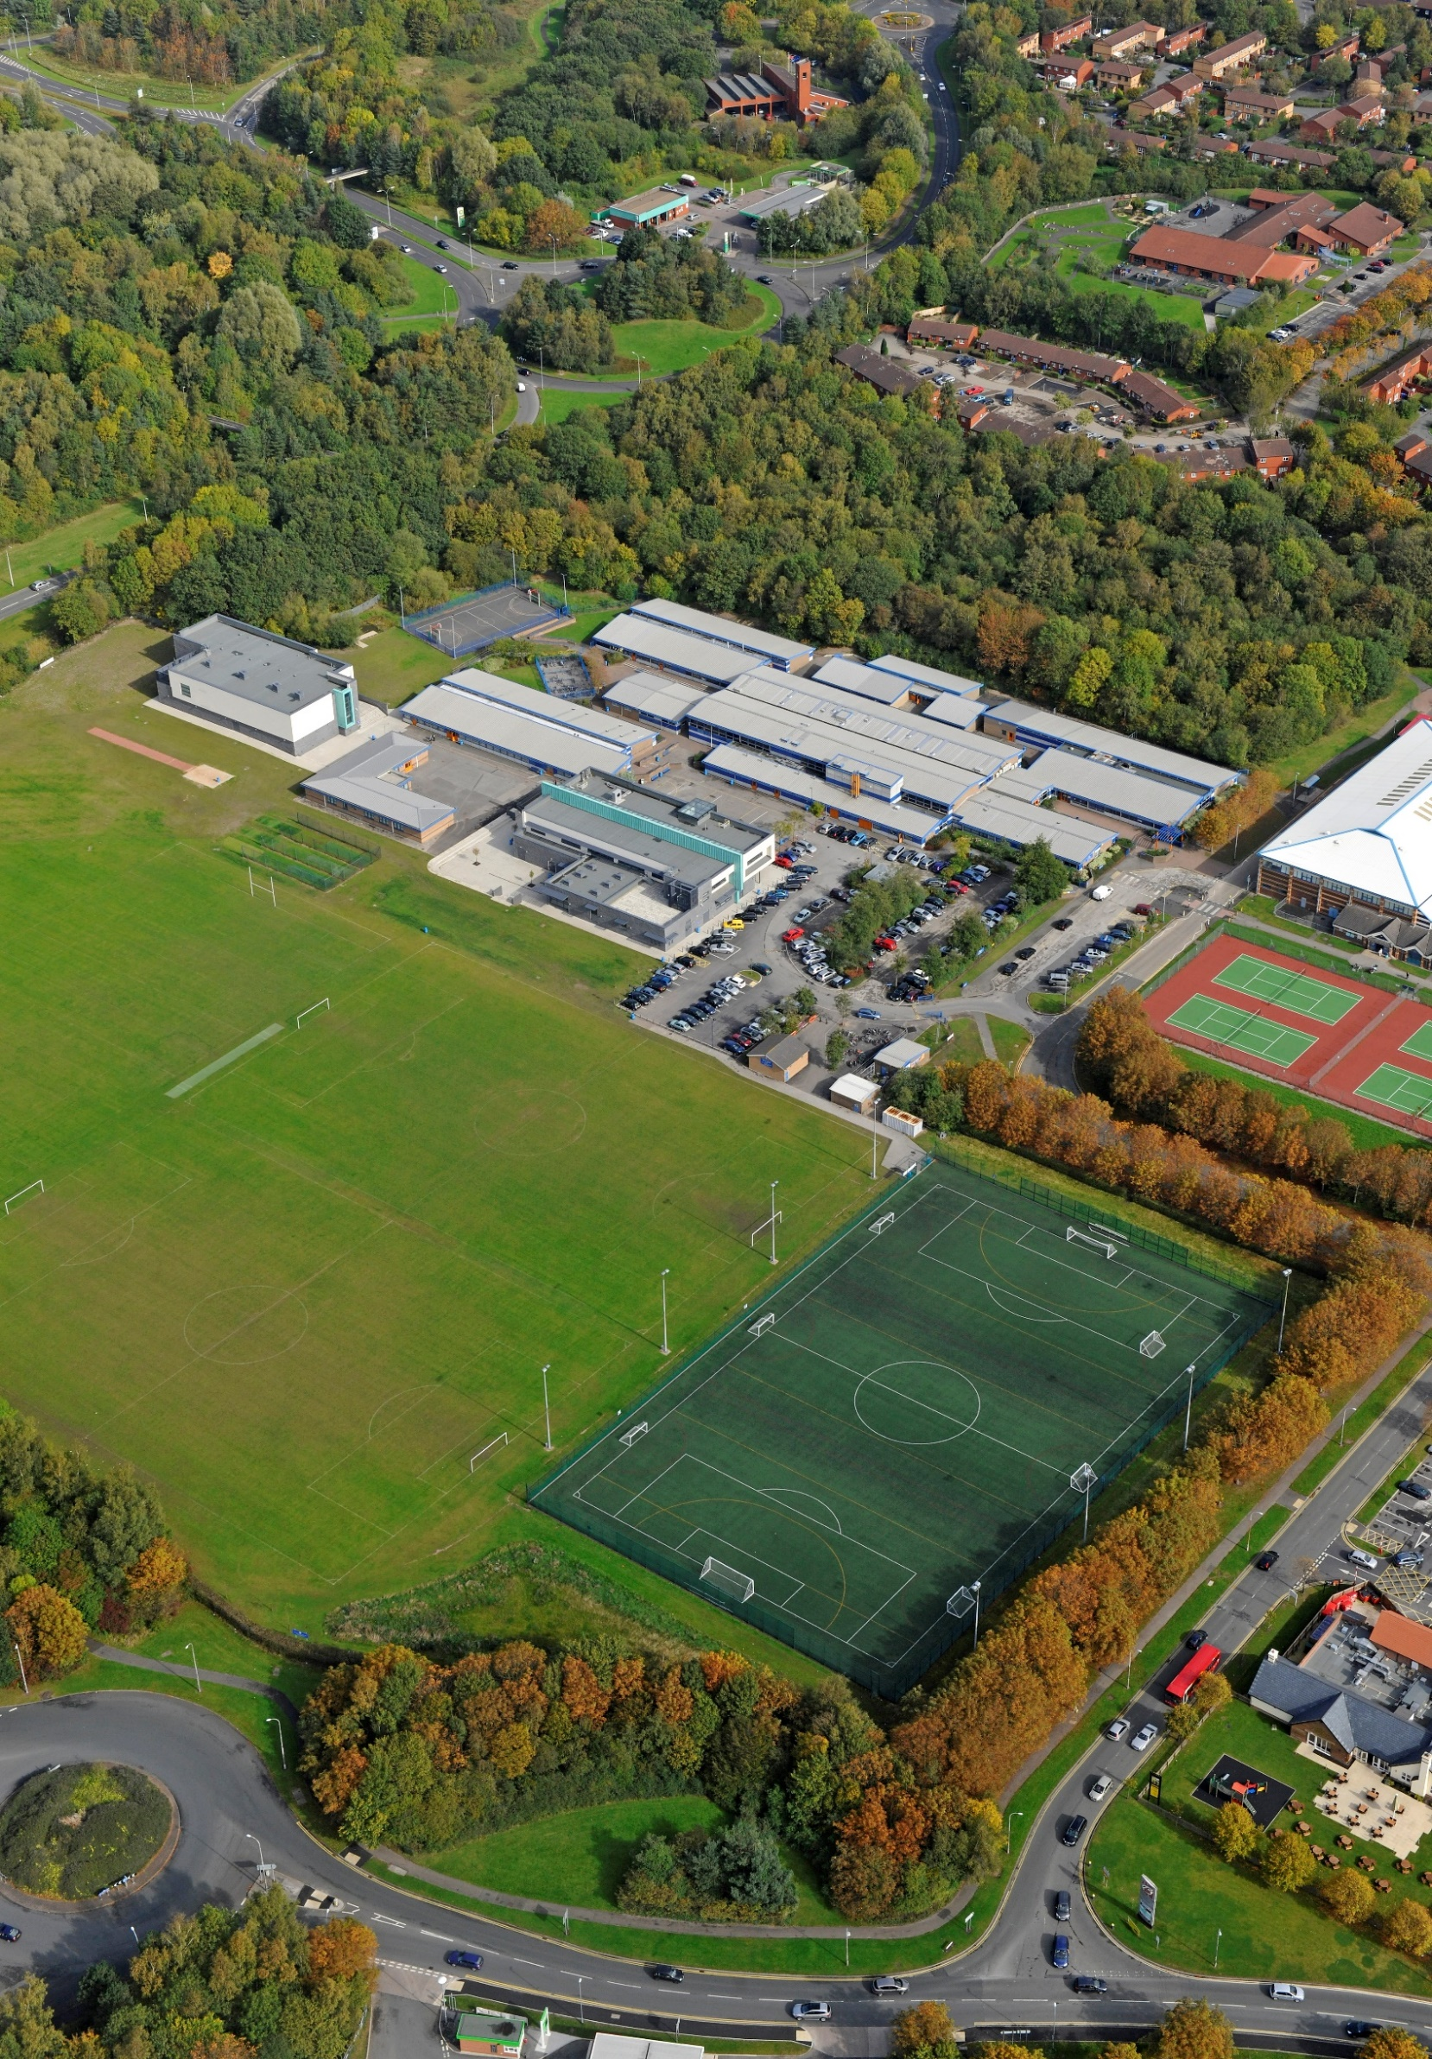

School Profile

JOB DESCRIPTION
- We joined One Community Multi Academy Trust on 1 September 2023
- The school is of an average size with 900 currently on roll.
- The most recent OFSTED inspection (December 2024) judged the school to be Good in all areas.
- The percentage of students on the Student Premium register is 40%, which is above the national average.
- The proportion of students with SEND (ECHP) is in-line with the national average.
- Most students are of white British heritage.
- Students arrive at the school with outcomes broadly in line with national averages.
Job title | Designated Provision – KS4 English Teacher
Reporting to | Provision lead/ Deputy Headteacher
Job Purpose | The information contained below is to help staff understand and appreciate the nature of their post and the role they are to play in the organisation. However, it should be noted that, whilst every effort has been made to outline all the duties and responsibilities, a document such as this does not permit every item to be specified in detail. Broad headings may therefore have been used, in which case all the usual associated duties are included in this job description.  - To implement and deliver an appropriately tailored English curriculum, adapting approaches to meet individual needs for Key Stage 4 students.  - To teach across some other curriculum areas such as ASDAN to support the needs of students in the provisions  - To monitor and support the overall progress and development of students in the provisions  - To facilitate and encourage a learning experience which provides students with the opportunity to achieve their individual potential  - To contribute to raising standards of student progress and outcomes
Key Tasks and Accountabilities | Duties & Responsibilities  - To assist in the development of appropriate syllabuses, resources, schemes of work, marking policies and teaching strategies in the subject area  - Use effective behaviour management strategies consistently in line with the school’s policy and procedures  - To attend all CPD and relevant meetings  - To contribute to and support implementation of transition packages  - To plan and prepare courses and lessons to contribute to the DP’s planning activities  Staff Development: Recruitment/Deployment of Staff  - To take part in the school’s staff development programme by participating in arrangements for further training and professional development  - To continue personal development in relevant areas, including specialist knowledge and teaching methods  - To work as a member of a designated team and to contribute positively to effective working relations within the provisions.  Quality Assurance  - To help implement school quality procedures and to adhere to these  - To contribute to the process of monitoring and evaluation of the subject area in line with agreed School procedures, including evaluation against quality standards and performance criteria  - To seek/implement modification and improvement where required  - To regularly review methods of teaching and programmes of work  - To take part, as may be required, in the review, development and management of activities relating to the curriculum, organisation and pastoral functions of the School  Pastoral System:  - Promote pupils’ independence, self-esteem and social inclusion  - To promote the general progress and well-being of individual students.  - To liaise with the Provisions Lead to ensure the implementation of the Engagement Support System  - To register students, encourage their full attendance at all lessons and their participation in other aspects of school life when required  - To evaluate and monitor the progress of students and keep up-to-date student records as may be required  - To contribute to the preparation of Action Plans and progress files and other reports  - To alert the appropriate staff (Safeguarding Lead) to problems experienced by students where there is safeguarding concern in accordance with the School’s Safeguarding policy and training  - To contribute to and support effective implementation of Transition Programmes  - To communicate as appropriate, with the parents of students and with persons or bodies outside the school concerned with the welfare of individual students, after consultation with the appropriate staff  - To consistently apply the Behaviour Management systems so that effective learning can take place  Teaching  - To teach students according to their educational needs, including the setting and marking of work to be carried out by the student in School and elsewhere  - To assess, record and report on the attendance, progress, development and attainment of students and to keep such records as are required  - To provide or contribute to, oral and written assessments, reports and references relating to individual students and groups of students  - To ensure that ICT, Literacy, Numeracy and subject specialism(s) are reflected in the teaching/learning experience of students  - To ensure a high-quality learning experience for students which meets internal and external quality standards  - To prepare and update subject materials, using a variety of delivery methods which will stimulate learning appropriate to student needs and demands of the curriculum.  - To maintain discipline in accordance with the School’s procedures and to encourage good practice with regard to punctuality, behaviour and standards of work  - To mark, grade and give written/verbal and diagnostic feedback as required by the provision policy  OTHER PROFESSIONAL REQUIREMENTS  - Have a working knowledge of current legislation and relevant national documents  - Have established, during work in schools, effective working relationships with professional colleagues  - Set a good example to the students they teach, through their presentation and their personal and professional conduct  - To undertake any other duty as specified by School Teachers’ Pay and Conditions Body (STPCB) or as requested by the Headteacher if not mentioned in the above  - To play a full part in the life of the school community, to support its distinctive aim and ethos and to encourage staff and students to follow this example  - Are committed to ensuring that every student is given the opportunity to achieve their potential and meet the high expectations set for them.  - Understand the need to take responsibility for their own professional development and to keep up to date with research and developments in pedagogy  - Understand their professional responsibilities in relation to school policies and practices, including those concerned with pastoral and personal safety matters, including bullying  - Are aware of the role and purpose of school governing bodies  The postholder is responsible for the safeguarding and promoting the welfare of children and/or vulnerable adults. The Child Protection Policy outlines the teacher’s responsibility with regards to safeguarding.
The post holder may reasonably be expected to undertake other duties commensurate with the level of responsibility that may be allocated from time to time.

All employees have the responsibility to:
- Ensure any documentation produced is to a high standard
- Be aware and comply with policies, protocols and procedures relating to safeguarding, child protection, health, safety and security, confidentiality and data protection, reporting all concerns to the appropriate person
- Participate in training and other learning activities as required
- Provide appropriate guidance and supervision and assist in the training and development of staff as appropriate
- To promote the area of responsibility within the academy and beyond
- To represent the academy at events as appropriate
- To support and promote the Trust’s ethos
- To undertake any other duties and responsibilities as required that are covered by the general scope of the post.

REVIEW ARRANGEMENTS
The details contained in this job description reflect the content of the job at the date it was prepared. However, it is inevitable that over time, the nature of the jobs may change. Existing duties may no longer be required, and other duties may be gained without changing the general nature of the post or the level of responsibility entailed. Consequently, the Headteacher will expect to revise this job description from time to time and will consult with the post holder at the appropriate time.

Person specification

JOB TITLE | GRADE
Key Stage 4 Designated Provision Teacher (English) | Teachers Pay Scale plus SEND Allowance

NOTE TO APPLICANTS: Whilst all points on the specification are important, those marked ‘E’ are the key requirements. You should pay particular attention to these points and provide evidence of meeting them. Failure to do so may mean that you will not be invited to interview.

 |  | Essential | Desirable
Qualifications or Training: | - Qualified Teacher Status  - Degree in relevant subject  - Evidence of recent continual professional development  - Additional qualification/or training in special education needs (Autism/SEMH)  - Team Teach training or a willingness to undertake this training. | E  E  E  E | D
Experience: | - An excellent classroom practitioner  - Experience in teaching students with special needs including autism and SEMH  - Experience of working in small teams, able to involve teaching assistants in the teaching and learning process  - Experience of working with a wide range of partners  - Experience of working successfully in a team  - Evidence of commitment to own professional development | E  E  E  E | D  D
Knowledge and Practical Skills: | - Ability to adapt and respond to the varying needs and challenges children with autism and SEMH can sometimes display.  - Knowledge of the National Curriculum in KS3 and KS4  - The ability to plan and deliver stimulating teaching experiences in a range of settings  - Knowledge of approaches and interventions to use when teaching children with SEND (e.g. TEACH methods)  - Understanding of positive behaviour management techniques/strategies  - Ability to implement EHCPs  - An excellent understanding of inclusion, making the curriculum accessible to all learners  - Ability to form and maintain appropriate relationships and ensure personal boundaries with children are maintained.  - Demonstrate effective skills in working with vulnerable children  - Responsible attitude to use of authority and maintaining discipline  - The ability to plan for, assess, report and record student progress  - Confident in the use of technology in the classroom  - A commitment to high academic standards  - Knowledge of strategies used with children with social communication difficulties  - An interest in helping school develop extra- curricular provision | E  E  E  E  E  E  E  E  E  E  E  E  E  E | D  D
Personal Qualities & Attributes: | - Enthusiasm, flexibility and willingness to respond to new challenges  - To build and maintain effective relationships with children and adults  - Excellent communication skills  - Effective organisational skills  - The ability to work under pressure and prioritise effectively  - A positive attitude and willingness to contribute to whole school development  - A commitment to involving parents in the life of the school  - A desire for high expectations and standards for self and others  - The ability to work in partnership with the whole community  - Good health and attendance record  - Sense of humour and a positive outlook | E  E  E  E  E  E  E  E  E  E  E
Other | - Enhanced DBS Disclosure is required  - An ability to safeguard and promote the welfare of children  - Excellent presentation  - Fully committed to expectations that all students, including students with SEND, can achieve  - Fully committed to whole school development and inclusion. | E  E  E  E  E







