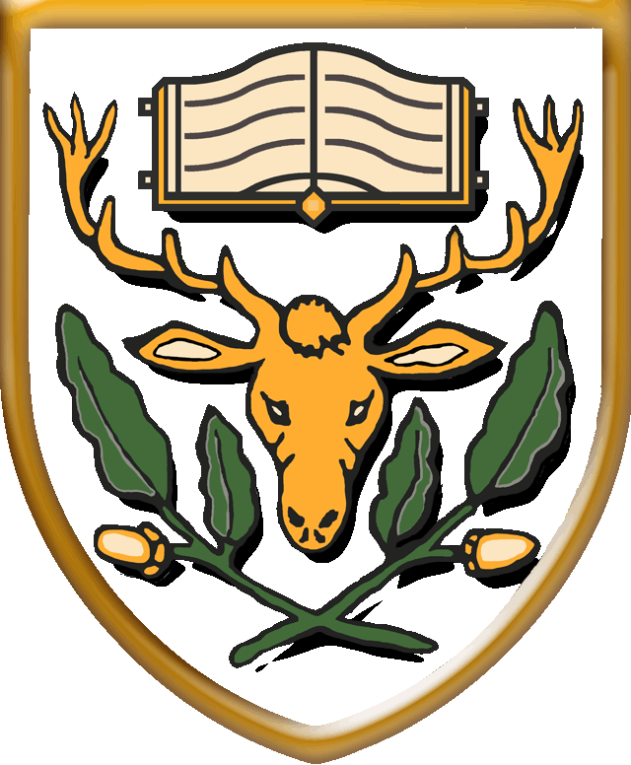

HIGHAMS PARK SCHOOL

Handsworth Avenue, Highams Park, E4 9PJ

TEACHER OF ENGLISH

1 Year Fixed Term

From September 2021

Salary: Outer London MPS £29,915 - £45,766

Highams Park School is looking to appoint a high-quality English Teacher to work alongside a dynamic and enthusiastic team of staff.

You will work within the English, Film and Media Department and ensure that student progress is maximised through innovative, challenging and engaging teaching. You will have excellent subject knowledge and be passionate about making a difference to the lives of young people.

The successful candidate will be required to teach English at Key Stages 3 – 5. A willingness to teach Media Studies at Key Stage 4 and/or 5 would be an advantage.

The English, Film and Media Department is well-resourced and highly experienced. This post represents an excellent opportunity to work with a dedicated team of colleagues in taking on the challenge of making the department truly outstanding. This role would be suitable for an NQT.

Highams Park is a very successful co-educational 11-18 Academy converter with 1600 students on roll including nearly 400 in the 6th Form. We pride ourselves on being a comprehensive school that serves the local area and in which there is a strong culture of traditional values coupled with an emphasis on high quality, forward-thinking teaching and learning.

Please email the school on scroft@highamsparkschool.co.uk Mrs Sharon Croft, HR Manager, or go to our website www.highamsparkschool.co.uk to find out more. Please complete our application form (download from website) and return by midday on Tuesday 15 June 2021. Interviews are planned to take place during that week.

Safeguarding children
We are committed to the safety of our pupils through our recruitment and school practices; all jobs are subject to an Enhanced Disclosure and Barring Service check.
The Disclosure and Barring Service (DBS) helps employers make safer recruitment decisions and prevent unsuitable people from working with vulnerable groups, including children.

