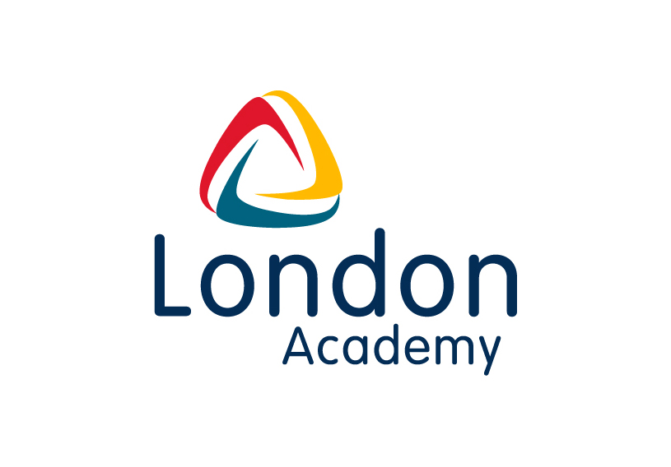

English Teacher (MPS/UPS)

For September 2021

Information about London Academy

London Academy is an ambitious all-through Academy in North London, serving a multicultural and disadvantaged community. In 2018/2019 we were in the top 1% of schools in the country in terms of progress achieving a progress 8 score of 1 overall and 1.35 specifically in English.

The Opportunity

We wish to appoint a high-quality graduate who has the necessary skills and attributes to enthuse our highly ambitious students to join our school as a teacher of English and inspire our students to become Leaders for Tomorrow. The ability to teach to A level will be an advantage. English is a highly successful department at KS3, KS4 and 5. Our progress 8 score for English in 2018/2019 placed us in the top 1% of schools nationally for progress made. This post would suit an NQT or a more experienced colleague looking to broaden their experience in an all through 4-19 Academy.

Our mission is to develop the leadership potential in both our staff and students and we want to be at the forefront of developing the next generation of school leaders. We can help prepare you for a future leadership position, investing in your development through regular coaching and a wide range of professional development opportunities, such as the NPQML.

Why work at London Academy?

- The opportunity to work with experienced and value driven colleagues that have a proven track record of raising attainment for a disadvantaged community
- A wide range of professional development opportunities, for example we were one of the first partner schools working with The Institute for Teaching on the Masters in Expert Teaching
- Experience of working with Ambition School Leadership and supporting colleagues completing Teaching Leaders and Future Leaders
- A commitment to engage with the latest educational research so it that informs all aspects of the Academy, for example curriculum design and pedagogy
- A focus on reducing workload by having centralised behaviour systems, centralised curriculum and a reasonable feedback policy.

Next Steps

To apply, please send your CV and a completed application form to office@londonacademy.org.uk. If you would like to discuss the post in confidence please email office@londonacademy.org.uk to arrange a time to have an informal conversation with a senior member of staff.
London Academy is an equal opportunities employer. London Academy is committed to safeguarding and promoting the welfare of children and young people and expects all staff and volunteers to share this commitment.

Enhanced DBS, Barred List and Prohibition checks will always be carried out on new employees.

The closing date for applications is 9am on Monday 12 April 2021. Applications will be viewed on a rolling basis so early applications are recommended.

Alex Warburton
Principal

