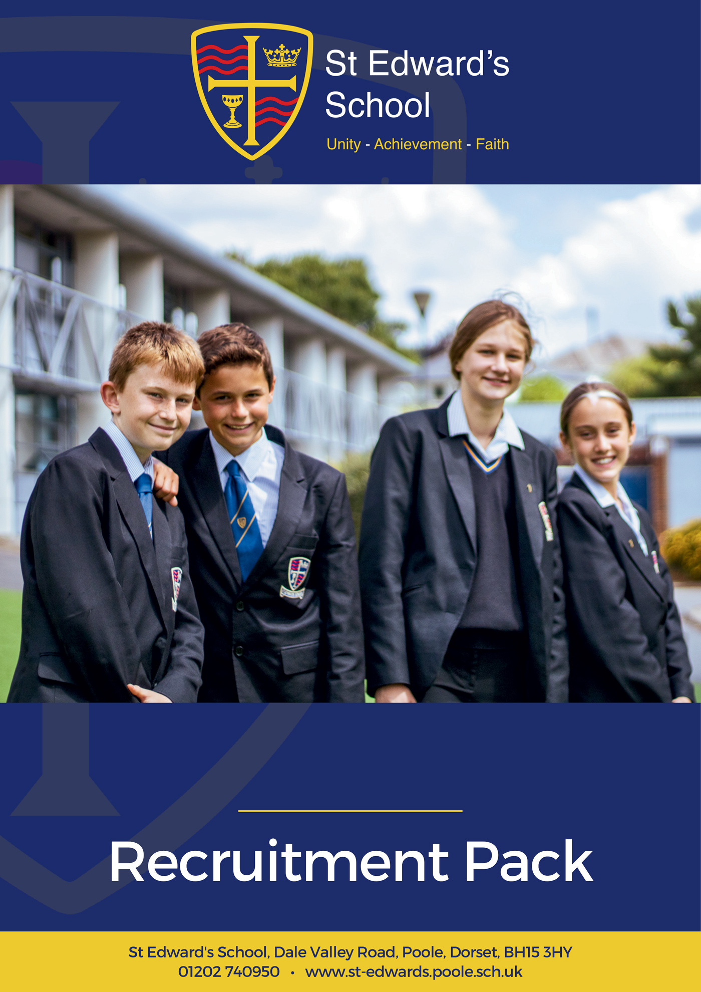

English Teacher

ENGLISH TEACHER
Temporary, Part time. 0.70 FTE or 0.80 FTE Maternity Cover
From November 2024 or sooner

MPR / UPR

St Edward’s School is a high-performing school with an exceptional English department. Our school is heavily oversubscribed and enjoys an excellent reputation for combining high expectations of all, with warm relational approaches to learning.

We are looking for an inspirational English Teacher to join our strong and supportive team. As a professional you will become part of a caring organisation deeply focused on securing outstanding futures for young people, whilst looking after the wellbeing and professional fulfilment of our staff.

This is an exciting opportunity to bring your own experience and potential to help us take the subject, and our school to new heights. The ability to teach English to the highest level from KS3 to KS5 is desirable.

What are we looking for in you? Applicants will have experience of teaching in the subject, and the potential to become an outstanding practitioner. You will share our vision for holistic education that protects the creativity and professionalism of teachers. You will also have a sincere commitment to our ethos and vision as a school, and our drive for continuous improvement.

As a school we know that happy and successful staff create a brilliant learning environment for our fantastic students. We offer great facilities, tailored CPD and a highly motivated staff community. This year our school was a finalist for the Staff Wellbeing School of the Year in the prestigious TES School Awards 2024 celebrating the culture and ethos around staff wellbeing.
If you would like to visit us, or have a conversation before making an application, please contact us to arrange a visit or call. We would love to hear from you!

Please visit our website at https://st-edwards.poole.sch.uk/ for further information about our unique school.

St Edward’s School is committed to safeguarding & promoting the welfare of children & young people. All appointments made are subject to an enhanced DBS check. Online searches may be carried out as part of due diligence checks.

Applicants must have UK Qualified Teacher Status or be on track to attain QTS.

Closing Date: Wednesday 10 July 2024
Interviews: TBC

Our Mission Statement
MAY WE BE ONE
In Purpose
Educating for life in all its fullness
In Faith
Encountering God who lives among us, calling us to unity
In Dignity
Nurturing confidence and maturity
About Us
St Edward’s School opened in 1963 as Roman Catholic School serving the parishes of Poole. It took its name from the local Saint, martyred at Corfe Castle. Although little is known of Edward, as a teenage king with a strong Christian faith and a commitment to protecting the poor he provides an excellent role model for our young people. His story is told through our school badge with the crown of a king, the cross of Christ, a cup to symbolise his murder by poisoning and the blood of a martyr. The crown and cup also remind us of the Kingdom of God, and the “one cup in which we all share”. (1Cov 10:16)
For many years, the school welcomed not only Roman Catholic families, but other Christians who were keen for their children to be educated in a faith context. In the early 1990’s the school’s second headteacher, Alan Murphy decided to formalise this arrangement and entered into talks with the Roman Catholic Church and the Church of England about St Edward’s becoming a joint church school. A new covenant, setting out the values and principles behind the commitment was signed by the Bishops of Plymouth and Salisbury in 1993.
From then on, the school has continued to grow in success and popularity. The vision of the school is to provide an excellent education, in a comprehensive and co-educational context that develops the character of young people through the St Edward’s Virtues, while safeguarding their experience of childhood.

Letter from the Executive Headteacher
At St Edward’s School we are committed to preparing young people to live life to the full. We believe that preparation for life is best faciliated in the midst of a caring and supportive community that attends to spiritual and moral formation, as well as academic excellence.
Our school is a very successful, heavily oversubscribed, and distinctive joint Roman Catholic – Church of England Voluntary Aided School supported by the Roman Catholic Diocese of Plymouth and the Church of England Diocese of Salisbury. We are a truly comprehensive school, which educates over 1000 students from the age of 11 to 18, and welcome people of all faiths and none.
Our staff are the key to our success, and we recognise the part that every colleague plays regardless of their role. Our teachers are encouraged to be creative, and to grow professionally in ways that interest and excite them. Only by being passionate about their subject and about learning can teachers ignite curiosity and inspire a similar passion in the young. Our horizon for our students is a life well-lived, and our ambitions for each child extend beyond examinations and university. Our ambition for you is to work with you so that your career is rewarding and satisfying. We want you to be happy in your work, and we invest heavily in the professional development of all of our colleagues, so that they continue to derive professional growth and satisfaction.
We believe that children deserve to be equipped for life with the best education, together with values that enable them to navigate future choices and opportunities. We are committed to providing both.
I believe that St Edward’s is a very special place to be, as confirmed by Ofsted, who in their most recent inspection in 2022 celebrated our positive learning community, with respectful, kind and polite students. Our curriculum was highlighted as being ambitious and challenging, strongly preparing students for future success. Our most recent Church School Inspection in 2023 rated us “outstanding” in all areas.
I am proud of our wonderful students, our dedicated staff and our supportive governors, parents and carers. I hope that your experience of us will lead you to believe that St Edward’s is the right home for you. Thank you for taking the time to get to know us a little better. We will always be glad of the opportunity to speak with you or to meet you if you’d like to find out more. Whatever you decide about your next career steps, we wish you the very best.

Mr Michael Antram
Executive Headteacher
Working at St Edward’s
St Edward’s is a popular place to work with low staff turnover and high levels of staff wellbeing and satisfaction. Our mission statement of ‘may we be one’ goes to the heart of what we do and how we do it and staff feel positive about the school and their role within it.
We have invested in the Employee Assistance Programme, which gives all staff access to confidential advice and support. The 24-hour support covers a wide range of areas, both work related and more general, including counselling, specialist information and financial and legal matters.
“EAP will always be there to support teachers and education staff no matter what you’re going through, big or small, we’re here for you. Day or night you can call to speak to someone without judgement who can help you find solutions to move past a difficult situation in your life.”
I am normally able to manage my wellbeing | If work gets difficult, I know how to get support | I enjoy my work
92% | 97% | 99%
Staff Wellbeing Survey – Autumn 2023

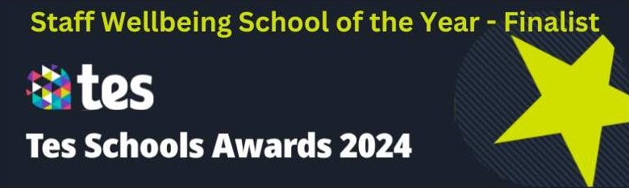
Staff Testimonials
“As a new member of the support staff I immediately felt welcomed by the team and the wider staff. Everyone has been very friendly and approachable allowing me to quickly feel settled and supported in my role.”  Lucy Lumber, Library Administrator  1 year at St Edward’s | 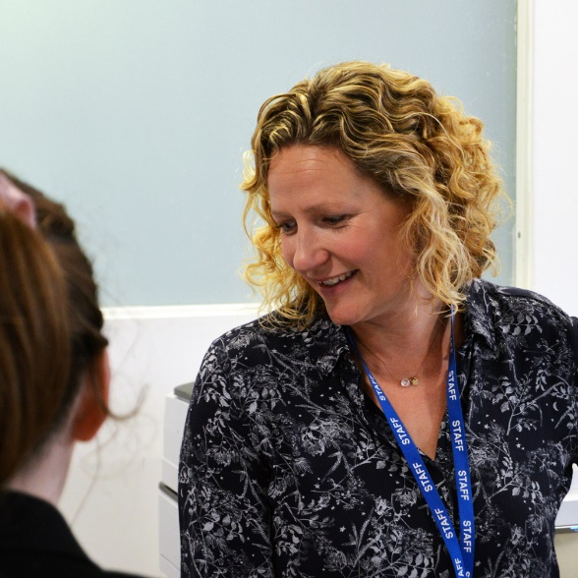
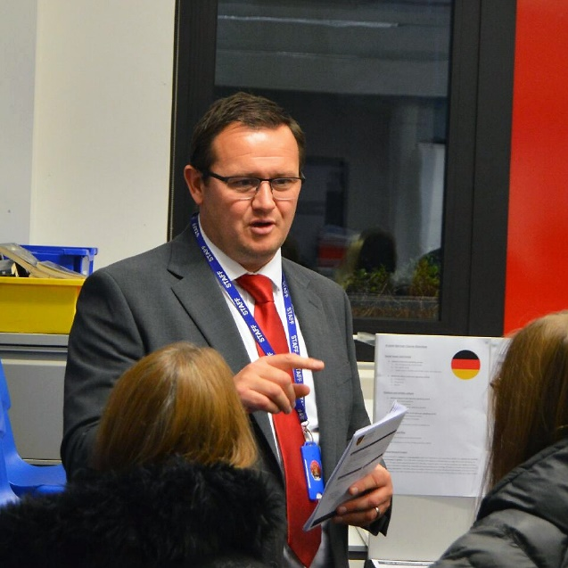 | “There are many reasons I have been at St Edward’s for more than 15 years, but probably the main one is the people here. Everyone is pulling in the same direction; the brilliant, polite, and friendly students, our happy and dedicated staff, and the supportive and capable leadership team.”  Matthew Lenarduzzi, Head of MFL  15 years at St Edward’s
“When staff leave St Edward’s, they always say something along the lines of… “This school is not like other schools. The staff care and look after each other. They are a community and there’s something special about working here.” I’ve always felt this and known this. Coming to work each day in a place where people genuinely care about you makes me feel very fortunate to work here. St Edward’s has always prided itself on caring about the whole child and I’ve always felt proud to be a part of that vision.”  Suzanne Bland, Teacher of PE  22 years at St Edward’s | 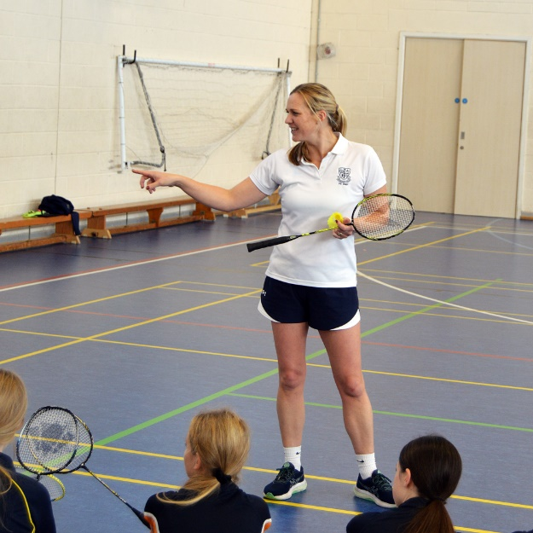
Staff Recruitment Information
APPLYING
Please read the Job Description and Person Specification before fully completing the application form. Where there are any gaps in your employment, please state the reasons why e.g. gap year, career break, unemployed etc. and give exact dates.

SUPPORTING INFORMATION
This section is very important as it gives you the opportunity to show us why you are applying and why you would be the best person for the job advertised. Please use the job description and person specification as a guide and give specific examples where possible, to demonstrate how you match the requirements of the post.

INTERVIEW AND SELECTION PROCESS
Those candidates who meet the requirements for the post will be shortlisted and invited to interview and details of the interview programme will be confirmed in writing. As part of the selection process, as well as assessing your skills and knowledge against the requirements of the role, specific questions will be asked to assess your suitability to work with children.

Under the Disability Discrimination Act 1995 and 2005, we are legally required to consider making reasonable adjustments to ensure that disabled people are not disadvantaged in the recruitment and selection process. We are therefore committed to meeting, wherever possible, any needs you specify on the application form. Please contact us if you need to discuss this in any detail.

We will consider any reasonable adjustments under the terms of the Disability Discrimination Act to enable an applicant with a disability (as defined under the act) to meet the requirements of the post.

Safeguarding
St Edward’s is committed to safeguarding and promoting the welfare of children and young people and expects all staff and volunteers to share this commitment.

If you do not hear from us by the interview date specified in the advert, please assume that you have not been shortlisted on this occasion.

PRE-EMPLOYMENT CHECKS

References
If you are shortlisted, we will normally take up references before the interview date. One of your referees must be your current or most recent employer. All offers of a post are made subject to receipt of satisfactory references without which we cannot confirm any offer of an appointment. Copies of references or references that are addressed “to whom it may concern” will not be accepted. On receipt of references, your referees may be contacted to verify any discrepancies, anomalies, or relevant issues as part of the recruitment verification process.

Disclosure & Barring Service Check (DBS)
Employment is subject to an enhanced DBS check. Checks will also be made against the Protection of Children List (PoCAL) and the Department of Education and Employment List 99. All such checks must be satisfactory before we confirm any offer of an appointment. Teachers are also checked against the Prohibition from Teaching check.

Under the Rehabilitation of Offenders Act 1974 (Exemption Amendment) Order 1986, there are a number of jobs where we must take account of convictions, even though they are ‘spent’. All posts at St Edward’s School are regarded as such. However, spent and/or unspent convictions may not necessarily make you unsuitable for appointment.

The amendments to the Exceptions Order 1975 (2013 & 2020) provide that certain spent convictions and cautions are ‘protected ‘and are not subject to disclosure to employers and cannot be taken into account.

Validation of Qualifications
All short-listed candidates will be asked to bring original certificates of relevant qualifications to interview. These will be photocopied and kept on file and may be confirmed as genuine with the relevant awarding bodies.

Right to Work in the United Kingdom
Under the Asylum and Immigration Act 1996, it is a criminal offence to employ anyone who is not entitled to live or work in the United Kingdom. Proof of this will be required at interview stage, where you will be asked to provide some original documentation to confirm that you are eligible to work within the UK. Photographic proof of identity will also be required.

Medical Assessment
A satisfactory medical assessment will be required before we confirm any offer of an appointment.

Child Protection
We are committed to safeguarding and promoting the welfare of children and young people and expect all staff and volunteers to share this commitment. We have a designated senior member of the leadership who is responsible for referring and monitoring any suspected cases of abuse. All members of staff will receive training in line with our child protection policy.

Code of Conduct
We believe that it is essential for standard of conduct at work to be maintained to ensure delivery of quality services and also to protect the wellbeing of all its employees and students.

St Edward’s School governors and headteacher regard everyone working within St Edward’s as a role mode to our students. As such employees should conduct themselves with integrity, impartiality, and honesty. Furthermore, everyone within St Edward’s school has an absolute duty to promote and safeguard the welfare of children.

STANDARD JOB DESCRIPTION FOR TEACHERS

Overarching purpose
Teachers make the education of their students their first concern and are accountable for achieving the highest possible standards in work and conduct.

TEACHING
- Set high expectations which inspire, motivate and challenge students.
- Establish a safe and stimulating environment for students, rooted in mutual respect.
- Set goals that stretch and challenge students of all backgrounds, abilities, and dispositions.
- Demonstrate consistently the positive attitudes, values and behaviour which are expected of students.

- Promote good progress and outcomes by students.
- Be accountable for students’ attainment, progress and outcomes.
- Be aware of students’ capabilities and their prior knowledge, and plan teaching to build on these.
- Guide students to reflect on the progress they have made and their emerging needs.
- Demonstrate knowledge and understanding of how students learn and how this impacts on teaching.
- Encourage students to take a responsible and conscientious attitude to their own work and study.

- Demonstrate good subject and curriculum knowledge.
- Have a secure knowledge of the relevant subject(s) and curriculum areas taught, foster, and maintain students’ interest in the subject, and address misunderstandings.
- Demonstrate a critical understanding of developments in the subject and curriculum areas.
- Demonstrate an understanding of and take responsibility for promoting high standards of literacy, articulacy, and the correct use of standard English, whatever your specialist subject.

- Plan and teach well-structured lessons.
- impart knowledge and develop understanding through effective use of lesson time
- promote a love of learning and children’s intellectual curiosity.
- set homework and plan other out-of-class activities to consolidate and extend the knowledge and understanding students have acquired.
- reflect systematically on the effectiveness of lessons and approaches to teaching.
- incorporate the use of relevant technology in lessons where appropriate.
- contribute to the design and provision of an engaging curriculum within the relevant subject area(s).

- Adapt teaching to respond to the strengths and needs of all students.
- know when and how to differentiate appropriately, using approaches which enable students to be taught effectively.
- have a secure understanding of how a range of factors can inhibit students’ ability to learn, and how best to overcome these.
- demonstrate an awareness of the physical, social and intellectual development of children, and know how to adapt teaching to support students’ education at different stages of development.
- have a clear understanding of the needs of all students, including those with special educational needs; those of high ability; those with English as an additional language; those with disabilities; those who attract Pupil Premium and be able to use and evaluate distinctive teaching approaches to engage and support them in closing any gaps in attainment.

- Make accurate and productive use of assessment.
- know and understand how to assess the relevant subject and curriculum areas you teach, including statutory assessment requirements.
- make use of formative and summative assessment to secure students’ progress.
- use relevant data to monitor progress, set targets, and plan subsequent lessons.
- give students regular feedback, both orally and through accurate marking within the agreed time and encourage students to respond to the feedback.

- Manage behaviour effectively to ensure a good and safe learning environment.
- have clear rules and routines for behaviour in classrooms and take responsibility for promoting good and courteous behaviour both in classrooms and around the school, in accordance with the school’s Behaviour Policy.
- have high expectations of behaviour and establish a framework for discipline with a range of strategies, using praise, sanctions and rewards consistently and fairly in line with the schools’ expectations.
- manage classes effectively, using approaches which are appropriate to students’ needs in order to involve and motivate them.
- maintain good relationships with students, exercise appropriate authority, and act decisively when necessary.

- Fulfil wider professional responsibilities.
- make a positive contribution to the wider life and ethos of the school.
- develop effective professional relationships with colleagues, knowing how and when to draw on advice and specialist support: being prepared to adapt practice where necessary.
- take responsibility for improving teaching through appropriate professional development, responding to advice and feedback from colleagues.
- communicate effectively with students, parents, and carers with regard to students’ achievements and well-being.
- Comply with all decisions, policies and standing orders of the school and the Borough of Poole; comply with any relevant statutory requirements, including Equal Opportunities legislation, the Health and Safety at Work Act and the Data Protection Act
- Have a commitment to safeguarding and promoting the welfare of children and young people in accordance with the school’s agreed procedure.

PERSONAL AND PROFESSIONAL CONDUCT
A teacher is expected to demonstrate consistently high standards of personal and professional conduct as defined below:
- act with honesty and integrity at all times.
- forge positive professional relationships within and beyond the school.
- be committed to collaboration and co-operative working.
- treat students with dignity, building relationships rooted in mutual respect, and at all times observing proper boundaries appropriate to a teacher’s professional position.
- have regard for the need to safeguard students’ well-being, in accordance with statutory provisions.
- show tolerance of and respect for the rights of others not undermining fundamental British values, including democracy, the rule of law, individual liberty and mutual respect, and tolerance of those with different faiths and beliefs.
- ensuring that personal beliefs are not expressed in ways which exploit students’ vulnerability or might lead them to break the law.
- have proper and professional regard for the ethos, policies, and practices of St Edward’s School, and maintain high standards in their own attendance and punctuality.
- have an understanding of, and always act within, the statutory frameworks which set out their professional duties and responsibilities.

Notes: The above duties are subject to the general roles and responsibilities contained in the Statement of Conditions of Employment.

This job description allocates duties and responsibilities but does not direct the particular amount of time to be spent on carrying them out and no part of it may be so construed. It is not necessarily a comprehensive definition of the post and will be reviewed annually. It may be subject to modification or amendment at any time after consultation with the post holder and the duties may be varied to meet the changing demands of the school at the reasonable discretion of the Headteacher.

This job description does not form part of the contract of employment. It describes the way the post holder is expected and required to perform and complete their particular duties.

PERSON SPECIFICATION – English Teacher
 | Essential | Desirable | Evidence
Qualifications
Good, relevant first degree or equivalent academic qualification | ✓ |   | AP & CT
Qualified Teacher status | ✓ |   | AP & CT
Experience
Proven track record of good / outstanding teaching of English and excellent outcomes | ✓ |  | AP IN & RF
Development of excellent working relationships with parents and carers, and other stakeholders | ✓ |  | AP IN & RF
High quality teaching to students of all abilities. | ✓ |   | AP OB & RF
Developing differentiated schemes of learning, that prepare students effectively for linear examinations |  |  | AP & IN
Commitment to personal professional development | ✓ |   | AP OB & RF
Experience as a form tutor and or/ pastoral work |  |  ✓  | AP & IN
The leading of prayer or reflection as a Form Tutor, or delivering assemblies |  | ✓ | IN
Skills
Excellent communication and organisational skills | ✓ |   | AP IN & RF
Ability to use IT effectively. |  |  | IN & RF
The ability to inspire, engage and motivate students | ✓ |  | AP IN & RF
Ability to work hard under pressure while maintaining a good humoured, positive, and professional attitude | ✓ |   | IN
Ability to organise and prioritise workload and work on own initiative | ✓ |   | IN
Excellent skills in managing student behaviour positively |  |  | AP OB & RF
Willingness to support Extra Curricular Activities |  |  | AP & IN
Knowledge and Understanding
The latest curriculum developments in English across Key Stages 3 - 5 | ✓ |  | IN
How to engage students in learning, creating curious and independent learners | ✓ |  | OB & IN
Understanding that the best teachers and the best learning take place in high quality professional relationships; and that the end goal of education goes well beyond examinations |  |  | AP & IN
Understanding of effective progress monitoring and intervention strategies | ✓ |  | IN
Safeguarding requirements, processes, and strategies | ✓ |  | IN
AP = Application, IN = Interview, CT = Certificates, OB = Observation and RF = References

Ofsted (2022) and Section 48 (2023) Quotes

Ofsted
“This school is a positive learning community.” | “The core values of kindness, hard work and the development of individual strengths and skills are evident in the school’s work.”
“There are positive and respectful relationships between staff and pupils. This leads to a calm learning environment.” | “Pupils are happy, friendly and polite.”
“This school is well led and managed.” | “The school’s ethos and values run through all they do: unity, achievement, faith.”
“Leaders ensure that there is an ambitious and challenging curriculum in place.” | “There is strong moral leadership from the headteacher.”
“Everything leaders do are in the best interests of the pupils that attend the school.” | “Staff have a very positive view of leaders. They say leaders are approachable and considerate of their workload.”
“Governors understand their responsibilities well and are cognisant of the need to support staff wellbeing.” | “Teachers have high expectations of what pupils can achieve through the curriculum.”
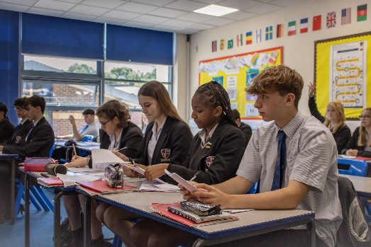

Section 48
“The mission statement is a clear and inspiring statement of the mission of the church and is lived out and understood by the whole community.” | “Provision for pastoral care is a strength of this school which takes supporting the development of the whole person seriously.”
“Leaders and governors have a clear and inspiring vision of the mission of the school.” | “The pastoral care of students is a priority for the school and as a result students feel valued and listened to.”
To Apply for the Position
If you are interested in applying for this role, we would love to hear from you. Please complete and return the application form on our website:
https://st-edwards.poole.sch.uk/information/recruitment/
Please do not submit additional documentation at this stage.
The deadline for receipt of applications is published on our website.
Interviews will be held shortly afterwards.
Thank you for your interest and for taking the time to apply to St Edward’s School.
Parent of Year 11 child, 2023
“Huge thanks for all the efforts made by teachers, having excellent teachers that inspire and encourage in such a supportive way makes all the difference. Thank you!”
“My son loves his new school, he has settled very well because of friendly and helpful staff at school.”
Parent of Year 7 child, 2023

