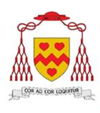 St John Henry Newman Catholic School

Headteacher: Mr Declan McArdle BA (Hons) MEd

Candidate Brochure
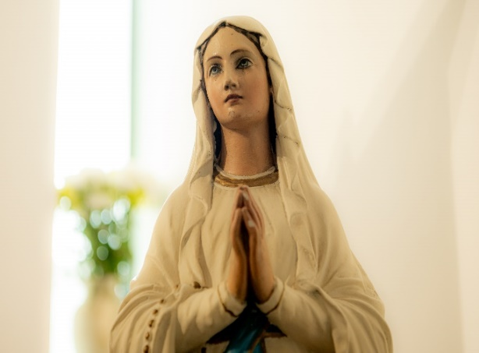



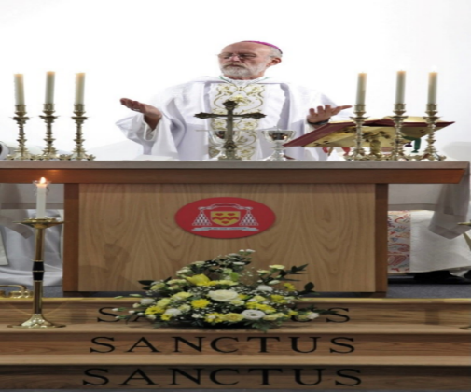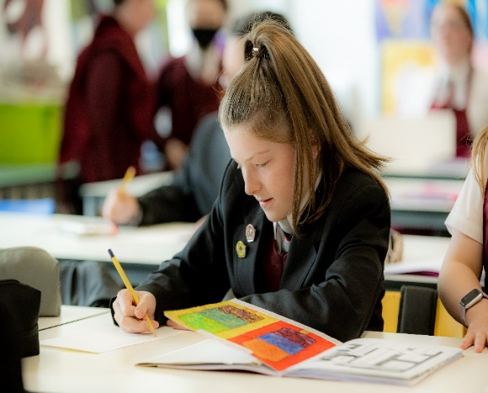

St John Henry Newman Catholic School

Contents

Page 3 | Welcome from the Headteacher
Page 4-5 | Mission Statement
Page 6 | About our School
Page 7 | Advert
Page 8 - 10 | Job Description and Person Specification

Also included with this application pack:
- Attachments - Notes to Applicant
- Application Form
- Rehabilitation of Offenders Form – issued at shortlisting stage
- Self-Disclosure Form – issued at shortlisting stage
- Recruitment Monitoring Form
- Consent to Obtain Reference Form
- Overarching Safeguarding Statement
- Staff Code of Conduct Policy
- School Privacy Notice - Staff
- Equality Act Reasonable Adjustment Statement

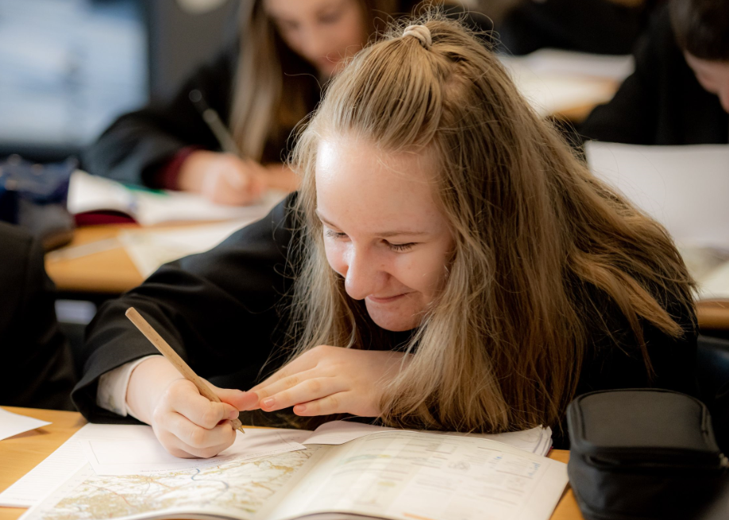

St John Henry Newman Catholic School

Welcome from the Headteacher
Dear Applicant
Thank you for your interest in the position of Senior Teaching Assistant at St John Henry Newman Catholic School.
We are a genuinely comprehensive school and believe that our mission is to nurture each child by placing Christ and the teaching of the Catholic Church at the centre of their lives.
We integrate Gospel values and the teachings of the Catholic Church into every aspect of learning, teaching and the totality of school life.
In the words of our patron St John Henry Newman, “To live is to change and to be perfect is to have changed often”; and so we have high expectations of our pupils; we expect them to work hard, to play hard and to take a full part in the life of the school. In return, we strive to provide the best teaching and guidance in a caring and supportive environment, where pupils are challenged and give of their best.
Strong pastoral care is vital to our success and creates a happy and caring atmosphere. As a smaller school, we get to know our pupils well; their well-being is our foundation. This strong pastoral care enables us to support our pupils, not only with their academic work, but also in the varied extra-curricular activities, which are hugely important as they develop into young adults.
It is an exciting time to join St John Henry Newman Catholic School. Following the flooding of our site in Carlisle we moved to a purpose-built modern school in a developing area of Carlisle in September 2020. After a turbulent time following the flood, the school is rapidly improving and was recently commended by Ofsted for the improvements being made in the quality of teaching, the progress of pupils, and for the highly effective pastoral support. Inspectors’ findings confirmed that a journey of school improvement is underway.
You will find here a wonderful and vibrant community of teachers and support staff committed to improve the life chances of all pupils and to develop a school that embraces the teachings of the Catholic Church.
We want our pupils to enjoy their education – to be happy, safe and secure and to grow in God’s love so that when they leave the school, they are equipped to change the world and make it a better place.

Yours
Declan McArdle
Headteacher

St John Henry Newman Catholic School

Mission Statement

Our mission is to educate our pupils in the wholeness of mind, body and spirit through the teachings of Jesus Christ as proclaimed by the Catholic Church by placing Him at the centre of pupils' lives. We encourage pupils to cultivate Christian virtue and an appropriate sense of social responsibility. We support the spiritual and mental well-being of all our community on a daily basis.

Our school commits itself to the principles of Catholic education and academic excellence, leading our pupils from shadows and images to the fullness of the Truth, as envisioned by the St John Henry Newman. We inspire an enthusiasm for life-long learning and are committed to success for all, ensuring that all our community has the highest aspirations to achieve the best outcomes in life.
St John Henry Newman Catholic School
Governors’ Strategic Vision 2023-2028
This text sets out our aspirations for St John Henry Newman Catholic School and provides a description of the school the governors would like to see evolve over the next five years.
In everything we do, we will aim to affirm Cardinal Newman’s inspirational maxim:
Cor ad Cor Loquitur (Heart Speaks to Heart)
We will strive to be a school which is marked by:
- Christian values, where Catholic teaching is at the centre of every aspect of school life
- equal respect for all members of the school community which is safe, inclusive and nurturing of all
- a staff team dedicated to our pupils and committed to professional self improvement no matter what our role
- a curriculum which fosters curiosity, challenges all pupils and enables them to explore wider horizons to make sense of the changing world around them
- promotion of positive career routes for all pupils, including through membership of our own distinctive sixth form
- active participation in the Bishop’s vision for Catholic education in the diocese as a member of the Mater Christi multi-academy trust

As a result of our collective efforts, we expect our pupils to be:
- become well rounded young people, open minded and receptive, honest and truthful
- grow into generous, grateful, hopeful adults able to fulfil their spiritual and personal potential
- be shaped by Christian values, discerning, compassionate and actively serving society
- know that they are valued and cared for, confident in their personal gifts and equipped to develop their unique strengths
- have respect for their own dignity and the dignity of others, able to act as both leaders and good team players
- develop into self-disciplined and courteous young people, conscious that they can be a positive example to others
The school will provide an environment which is:
- an inspirational place in which to learn: spacious, light, attractive and stimulating
- suitable to meet all needs – physical, academic, personal, social and spiritual
- furnished with a distinctive and prominent working chapel open to all, at all times, with regular Masses
- supportive of learning in all domains, flexible and responsive to the changing curricular requirements of the 21st Century
- responsive to the progression routes of all pupils, including the provision of high quality post-16 programs within its own distinctive sixth form.
- an environment which brings pupils together, with communal and recreational spaces conducive to a civilised experience
- safe, secure and appropriate to the diverse needs of the pupil’s community
- well-resourced with the equipment and materials required to provide the best contemporary education possible

St John Henry Newman Catholic School

About our School
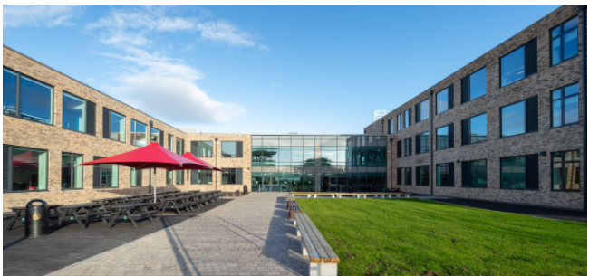
It is an exciting time for St John Henry Newman Catholic School, as we have moved to a new build school in the “garden village” area of Carlisle. Our school is a £15million new build in a rural location on the edge of the city. The school has been designed to provide the highest standards of education for our pupils and areas have been purpose built to allow staff to teach effectively in their subject areas.
St John Henry Newman Catholic School offers:
- An exciting, engaging curriculum underpinned by excellent teaching
- Committed and caring staff
- Continual Professional Development
- Governor support
At St John Henry Newman Catholic School, we are committed to the high achievement of all our pupils. We cultivate success and foster the highest aspirations through excellent teaching. We are a learning community which has high expectations and actively seeks to celebrate the good in every individual. St John Henry Newman Catholic School is built on the Christian values of trust, respect and compassion.
We inspire an enthusiasm for life-long learning and are committed to success for all.
St John Henry Newman Catholic School opened in 1967 and we are very proud of the long history of achievements gained by our pupils. Our expectations are high and we continue to ‘raise the bar’.
Our small sixth form ensures that all of our pupils’ individual needs are catered for which in turn ensures we are well placed to help each individual to make their expected progress.
Supported by a strong careers programme, our pupils continue to be successful in their transition from school to employment, apprenticeships and further education and training. Pupils receive individual guidance on their next steps and we are proud to say that our school leaver statistics are above the national average with close to 100% of our pupils selecting appropriate future steps.
St John Henry Newman Catholic School seeks to provide a distinctly Catholic education in partnership with parents, families, the local Church and wider community. Everyone is encouraged to be the best person that they can be and is both nurtured and challenged in a safe and secure environment. Mutual respect is at the heart of our school community and Gospel values of peace, justice and reconciliation are of paramount importance.

St John Henry Newman Catholic School

English Teacher
Maternity Cover MPR/UPR
Required February 2026 – September 2026
St John Henry Newman Catholic School is seeking an enthusiastic, inspirational and innovative English Teacher to join a highly professional and forward-thinking English Department. This is a temporary post to cover Maternity Leave.
Our school has a distinctive caring and Christian ethos with the emphasis on the individual and supporting pupils in fulfilling their full potential.
The successful candidate will be expected to teach to GCSE and have the potential to teach A Level.
St John Henry Newman Catholic School supports career development and progression with excellent resources in a brand-new school building. We are therefore interested in talking to both experienced teachers looking for a new challenge as well as early career teachers at the beginning of their career.
St John Henry Newman Catholic School is committed to safeguarding and promoting the welfare of young people. This post will be subject to satisfactory DBS and health checks.
For an informal chat about the post or to request to visit our school please contact Louise Tickell, Head of English by email: ltickell@newman.cumbria.sch.uk
Application packs can be requested by emailing vacancies@newman.cumbria.sch.uk or downloaded from our website at http://newman.cumbria.sch.uk/Vacancies/

Your application form should be supported by a letter of no more than two pages of A4.
Completed application forms can either be forwarded to the email address above or by post addressed to the Finance Office.
The closing date for applications is 12pm Monday 24th November 2025
Interviews will be held on Wednesday 26th November 2025
Short listed candidates will be contacted by telephone or email

Job Description and Person Specification
Catholic Voluntary Aided School
Job Description

Post: Teacher
Responsible to: Subject leader
Responsible for: Teaching across the age and ability range of the school as directed by the Headteacher

Professional duties: (These duties relate directly to the School Teachers’ Pay and Conditions Document)

Mission Statement:

Working with the Headteacher and Senior Leadership Team in implementing the school’s mission statement.

From time to time contributing to the review of the mission statement.

Teaching:
In each case having regard to the curriculum for the school, and with a view to promoting the development of the abilities and aptitudes of the pupils in the class or group assigned to her/him:
- Planning and preparing courses and lessons according to the school formats
- Registering pupils in line with school protocol
- Teaching, according to their educational needs, the pupils assigned to her/him, including the setting and marking of work to be carried out by the pupil in school and elsewhere
- Monitoring, assessing, recording and reporting on the development, progress and attainment of pupils, following school procedures

Other activities:
- Maintaining and promoting the good name of the school
- Promoting the general progress and well-being of individual pupils and of any class or group of pupils assigned to her/him
- Providing guidance and advice to pupils on educational and social matters and on their further education and future careers, including information about sources of more expert advice on specific questions; making relevant records and reports
- Making records of and reports on the educational personal and social needs of pupils using school systems and formats
- Communicating and consulting with the parents of pupils
- Communicating and co-operating with persons or bodies outside the school; and
- Within the 1265 hours participating in meetings arranged for any of the purposes described above

Assessments and reports:
- Providing, recording and contributing to oral and written assessments reports and references relating to individual pupils and groups of pupils

Continuous Professional Development:
- Participating in arrangements made in accordance with regulations made for the appraisal of her/his performance and that of other teachers.

Review, induction, further training and development:
- Reviewing from time to time her/his methods of teaching, pupil monitoring and assessment and programmes of work
- Participating in arrangements for her/his further training and professional development as a teacher including undertaking training and professional development which aim to meet needs identified in appraisal / performance management objectives or in appraisal / performance management statements
- In the case of a teacher serving an induction period, participating in arrangements for her/his supervision, training and well-being

Educational methods:
- Advising and co-operating with the head teacher and other teachers on the preparation and development of courses of study, teaching materials, teaching programmes, methods of teaching and assessment and pastoral arrangements

Discipline, health and safety:
- Contributing to risk assessments and promoting a healthy and safe working environment
- Maintaining good order and discipline among the pupils and safeguarding their health and safety both when they are authorised to be on the school premises and when they are engaged in authorised school activities elsewhere

Staff meetings:
- Participating in meetings at the school which relate to the curriculum for the school or the administration or organisation of the school, including pastoral and pupil progress arrangements

Cover
- No teacher shall be required to provide such cover for more than 38 hours in any school year

Public examinations:
- Participating in arrangements for preparing pupils for public examinations, in monitoring and assessing pupils for the purposes of such examinations and recording and reporting such assessments, and participating in arrangements for pupils’ presentation for such examinations

Management:
- Contributing to the selection for appointment and professional development of other teachers and support staff, including the induction and assessment of new teachers and teachers serving induction periods
- Assisting the head teacher in carrying out threshold assessments of other teachers for whom he has management responsibility
- Co-ordinating or managing the work of other staff
- Taking such part as may be required of her/him in the review, development and management of activities relating to the curriculum, organisation and pastoral functions of the school

Administration:
- Participating in administrative and organisational tasks related to such duties as are described above, including the direction or supervision of persons providing support for the teachers in the school
- Attending assemblies, registering the attendance of pupils and supervising pupils, whether these duties are to be performed before, during or after school sessions
- A teacher should not routinely undertake tasks of a clerical or administrative nature which do not call for the exercise of a teacher’s professional skills and judgment

Other duties:
Any other duties the head may direct within the conditions of service.
Review
This job description will be reviewed annually or sooner if required.

D M McArdle
September 2025

