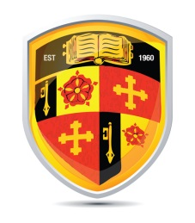

ST. PETER’S CATHOLIC HIGH SCHOOL

PROFILE OF THE ENGLISH DEPARTMENT

The English Department at St. Peter’s is a highly successful, warm and creative team. The department consistently achieves very good results at GCSE. In 2019 85.7% of students achieved Grades 9-4 in English. 25.8% of students achieved at Grades 9-7.

English Literature in 2019 saw 79.2% 9-4 Grades of which 22% were within Grades 9-7.

Staffing
The English department currently consists of 8 full time and one part time teacher. All of these staff are professional, dedicated English specialists with a real desire to translate their love of the subject to the students in their care.

Curriculum
Pupils receive four 100-minute English lessons each fortnight in Year 7 and 9. Year 8 receive three 100-minute lessons a fortnight. In KS4 Year 10 receive four 100-minute lessons a fortnight whilst Year 11 receive five classes over the two-week cycle.

The KS3 curriculum is a structured and integrated framework that fully prepares students for the rigour and challenge of the GCSE course through a spiral curriculum model. Language and Literature are both explicitly explored and students can see their skills developing over time.

All classes are mixed-ability with the exception of a small, targeted SEN group in each year. The department currently teaches the AQA GCSE specification with Years 10 and 11.

Inspection
The school was last subject to a full OFSTED inspection in February 2019, when it was judged to be Good.

This is a great opportunity for a committed and effective individual to enhance and enrich a highly successful department and help move us forwards towards a very bright future.

