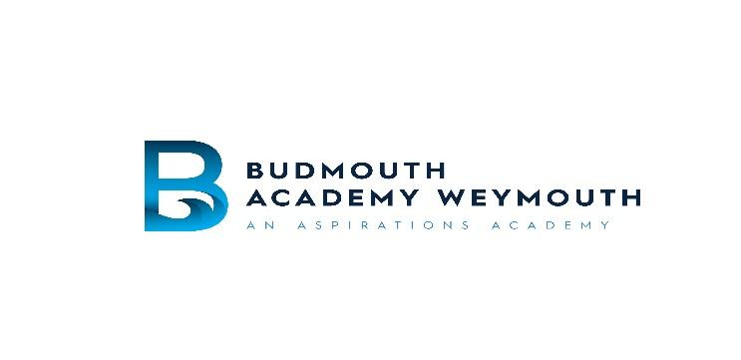

Budmouth Academy Weymouth

Chickerell Road, Weymouth,

Dorset. DT4 9SY

Telephone (01305) 830500 Fax (01305) 830555

Website : www.budmouth-aspirations.org

Principal: Mr David Herbert

Salary: MPS

Contract Type: Full time

Contract Term: Permanent

Start Date: 1st September 2021

Closing Date: 22nd April 2021

Interview Date: TBC

Teachers of English

We require well-qualified English Teachers who have a passion for teaching English and enabling the progression of our students. We are looking for individuals who are able to fulfil a team role that will complement the energy, dynamism and originality of thought present in our established team. These posts would suit an NQT or a teacher with experience and as your professional development is important to us, there are highly supportive induction programmes and CPD opportunities during your time at the school.

Our current team offer a range of extra-curricular support sessions to ensure students reach their full potential, and if successful, we would hope that you would share this ethic. Budmouth Academy has a highly successful 6th form and you will have the opportunity to teach post 16; English Literature and English Language.

Budmouth Academy Weymouth is committed to safeguarding and promoting the welfare of young people and expects all staff to share this commitment. These posts are subject to an enhanced DBS check. We value the diversity of our workforce and welcome applications from all sections of the community.

For specific information regarding these positions, please contact Ms Lesley Carter, Assistant Principal, lacarter@budmouth-aspirations.org.. An information pack including the Application form, Job Description, Person Specification, and Statement of Child Protection summary can be found on the Budmouth Academy Weymouth website. The Application form should be completed and sent to Lucy Vincent, HR & Payroll Officer lvincent@budmouth-aspirations.org.

If you have not heard from us by 30th April 2021 then please assume that on this occasion your application has been unsuccessful.

