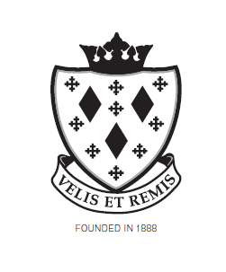

Stockport School

Reader/Scribe

Job Description

Post reports to:

SEN / Exams Officer

Main Purpose of the job

To be reader and/or scribe for students during examinations.

Summary of responsibility and personal duties

- A reader would be required to read the exam paper word for word – you could not elaborate, explain any part of the paper or assist in any way.
- A scribe would be required to write exactly what is requested by the candidate, word for word. This requires a good level of literacy from the Scribe (e.g spelling, punctuation and grammar, legible handwriting), as otherwise the candidate would be disadvantaged.
- Undertaking such other activities related to the examination work of the school appropriate to the post

