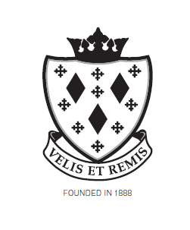
Stockport School

Person Specification

Post Title Examination Invigilator / Reader Scribe

Attributes | Essential | Desirable | How Identified
Relevant Experience | Ability to relate to candidates while maintaining an air of authority.  Good interpersonal skills.  Ability to work to follow all instructions including those laid down by the Exam Board.  A good punctuality record.  Reader/Scribe – a good level of literacy and reading skills. Legible handwriting. | Ability to work as part of a team or alone.  Ability to keep calm during unexpected circumstances.  Ability to be firm but fair at all times. | Application form / Interview

