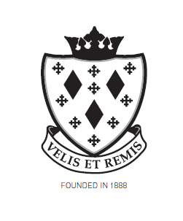
Stockport School

Exam Invigilator

Job Description

Post reports to:

Examination Officer

Main Purpose of the job

To be an invigilator during examinations.

Summary of responsibility and personal duties

- Ensure that exam conditions are maintained from the time the students enter the exam venue until they have left the room.

- Opening and distributing papers and any other authorised materials to candidates. Responding to candidates queries in accordance with exam regulations.

- Collecting scripts in correct order.

- Delivering the scripts to a secure area.

- Undertaking such other activities related to the examination work of the school appropriate to the post.

