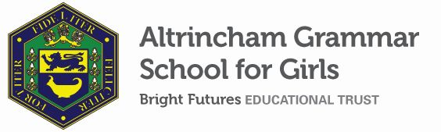

Examinations Officer
Required from 9 January 2022
Term time plus 2 weeks; Permanent
Grade 6; NJC scale points 21 to 25 (Bright Futures scale Grade 6)
Part time, 36.25 hours; term time plus 2 weeks
Actual pay £25,384.00 rising to £28,124.89 p.a.

The Bright Futures Educational Trust is a partnership of schools based in the North West. The Trust’s vision is the best for everyone, the best from everyone. Our values of community, passion and integrity are at the heart of everything we do. There are currently twelve schools within the Trust. The Trust is committed to providing all staff with the training and support they need to be the best in their profession. Benefits include: working cross-phase, knowledge exchange between our schools and the opportunity to work with some of the most inspiring colleagues in their profession.

Altrincham Grammar School for Girls is seeking to appoint a well-qualified and confident Examinations Officer to manage the organization and administration of both internal and external examinations. Experience in a similar role or of working within a school would be an advantage.

Further information on the role can be found on the school website.

Our new portal contains our on-line application form and disclosure of criminal background form. Please click on the link HERE, or find it on our website. Please complete the forms by 8 a.m. 12 December 2022.

Closing date for applications is 12 December 2022 at 8 a.m.
Interview date is Friday 16 December 2022.

ADDITIONAL INFORMATION
Further information about the school, a copy of the school’s prospectus and the most recent OFSTED inspection are available from the school’s website.

Bright Futures Educational Trust is committed to safeguarding and promoting the welfare of children and young people and expects all staff to share this commitment. Any successful applicant will be required to undertake an Enhanced Disclosure check by the DBS. This post is exempt from the Rehabilitation of Offenders Act 1974.

