INFORMATION PACK
Altrincham Grammar School for girls
Examinations Officer
Permanent
Required 9 January 2023

Overview of the Role

Altrincham Grammar School for Girls is seeking to appoint a well-qualified and confident Examinations Officer to manage the organization and administration of both internal and external examinations. Experience in a similar role or of working within a school would be an advantage.

The full job description and person specification are at the end of this pack.

Bright Futures Educational Trust

Bright Futures Educational Trust (The Trust) is a multi-academy trust (MAT) set up in 2011. The Trust is made up of a richly diverse group of schools in Greater Manchester and Blackpool. We are passionate about working together within and beyond the Trust to achieve our aspirational vision: the best for everyone, the best from everyone. We are an organisation that is underpinned by values of: community, integrity, and passion. In everything we do, we remember that we are accountable to the children, families, and communities that we serve.

Our schools have their own identities and form one organisation and one employer, Bright Futures Educational Trust. Bright Futures’ Board of Trustees maintains strategic oversight of the Trust and delegates some of its responsibilities to the Executive Team, Principals, and local governing bodies. We place a high value on integrity and probity and take seriously our accountabilities for making the best use of public money. How decisions are made is described in our delegation framework. You can find out more about the Trustees and the Executive Team on our website: About Us

The central team comprises the Executive Team: John Stephens, CEO; Edward Vitalis, Chief Operating Officer; Gary Handforth, Director of Education; Lisa Fathers, Director of Development, Partnerships and Teaching School Hubs; Lynette Beckett, Director of HR & Strategy. The focus of these roles is to work with schools, providing high quality and timely guidance, leadership, challenge, and support. In addition to the Executive Team, we have central operations for Finance, HR, Educational Psychology, Marketing and Communications, and Digital Technologies. Please see our website brochure which explains our central operations: Working together for a Bright Future.

Bright Futures Development Network is another important outward facing component of our organisation made up of a number of hubs and networks at the heart the Trust. In January 2021, after significant national reforms to the teaching school policy Bright Futures was designated with two new large-scale Teaching School Hubs, which replace the Alliance for Learning Teaching School. This growth and expansion in our outward facing work brings about a significant increase in accountability and reach. The two Bright Futures Teaching School Hubs are designed to provide strong strategic regional leadership to build robust partnerships to support teachers and leaders in every phase and type of school, at each stage of their development. A crucial part of the hub remit is carefully ensuring structured collaboration. The Teaching School Hubs are at the forefront of providing high quality professional development, playing a significant role in the implementation and delivery of: The Early Career Framework, National Professional Qualifications (NPQ), Initial Teacher Training and Continuous Professional Development (CPD). The Hubs work directly with the Department for Education and national NPQ/ECT providers. In addition to this, the Hubs enhance the professional development needs of Bright Futures schools and academies. Within this outward facing area of Bright Futures Educational Trust, we have a commercial offer run through the Alliance for Learning which provides first-class school improvement services and CPD to over 700 schools, further complementing the work of our Teaching School Hubs. Our School-Centred Initial Teacher Training (SCITT) Bright Futures SCITT is also an integral part of the Teaching School Hubs, with over 10 years’ experience and judged Good by Ofsted, we offer Early Years, Primary and Secondary teacher training programmes. Within the Bright Futures Development Network, we are also proud to have a Maths Hub: NW1 Maths Hub offering a wide range of maths specific high-quality professional development opportunities and training/coaching to 500 schools.

Collaboration and strong relationships form one of the ‘commitments’ in our Strategy and all components of the Bright Futures’ family work closely together. Our Strategy was developed collaboratively and can be found on our website: Our Strategy

Altrincham Grammar School for Girls
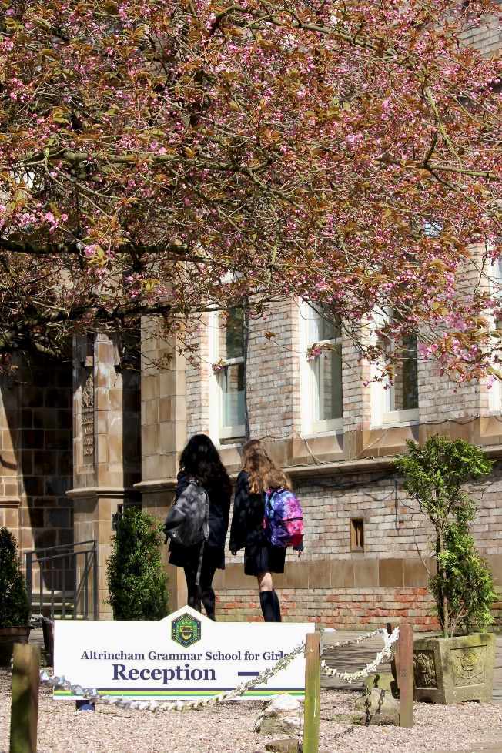
Altrincham Grammar School for Girls (AGGS) is a highly successful single sex 11 -18 academy in the South Trafford area. AGGS was in the first cohort of schools to be designated a national teaching school in 2011. AGGS is the lead school in ‘The Alliance for Learning’, which comprised schools of every type and phase, plus universities, throughout a wide geographical area. The impact of teaching school activities has been felt within the Trust and far beyond. We have a reputation for excellence regionally and nationally, of which we are very proud.

AGGS is committed to providing equal opportunity in recruitment and employment to all individuals. We will consider candidates without regard to race, ethnicity, gender, religion, sexual orientation and identity, national origin, age, military or veteran status, disability or any other legally protected status; and without discrimination based on socioeconomic, marital, parental or caregiving status, or any of the previously listed characteristics or statuses.

We value the diversity of our staff and reject any form of harassment, discrimination or victimisation. The Bright Futures Educational Trust vision is: ‘the best for everyone, the best from everyone’. To achieve this, we create and maintain a work environment and culture where people from different backgrounds, and with varying lifestyles, interests, opinions and responsibilities, treat each other with dignity and respect. It is a climate in which our staff feel safe and are inspired and motivated to be their best.

Our school is dedicated to sustaining and promoting diversity with respect to recruitment, promotion, training and general treatment during employment. We are actively seeking to extend the diversity of our staff. Furthermore, we welcome candidates who have not had previous experience of working in a grammar school.

We aim to ensure that our recruitment processes set up all candidates for success. At interview our aim is to provide a positive experience. We don’t want to catch anyone out, but rather to provide the opportunity for all candidates to be themselves and show us what they are capable of.

WHY WORK FOR US?
We offer a great opportunity to join an organisation which really lives its values. Our working environment is very inclusive and whilst you can expect to be challenged in your role, you will be supported through professional learning, treated fairly and with dignity and respect. Please see the Equality,
Diversity, an Inclusion statement on our website.

Terms and Conditions

Salary: NJC scale points 21 to 25 (Bright Futures scale Grade 6). The full-time equivalent pay is £28,900 rising to £32,020 per annum. The actual pay based on the below working pattern commencing £25,384.00 rising to £28,124.89, per annum actual pay. Pay progression is linked to performance.

Working weeks: This is a great opportunity for flexible working as the role will work 38 weeks during school term time and an additional 2 weeks to be agreed. A total of 40 weeks.
Hours: 36.25 hours per week over 5 days. Flexible working will be considered, please discuss at interview if you wish this to be considered.
Holidays: You will be paid for the prorate equivalent of 25 days, plus 8 public holidays. This increases to 30 days plus 8 public holidays after 5 years’ service.

Pension: Local government pension scheme. Please take a look at the website: https://www.gmpf.org.uk/.

Other: We offer salary sacrifice schemes for purchasing bikes used for travel to work and technology for personal use, through monthly interest free salary deductions.
We also offer opportunities for professional development.

How to Apply
We can only accept completed application forms, rather than CVs. This is because the regulatory guidelines of
Keeping Children Safe in Education (2021), require us to check various details of job applicants and an identical
application format for each candidate enables us to do this. We use a process that does not identify personal
characteristics to the shortlisting panel. This is part of our commitment to equalities and diversity.

NO AGENCIES PLEASE.

Our application form is available online, along with the disclosure of criminal background form. The portal link is HERE. Alternatively, you can click Apply Now on this role via the current vacancies page of our website. Please upload the forms by 9:00 a.m., 12 December 2022.

The selection will take place on 15 December 2022. You will be notified after the closing date whether you have been shortlisted.

Keeping Children Safe in Education
Bright Futures Educational Trust is committed to safeguarding and promoting the welfare of children and young people and we expect all staff and volunteers to share this commitment. This post is exempt from the Rehabilitation of Offenders Act 1974; pre-employment checks will be carried out and references will be sought for shortlisted candidates and successful candidates will be subject to an enhanced DBS check and other relevant checks with statutory bodies.

Data Privacy
You can read the details of how we use the personal data that you provide us with in our Job Applicants’ privacy notice on our website: Applicant Privacy Notice

JOB DESCRIPTION
Examinations Officer

Main Responsibilities
- To ensure the efficient and accurate organization and administration of all aspects of the school’s external and internal examinations processes.
- To ensure all examination arrangements are fully compliant with awarding body regulatory requirements and manage the smooth running of examination sessions including deployment of examination invigilators.
- The examinations officer is responsible for the administration of public examinations related to GCSE, A Level and other examinations or test sessions within the school such as the entrance examination and university entrance tests.
- The examinations officer reports to the Assistant Vice-Principal responsible for Achievement and Curriculum.

Key Areas of Responsibility
Administration and organisation of all public and internal examinations:
- To act as the principle link between the school and awarding bodies;
- To ensure full compliance with examination board regulations;
- To co-ordinate the preparation and submission of entries to examining bodies, including processing estimated and final entries;
- To check entries are correct and agreed by both students and staff;
- To manage the SIMS examinations module;
- To book examination rooms and draw up seating plans for all examinations;
- To manage examination clashes and organise supervision;
- To liaise with the Assistant Vice-Principal (Achievement & Curriculum), the Head of Sixth Form and the Vice-Principal regarding the organisation of examinations, student discipline during examinations and any issues related to student conduct relevant to examinations, including the briefing of students at assemblies, supported by key members of the teaching staff;
- To be responsible for secure storage of examination papers and related paperwork;
- To ensure all necessary stationery and materials are supplied to all examination rooms;
- To advise school leaders on special consideration regulations and oversee applications and access arrangements for special considerations liaising with the SENCO, relevant senior leaders and heads of department;
- To co-ordinate the team of invigilators, including recruitment, training, management and deployment of invigilation staff;
- To issue entry statements and examinations timetables to students, making any necessary corrections and making arrangements to deal with timetable clashes;
- To download GCSE and A Level results into SIMS examinations module and to administer the distribution of results to students;
- To deal with queries, where appropriate from students, staff and parents relating to results and examinations;
- To process examination reviews, script requests and re-sit requests in line with school policy;
- To check certificates as they arrive and ensuring students receive correct copies;
- To advise the Principal and AVP (Achievement & Curriculum) on awarding body regulations on appeals;
- To provide accurate relevant and timely data following the public examination cycle;
- To contribute to new staff induction and to ensure that all staff are updated on dates, changes in examination procedures, entries and results;
- To attend appropriate courses and local network meetings such as those organised by the awarding bodies
- To ensure all relevant information is made available to interested parties as appropriate.

Additional School Examinations:
- To liaise with the AVP (Achievement & Curriculum) and heads of departments to ensure appropriate timetabling and invigilation arrangements are in place for the school’s internal and mock examinations
- In liaison with the Admissions Officer, to support with matters relating to the entrance examination, including but not limited to administration, organisation, communication and logistics; to support with arranging the marking of papers and collating of results; to liaise with the Admissions Officer and SENCO on special requirements;
- To organise the administration of University Admissions Tests;
- To work closely with the AVP (Achievement & Curriculum) and Data and Systems Manager to ensure full and accurate data analysis to support school improvement.

Additional Administrative Duties:
- To support the Admissions Officer at open evenings, if required;
- To assist the AVP (Achievement & Curriculum) in other administrative duties and responsibilities commensurate with the level of responsibility of the role.
- To liaise with the Principal and the Business and Finance Manager in agreeing the annual budget for examinations expenditure;
- To monitor and control examinations budget expenditure including expenditure on invigilation to ensure the efficient and effective deployment of resources.

Quality Assurance:
- To be directly responsible for the day to day co-ordination of the team of examination invigilators;
- To quality assure the work of examination invigilators;
- To ensure invigilators and invigilation processes are fully compliant with safeguarding requirements.

School-wide Responsibilities
- To be aware of and act upon relevant school policies and in particular those associated with child protection/safeguarding and health and safety;
- To be responsible for maintaining a clean and tidy environment;
- To attend relevant meetings as required;
- To act as a role model for the students in school;
- To act as an ambassador for school and ensuring that the school’s high standards are promoted at all times.

PERSON SPECIFICATION
Examinations Officer

 | Essential | Desirable | How tested
Qualifications, Educational, Training | Good educational background with strong literacy and numeracy skills.  GCSE’s (or equivalent) with grade B or above in English. |  | - Application form
Relevant Experience | Experience of office or administrative work. | Experience in a school environment.  Experience of working as an exams officer. | - Application form
Safeguarding | Commitment to demonstrating a responsibility for safeguarding and promoting the welfare of young people. |  | - Application form  - Interview
Knowledge, skills, abilities | Detailed knowledge of school public and internal examinations structure and processes.  Knowledge of the principles of examinations timetable planning.  Excellent organisational skills.  Excellent written and oral communication skills.  High level of attention to detail and accuracy.  Microsoft Office components, especially Word and Excel.  Health and safety issues as they relate to this particular environment.  A good telephone manner.  The ability to work efficiently at speed.  The ability to be self-motivating.  The ability to work under pressure.  The ability to prioritise.  Tact and discretion and an ability to maintain confidentiality. | First aid qualified.  Experience with SIMS or other management information system. | - Application form  - Interview  - Tasks
Others | Flexibility, adaptability and a willingness to be involved in change.  Commitment to further training and development of our teaching school aims.  Willingness to participate in all aspects of school life and assist others with their roles.  Self-confidence and willing to take the initiative.  A positive approach to challenges, which seeks solutions to problems and addresses difficulties with cheerfulness and good humour.  A genuine commitment to improving the quality of provision for students in our school.  Smart, professional appearance.  DBS clearance. |  | - Interview  - Tasks
Our values | Community: Evidence of working together for a common purpose and encouraging diversity  Integrity: Evidence of doing the right things for the right reason  Passion: Evidence of taking personal responsibility, working hard and having high aspirations. |  | - Interview  - Task

