Post Number
Job Title | Examinations Officer
Department | Whole School
Prepared by and date | J Doyle – January 2025
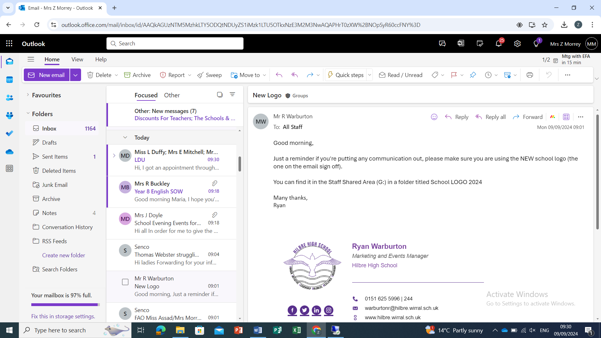
Employee Specification Form

Factors | Personal Attributes | Stage  Identified
Qualifications | Essential  - GCSE Maths and English Grade A-C/9-4 or equivalent.  Desirable  - Relevant Academic qualification to graduate level or equivalent within a management/administration environment. | Application
Experience | Essential  - Experience of whole school examination management and processes within a secondary school setting.  - Experience of working with a wide variety of stakeholders.  Desirable  - Experience of leading and managing a team of staff. | Application
Knowledge and Skills | Essential  - Knowledge of school-based MIS and Examination entry systems.  - Higher level of ICT skills and experience.  - Knowledge and understanding of the national examination system.  - Experience of school data systems.  - Good numeracy skills.  - Excellent analytical skills.  - Above average attention to detail.  - Ability to work calmly under pressure.  - Ability to work accurately and effectively within tight deadlines.  - Experience of maintaining data in a secure environment, including inputting, extracting and analysing relevant data from a management information system.  - Good written and verbal communication skills with the ability to be able to establish and maintain good working relationships with all school staff, students and parents/legal guardians.  - Understanding of individual children and young peoples’ needs.  - Understanding of SEND additional Access Arrangements. | Application/  Reference/  Interview
Personal Qualities | Essential  - Ability to work under pressure and determination to succeed.  - A real team player with a flexible and calm approach.  - Professional manner and attitude.  - Trustworthy, responsible, reliable and punctual.  - Efficient and meticulous in organisation and attention to detail.  - Patience, resilience and a sense of humour.  - A positive outlook, well-motivated, enthusiastic and energetic.  Desirable  - Ability to identify, recommend and implement improvements to processes and procedures.  - Ability to show initiative and prioritise one’s own workload. | Application/  Reference/  Interview

Safeguarding requirements:

Hilbre High School are committed to safeguarding and promoting the welfare of children and young people. This role has been assessed as working in regulated activity and is subject to an Enhanced DBS plus Children’s Barred List Check.

Any offer of employment will be subject to the receipt of a satisfactory Enhanced DBS disclosure with a child barred list check, receipt of references and successful completion of vetting procedures. It is an offence to apply for this role if candidates are barred from engaging in Regulated Activity relevant to children.

