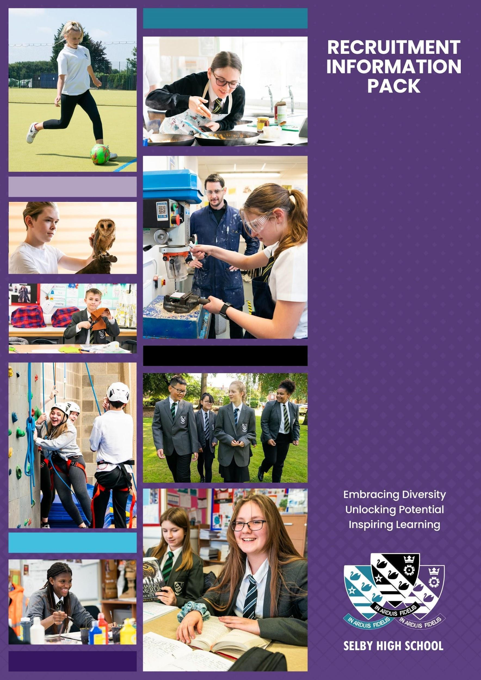

**Examinations and Data Officer**

**September 2024**

**WELCOME**

Dear Candidate,

Thank you for your interest in the post of Examinations and Data Officer. This is a crucial role for the school and we are looking for a candidate with excellent management skills, and the ability to form positive relationships with students and staff. The successful candidate will also have a good understanding of school data systems, as they will work closely with the Data Officer, and deputise for them in their absence.

Selby High School is an ambitious, forward looking, and successful 11-16 secondary school located in North Yorkshire and rated ‘good’ in our last inspection.  We are proud of our school and the opportunities it provides for both students and staff.  Our ambition is success for everyone through encouragement, teamwork, mutual respect and an enjoyment of learning.  We aim to create an environment where we all understand that by supporting each other and working together, we achieve more.

We offer a comprehensive induction programme and continual professional development for our staff.  We will provide you with excellent training opportunities, and encourage you to have high aspirations for your future career.

Selby High School is a great place to work. Please, just take a little time to look at the whole school twitter feed [https://twitter.com/SelbyHigh](https://twitter.com/SelbyHigh%20) to see some of the opportunities of the school.  If you have a little longer to spend, our school website at <http://www.selbyhigh.n-yorks.sch.uk/> gives a real insight into the character of our school.

This information pack contains the Job Description and Person Specification, together with some background information about the school.  We hope this gives you a feel for Selby High School. If you wish to visit prior to putting in your application, then you would be most welcome. I look forward to receiving your application.

With all best wishes.

Yours faithfully



Nick Hinchliffe

Principal

**ABOUT SELBY**

Selby is a small market town situated 14 miles (22.5 km) south of the city of York, along the course of the River Ouse. It is dominated by the superb Abbey, founded in AD1069 by Benedict when he saw three swans on a lake in Selby which he interpreted as a sign of the Father, Son and Holy Ghost, resulting in the official crest of Selby Abbey, and subsequently, Selby High School.

Selby local government district has a population of 82,900. It is a fairly rural district with a population density well below the national average. Selby town, with a population of 24,680 is its only major settlement, with a population of more than 15,000.

Selby has a growing local economy with new housing and shops being built on the town's outskirts. The riverfront area is also being revamped with modern housing and flats. This is anticipated to bring population growth and enhanced demand for high quality educational places into the future. Selby is ideally located to a whole variety of places, facilities and activities for culture, leisure, commerce and learning. There is a wide range and variety of housing and prices are below the national average.

|  |  |
| --- | --- |
| The district of Selby is contained within both the Leeds City Region and the York, North Yorkshire and East Riding Enterprise Partnerships. The Leeds E.P. Strategic Economic Plan (2016-2036) describes Selby as follows:  “The district of Selby sits on the eastern boundary of Leeds City Region within the county of North Yorkshire. Both the market town of Selby and the wider district are home to many highly skilled and paid employees, many of whom travel each day to Leeds, York and beyond. Its economy is characterised by manufacturing, distribution, construction and energy production; drawing its employees from the district’s market towns and villages, as well as neighbours including the East Riding, Wakefield and Doncaster.”  Looking ahead, the district has a key role to play in providing space for business growth in the Leeds City Region. The unemployment claimant count rate in Selby is around 1.3% (Sept 2016) which is well below the national average.  In terms of further education, Selby College is graded ‘good’ in all areas by Ofsted. It is a tertiary college providing the town`s sixth form as well as a small range of Higher Education courses, apprenticeship programmes and courses for adults. There is easy access to Leeds, Hull and York for Universities and it is to these centres that the majority of local, young HE entrants progress.  In short, Selby is a hidden gem, with both its own delights and very easy access to a diverse range of activities and experiences, for individuals and families of all ages. | **Selby Abbey has been at the heart of the community since 1069.** |

**LIVING IN NORTH YORKSHIRE**

**Knaresborough**

North Yorkshire is England's largest county and one of the most rural. The area comprises the Yorkshire Dales and North York Moors, three Areas of Outstanding Natural Beauty, the Pennines and a stunning coastline around Scarborough and Whitby. The area hosted the phenomenal Tour de France in 2014, and due to its success has created the Tour de Yorkshire with global recognition. There are ruined castles and abbeys, serene gardens, unique breweries, thrilling rides and industrial heritage. Something for everyone!

North Yorkshire has plenty to offer the outdoor enthusiast. From the hard gritstone of Almscliff and Brimham Rocks to the limestone of Malham, Gordale and Kilnsey, climbing venues are in abundance. The Yorkshire Dales is the premier area for caving and for mountain biking; there are the bridleways of the Dales and North York Moors as well as the renowned trail centre at Dalby Forest. The Sustrans trail centres are all easily accessible for days and weekends away, as is the Lake District and the fells, crags and coast of Northumberland. There are a small number of sailing clubs on reservoirs around the county and fantastic surf sport venues and sea kayaking on the east coast.

While the county is rightly known for its wide-open spaces, it also incorporates attractive market towns including Pickering and Helmsley, traditional seaside towns, the Spa town of Harrogate and the ancient city of York - the most visited city outside of London. There are a wide range of shopping, leisure and cultural facilities as well as excellent schools, universities, road and rail links; there really is everything to offer you and your family as a place to work, live and enjoy!

Travelling further afield we have convenient connectivity, with close proximity to metropolitan cities of Leeds and Newcastle, with little over two hours commute on the main train line to London. We border the Lake District, Lancashire, County Durham, and Yorkshire & Humber regions with all they have to offer.



**Whitby**

**SELBY HIGH SCHOOL**

|  |  |
| --- | --- |
|  | Selby High School is a thriving, successful, and popular school. The ‘can do’ ethos at the school ensures the very best for each and every one of its students. Following our successful OfSTED inspection, everyone at the school is eager to move towards outstanding in every area. Selby, located in North Yorkshire, benefits from good commuter links with York and Leeds.  Selby High School is an equal opportunities employer. We have a robust child protection policy and are committed to safeguarding the welfare of our children and young people. It is our objective to ensure that job applicants and staff are treated solely on the basis of their merits, abilities and potential. We do not discriminate against any applicants on the basis of any protected characteristics, and welcome applications form all sections of the community. |

As a school we work in a positive and supportive environment with learning and teaching at the heart of all that we do. We have committed and talented staff who aim to inspire everyone in our school community with a love of learning and, by doing so, maximising students’ life chances. We provide all our staff with a laptop computer and a full professional development and induction programme, both of which have been judged to be outstanding.

Please visit our [Policies page](https://www.selby-high.org.uk/Policies/) for the most up to date policies including Safeguarding & Child Protection and the Equalities Scheme which are part of the interview process.

|  |  |  |  |
| --- | --- | --- | --- |
|  | **Community and Culture** – Our school is a community, in which we provide help and support for one another, in line with our values. |  | **Prioritising high quality planning** – Effective  teaching and learning is underpinned by sensible, appropriate planning that is focused on the needs of all learners. |
|  | **High quality recruitment, retention and**  **development** – Our commitment to Career Pathways ensures that our staff team is always of the highest quality. |  | **Developmental teaching and learning** – We know that teaching time is like ‘gold dust’ and all staff need to be supported to deliver consistently good or better lessons. |
|  | **Supportive staff appraisal** – Aspirational targets that foster the improvement and development of all our colleagues, across the school. |  | **Communication commitment** – We strive to ensure that whole school communication is clear, timely, useful and manageable for all. |
|  | **Streamlined data and report management** – A  sensible approach that avoids duplication and leads to meaningful improvements for students. |  | **Wellbeing – A welcoming place to work** – We are an inclusive school community, committed to equality and diversity and a place where staff are happy in their work. |
|  | **Marking that is manageable and meaningful** – Time invested in marking and feedback should be proportional to the impact on student progress. |  | **Managing workload** – We believe that time well  spent is that which has the highest impact on raising standards, rejecting things that create unnecessary burden for little gain. |

**STAFF BENEFITS**

|  |  |
| --- | --- |
|  | Vivup is a provider of employee benefits in partnership with North Yorkshire County Council  North Yorkshire County Council recognise there is more to pay than just salary and they offer access to a wide range of competitive benefits.  The Vivup website provides colleagues with access to a host of voluntary benefits including discounts on goods and services such as your day to day shopping, days out, travel, electrical goods, leisure activities as well as links to salary sacrifice schemes. |
|  |  |

**Lifestyle Savings**

Explore a huge range of discounts to help you save money across hundreds of the UK’s favourite high-street and online retailers.

**Support & Wellbeing**

Access expert help and support for life’s ups and downs 24/7, 365 days a year. Make the most of the schemes available to help your money go further.

**DISCLOSURE**

All successful applicants are required to complete an enhanced DBS check and any offer of employment will be subject to satisfactory references and checks.

**HOW TO APPLY**

If you decide to apply, and we do hope you will, please complete the application form. This should be returned by e-mail to Caroline Airth at [admin@selbyhigh.co.uk](mailto:admin@selbyhigh.co.uk)

**Closing date:** Noon on Friday, 27th September, 2024

**POSITION:** Examinations and Data Officer

**SALARY:** Band H (£29,269 - £32,076 pro rata)

**REPORTS TO:** Principal, Vice Principal and Assistant Principal (and other identified staff)

**HOURS:** 37 Hours per week. Term Time Only plus 1 week

# Job Purpose

To manage arrangements for all public examination entries and internal testing, ensuring that there is a systematic approach to the administration of examinations and that the service meets quality standards.

Through liaison with the Assistant Principal in charge of Exams and the Vice Principal in charge of Data to support with Exam and Data related tasks.

To take responsibility for the administration of Student Data Records, and to provide administration support to the careers team.

**Key Responsibilities**

* Administer the school examinations process.
* Recruitment and management of our Exam Invigilators.
* Ensure compliance with JCQ and awarding body policy and procedures.
* Quality Nominee for BTEC.
* Communicate regulations in relation to the exams process to staff, parents/carers/guardians and students, on at least, an annual basis.
* Administer and run annual reading, spelling, PASS and LUCID assessments.
* Manage and administer the mock examinations process in line with school policy.
* Create domestic base data and examination timetables.
* Production of tracker sheets and reports for end of year and mock exams
* Recruitment, supervision and timetabling of invigilation staff and performance management thereof.
* Contribute towards the setting of the exam budget, including managing areas of spend.
* Develop the use of ARBOR to suit the needs of the school, particularly the Assessment Manager & Exams Organiser modules. Develop mark sheets, templates, grade sets etc.
* Provide expertise and advice to staff and students.
* Collate information for statistical returns.
* Quality assure DfE examination results data, prior to its publication.
* To engage with training and development, and work shadowing of the Data and Examinations Officer.
* Work closely with the Data and Examinations Officer, in order to deputise as and when required.

**Other Administration Duties**

* Manage and develop the process for maintaining and updating student records on the school’s Management Information System - ARBOR, and paper copies kept in the school office. At agreed times throughout the

academic year for each year group, and in line with DfE recommendations, post home SDR forms annually for the whole school, recording and monitoring their return.

* Manage the collection of the NYC Consent and Medical Information for Educational Off-Site Visits form for all students, annually, at the start of the Autumn Term.
* Provide support for the careers team:

1. Liaise with potential providers and organisations for the annual Careers Fair
2. Maintain the work experience data base
3. Support with the organisation of the Selby College Taster Day.

* Undertake general administrative and clerical tasks as required including supporting the Student Services reception desk during busy periods and providing emergency first aid assistance.
* Help train others in the department in the use of ARBOR.
* Provide cover for team members as required.

**Safeguarding**

* Be responsible for promoting and safeguarding the welfare of children and young people that you are responsible for and come into contact with.
* Undertake annual training in the most recent legislation.
* Be able to recognise when a child or young person is in danger or at risk of harm and take action to protect them.
* Make considered judgements about how to act to safeguard and promote a child or young person’s welfare

**Data Protection**

* Comply with the County Council’s policies and supporting documentation in relation to Information Governance this includes Data Protection, Information Security and Confidentiality.

**Development**

* Ensure continued personal professional development through attendance at relevant training.
* Undertake appropriate training in the use of ICT software programs to ensure the most effective and efficient processes support your work.

**General**

* Undertake any other duties as reasonably required by the Principal.
* Contribute to the life of the school community and to support its ethos and policies.

**Health & Safety**

* Be aware of the responsibility for personal health, safety and welfare and that of others who may be affected by your actions or inactions.
* Be aware of the specific issues relating to health and safety in your area and make appropriate assessments of any risk.
* Co-operate with the employer on all issues to do with health, safety and welfare.

**Person Specification**

|  |  |  |
| --- | --- | --- |
| **CRITERIA** | **ESSENTIAL** | **DESIRABLE** |
| **Qualifications & Training**  Level 2 literacy & numeracy (or equivalent)  Relevant level 3 qualification in business / finance / administration or equivalent  ARBOR Application Training  Microsoft Office including Excel and Word  Appropriate first aid training | X | X  X  X  X |
| **Experience**  Examinations and Data Officer experience  Arbor experience  Experience of working in a busy office environment and of managing teams  Significant experience in public / private sector administration, with experience of computerised management information systems. | X  X | X  X |
| **Knowledge**  Substantial knowledge of office and admin systems  Knowledge of school procedures | X | X |
| **Occupational Skills**  Excellent ICT skills in the use of Word & Excel  Excellent written and verbal communication skills: able to communicate effectively and clearly with a range of staff, children, young people, their families and carers.  Problem solving skills  Highly developed organisational skills  High level literacy and numeracy skills  Ability to work independently and on own initiative  Leadership skills  Report writing skills | X  X  X  X  X  X  X  X |  |
| **Personal Qualities**  Attention to detail, neatness and accuracy  Dependability, reliability & flexible approach  Ability to work successfully as part of a team and lead a team  Confidentiality  Ability to work to deadlines and prioritise own workload | X  X  X  X  X |  |
| **Other Requirements**  To be committed to the school’s policies and ethos  Willingness to undertake training and development to understand the schools data requirements and how to produce required data.  To be committed to Continual Professional Development.  Motivation to work with children and young people.  Ability to form and maintain appropriate relationships and personal boundaries with children and young people. | X  X  X  X |  |
| **Equal opportunities**  To assist in ensuring that NYCC’s equalities policies are considered within the school’s working practices in terms of both employment and service delivery | X |  |