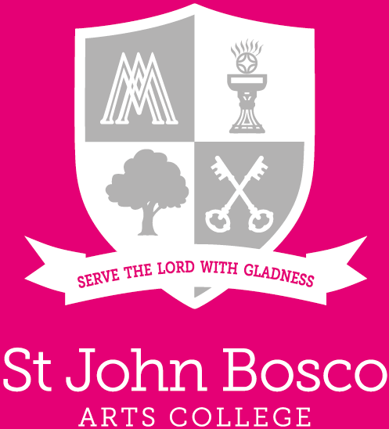

Exams Officer
  - May 2024
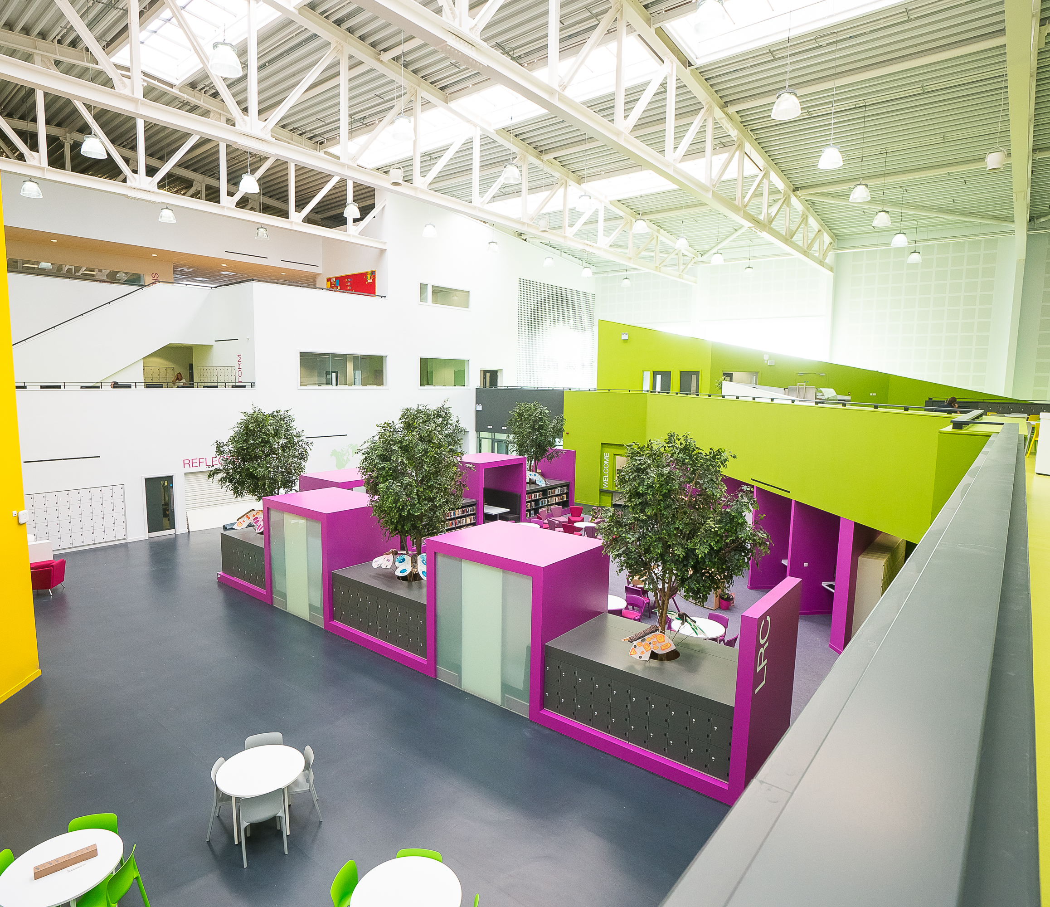


VISION AND VALUES

Contact details:

www.stjohnboscoartscollege.com
St John Bosco Arts College, Storrington Avenue, Liverpool L11 9DQ
Tel: 0151 330 5142
Email: enquiries@stjohnbosco.org.uk

Table of Contents

VISION AND VALUES 2
Contact details: 3
Letter from the Headteacher 4
Job Advertisement 5
Our Curriculum 6
Bosco Benefits 7
JOB DESCRIPTION 8
Person Specification 10

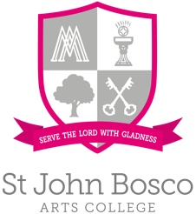

Letter from the Headteacher

May 2024

Dear prospective applicant,
St John Bosco Arts College is excited to announce the opening for an Exams Officer within our vibrant school community. This key position offers the unique chance to contribute significantly to the smooth running and success of our examination processes, a cornerstone of our academic structure.
Our ethos emphasises creating a nurturing and respectful environment, encouraging growth in faith, hope, and love. We aim to provide an ambitious educational experience, preparing students and staff for future challenges.
As the Exams Officer, you will be central to our commitment to academic excellence. Your role will encompass organising, managing, and overseeing all aspects of exam administration, from planning and timetabling to ensuring compliance with examination board regulations. We encourage the development of a team of in-house invigilators working with existing agency exams staff. A keen eye for detail, exceptional organisational skills, and the ability to work under pressure are critical for success in this role.
We seek a confident, innovative individual capable of enhancing our school's examination processes. Further details enclosed will aid in determining if this opportunity aligns with your professional goals.
If you share our values and believe in your ability to contribute to our vision, we would be delighted to consider your application. Visits to our school are welcome, and we encourage arranging this by contacting Executive Officer, Caroline Waters, at 0151 330 5142 or watersc@stjohnbosco.org.uk.
St John Bosco Arts College is driven by principles of Love, Faith, Community, Respect, and Hope in all we undertake. United by these values, we strive to inspire and empower our next generation.
We look forward to your application and the potential to welcome you into our community.
Yours faithfully

Darren Gidman
Headteacher

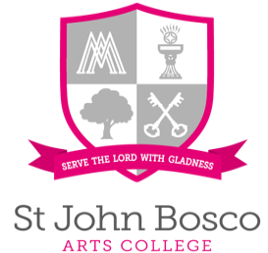

Job Advertisement

Exams Officer

Reports to: Headteacher
Assistant Headteacher
Start Date: ASAP
Salary: PASS Scale 6 – (£27,803 - £30,296) pro rata - term time only + 2 weeks. Actual salary £24,780.
The salary is competitive, negotiable based on experience and qualifications. We're flexible and eager to discuss options that may suit some candidates such as part time work to ensure we find the right candidate. If you're considering a term-time contract, we're open to discussions about extending it to a full-year position. We'd love to hear from you!
The Governors of St John Bosco Arts College, an 11-18 Girls Catholic Specialist Arts College, are seeking a highly skilled, motivated, and dynamic Exams Officer. This essential role focuses on managing and enhancing the examination processes of our school, necessitating a candidate who is not only proficient in administrative duties but also passionate about ensuring the smooth execution of examinations to support our students' educational achievements.
We are looking for an experienced individual who can effectively manage and oversee all aspects of examinations, from planning and coordination to compliance with examination board regulations and standards. The ideal candidate will have a clear vision for the efficient and effective running of exams, demonstrating the ability to lead, inspire, and ensure accuracy and fairness in all exam-related activities. Strong interpersonal, organisational, and communication skills are essential.
Candidates are invited to review the job description/person specification, articulating how they meet the outlined criteria and the unique qualities and experiences they would bring to the role.
For more details and to access the application form, please visit the school website.
Closing date: ​12 noon Friday, 17th May 2024
Please note that only applicants who have been shortlisted for posts will be contacted following the closing date.
Interviews: ​to be confirmed
As part of the shortlisting, we will carry out an online search as part of due diligence on the shortlisted candidates. This may help identify any incidents or issues that have happened, and are publicly available online, which the college might want to explore with the applicant at interview.
Our school is committed to safeguarding children and has safer recruitment procedures in keeping with DFE statutory guidance. All posts are subject to the required DFE preemployment checks being completed including an Enhanced DBS Certificate [including a Children’s Barred List Check]. Our recruitment pack contains key safeguarding policies including our code of conduct for staff and volunteers which everyone must adhere to.

Our Curriculum

Find out more about our curriculum here.

We believe our students should be provided with a broad, balanced, rich, coherent, progressive curriculum with the EBacc at the core. This curriculum should promote spiritual, moral, cultural, mental and physical development of the pupils and prepare them for the opportunities, responsibilities and experiences of adult life.

The curriculum aims to enable all pupils to become:

- Creative learners – who enjoy learning, make progress and achieve well
- Confident individuals – who are able to lead safe and healthy lives
- Caring citizens – who make a positive contribution to society
Equality of access and opportunity is central to our curriculum provision for all.

We have an effective governing body who alongside the leadership team, encourage collaboration, promote a coaching culture, and build capacity across the whole school. Our innovative curriculum is developed and delivered by expert staff.

We provide excellent CDP opportunities.

Learn more about St John Bosco and his story…

https://www.youtube.com/watch?v=5rXZxoLCkes

http://www.donboscowest.org/saints/donbosco

Bosco Benefits

At St John Bosco Arts College, we pride ourselves on offering our staff a range of benefits that help them to thrive both in and out of work. Here are just some of the benefits of being an employee at our school:
- Outstanding CPD opportunities and development, facilitated by our in-house Teacher Development Partnership and our role as part of a Teaching School Hub, which provides a broad network of connections across the city region.
- Pupils who are a joy to work with and for, as well as colleagues who are fully committed and go above and beyond to serve the pupils and support each other.
- A Communications Policy that promotes better work-life balance, allowing you to maintain a healthy equilibrium between your professional and personal life.
- A state-of-the-art building, featuring modern facilities and a well-designed workspace.
- Beautiful gardens and excellent facilities that help to create a positive and vibrant learning environment.
- Dedicated working parties that support staff in areas such as appraisal, teaching and learning, workload, and diversity.
- Opportunities for dedicated career conversations, which can help you to plan your professional development and identify new areas of growth.
- Dedicated collaborative time, enabling you to work alongside your colleagues and share ideas and expertise.
- We are proud to be a cornerstone and pilot of establishing the DfE workload reduction toolkit, demonstrating our commitment to reducing teacher workload and improving well-being.
- A range of Salary Sacrifice Schemes, enabling you to access cost savings on a variety of purchases and expenses.
- A Cycle to Work Scheme, allowing you to save money and stay healthy by cycling to work.
- Access to Medicash, providing valuable health and well-being benefits to all employees.
- Free tea and coffee, as well as delicious and healthy food available at school canteen prices.
We are proud to offer our staff a range of benefits that help them to thrive both in and out of work. If you join us, we believe you will find a welcoming and supportive community that will help you to achieve your professional goals while maintaining a healthy balance in your personal life.

JOB DESCRIPTION

Reports to: Headteacher
Assistant Headteacher
Start Date: ASAP
Salary: PASS Scale 6 – (£27,803 - £30,296) pro rata - term time only + 2 weeks. Actual salary £24,780.
The salary is competitive, negotiable based on experience and qualifications. There is also the opportunity for this Term Time only contract to be extended to a full-year basis – please get in touch.

PURPOSE OF JOB:
- To manage the whole examination process
- To maintain and develop attendance mechanisms and to manage the cover system to ensure continuity of teaching and learning.

KEY DUTIES & RESPONSIBILITIES:

EXAMINATIONS
- To plan, organise and supervise all aspects of examination, Mock Exams and CATs testing arrangements to ensure that an efficient and effective service is provided
- To administer all examination entries
- To administer BTEC Registrations
- Oversee all post-results services
- To develop and train a team of invigilators
- To plan and organise the examination timetable including room allocation and preparation
- To organise, oversee and supervise examination invigilation and train all invigilators
- To be conscious with all relevant regulations and ensure compliance
- To liaise with staff, examination boards and other agencies as required
- To organise and be in attendance on results days
- To analyse results and other statistics and represent them as required
- To prepare estimates of expenditure and exercise day to day control of the examination budget
- To prepare Course Manager [SIMS] with relevant course data, to support with the census return
- To ensure Post 16 data and prior attainment records are accurate
- To undertake all exam data checking processes
- To work alongside the data manager providing all relevant data to other systems and returns.

SCHOOL ETHOS AND REGULATIONS
- To contribute to the distinctive catholic Salesian ethos of the school, as outlined in the mission statement.
- To support and follow the policies and procedures set out in the staff handbook and as directed by the governing body

OTHER
- To undertake other essential administrative tasks as directed by the Business Manager
- To undertake training courses and develop new skills as required by the post
- Undertake any other duties as reasonably requested by the Headteacher.
- To take advantage of all opportunities for professional development

This post is based on a term time only contract. However, because of the particular requirements relating to examinations, the post holder will be required in college on both weeks when the GCSE and A-level results are published so that they can be analysed and prepared for individual students, and these two weeks will be paid as overtime.

Person Specification
Required Attributes | Essential  or  Desirable | To be assessed by
Experience:  Examination systems and their relationship to the curriculum  Managing resources and staff  Use of SIMS Exams and Assessment Manager | E  E  E | Application  Application  Application
Knowledge, skills & abilities:  Organisational skills, with an ability to work under pressure  Self motivated with the ability to motivate others  Effective interpersonal skills with the ability to communicate with people at all levels and to supervise staff and pupils  Ability to develop own knowledge, skills and understanding to enhance personal performance  Well developed ICT skills  Excellent organisational skills, demonstrating initiative, discretion and professionalism  Ability to be flexible and adaptable whilst working as part of a team  Ability to convey technical issues in non- technical language | E  E  E  D  E  E  E  E | Application/Interview  Application/Interview  Application/Interview  Application/Interview  Application/Interview  Application/Interview  Application/Interview  Interview
Other:  Commitment to equal opportunities, positive relationships and continuous improvement  Commitment and empathy with the distinctive Salesian ethos of the school | E  E | Application/Interview  Application/Interview

www.stjohnboscoartscollege.com
Storrington Avenue, Liverpool L11 9DQ
Tel: 0151 330 5142
Email: enquiries@stjohnbosco.org.uk

Contact Us |  | 0151 330 5142 |  | www.stjohnboscoartscollege.com  enquiries@stjohnbosco.org.uk

