The Poplar Adolescent Unit and the St Aubyn Centre Therapeutic Education Departments are the Essex County Council specialist providers of education for all young people admitted to the two psychiatric hospitals in Essex.
- Poplar Adolescent Unit Therapeutic Education Department is situated at Rochford Community Hospital in south Essex and teaches young people from the Poplar ward. There are adult wards and community services on the same site and we share some facilities with these.
- The St Aubyn Centre Therapeutic Education Department is situated at the St Aubyn Centre in Colchester. This is a purpose built centre with two wards, Longview and Larkwood. We teach children from both wards.

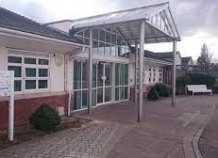 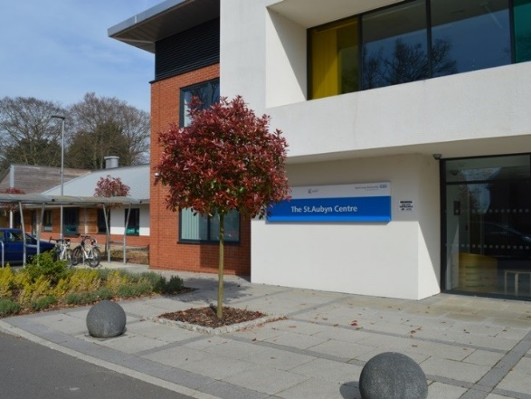
Poplar at Rochford Community Hospital The St Aubyn Centre

All young people admitted to either hospital have mental health problems of a severity considered too great to be managed in the community. Difficulties include depression, suicidal ideation, psychosis, obsessive compulsive disorder, eating disorders and others. Often young people present with more than one condition and many of our young people are neurodiverse. We also have significant number of looked after children and children who are not in employment, education or training. The length of stay is commonly six to twelve weeks although some admissions are a few days and some stay much longer. Education is part of the programme for all young people admitted to both hospitals.
We believe that all young people should be provided with appropriate education in a safe, stable, containing learning environment. Our students are aged 13 to 18 and range from mild learning difficulties to gifted and talented. Our curriculum combines academic work and personal development. Young people are given opportunities to succeed through the use of highly personalised Individual Education Plans, which are linked to the Care Pathway for their mental health needs.
We see engagement with education in the widest sense as fundamental to recovery. The education teams work very closely with the nurses, doctors and therapists at the centres and with a wide range of professionals in the community. We maintain close contact with the young people’s home schools and work with them on reintegration back to school when they are able to. Where students are not in education, employment or training we try to find suitable provision for them to engage with when they leave hospital.
Both hospitals have dedicated classroom spaces for education. At Poplar, the main classrooms are situated across the carpark from the ward so some children are unable to attend these due to their risk levels. These young people are taught in a small classroom on the ward until they are able to attend the main school area. At St Aubyns the classrooms are integrated within the unit, so all young people are able to attend the main classrooms.
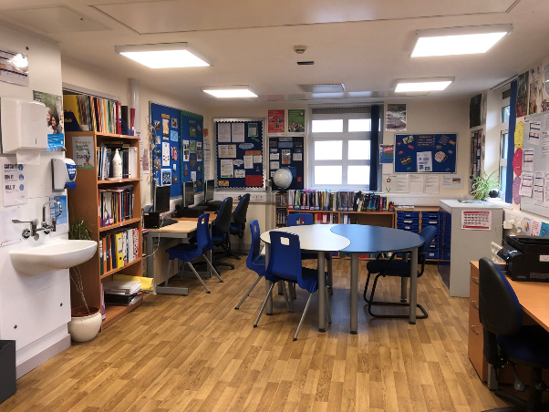
“Students say they like coming to the unit because the teachers are ‘really helpful and they do more than they have to’. They know their teachers respect and value them and their own behaviour reflects this. They are respectful to each other and adults, and try to do their best even when they are not well.”
Poplar Ofsted

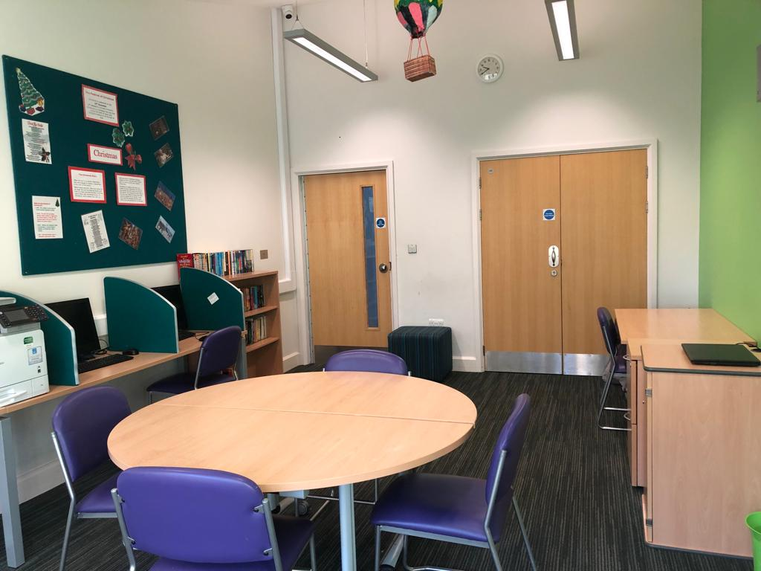
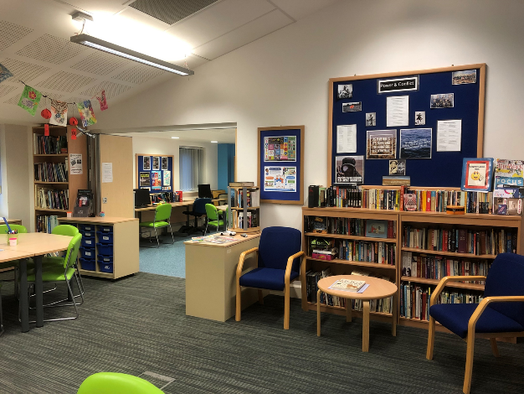
“The very highest expectations, strong relationships between staff and students, and a ‘can do’ approach underpin the success of the unit. A profound understanding of the mental health needs of students, coupled with the unit’s informed and therapeutic approach to their education, cements this success.”
St Aubyns Ofsted

For more information, please see the schools’ websites
https://www.staubyn-centre.essex.sch.uk/
https://poplaradolescentunit.essex.sch.uk/

