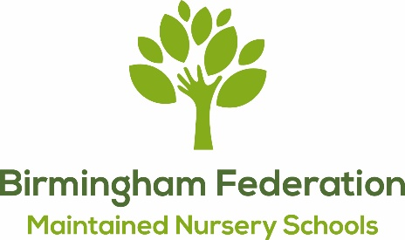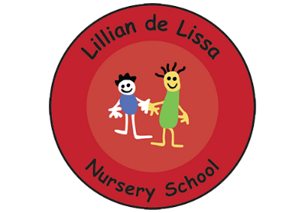
Executive Head Teacher (L15 - L21) to start January 2025
Lillian de Lissa Nursery School and St Thomas Centre Nursery School
The Birmingham Federation of Maintained Nursery Schools consists of nine Maintained Nursery Schools, each with individual personalities, spread across South and Central Birmingham. We are driven by our goal to secure excellent, responsive and creative early education for all children. Our schools offer high quality and inclusive early learning which, alongside the other Maintained Nursery Schools in the city, provide an important role in the development of all Birmingham's young children.

Our Governing Board is now seeking to appoint a visionary and committed early years leader to take Executive Headship responsibility for a cluster of 2 OFSTED outstanding Nursery Schools. This is of interest to current head teachers at nursery schools, deputy head teachers in nursery or primary schools, or leaders responsible for early years in primary schools with at least 2 years of experience.
Both nursery schools work with child centred practice at the heart of all provision. We pride ourselves on being flexible and facing every new challenge head on so to continue in offering each child and family what is best for them.
We provide a safe and secure environment, and the early years provision we offer makes a huge difference to the children and families we work with.
We are looking for someone with innovation, inspiration and impact.
We can offer you:
- The opportunity to make significant contributions to the development, educational and life chances of children and families in our schools.
- The support and partnership of highly committed SLT, governors and parents.
- A commitment to ongoing high quality professional development.
- A visionary approach to shaping the landscape of inclusive early years education.
You will offer us:
- Inspirational, strategic leadership.
- A positive and creative approach to further enhance our high quality, inclusive provision.
- Skills to build positive relationship with our staff team, communities, and partners.
- Knowledge and expertise in managing budgets and generating new income sources.
- Commitment to ensuring the highest standards of safeguarding, throughout our school communities.
A visit to the schools is encouraged and a number of dates are set out in the Candidate Pack. An informal conversation with the Chair of Governors (Sean Delaney) is also possible; He can be contacted via s.delaney@crec.co.uk
Applications to be submitted via Birmingham City Council and should be received by no later than 9am on Monday 3rd June 2024. Shortlisting will take place w/c 10th June and interviews are scheduled for 24th June 2024.
The successful applicant will be required to undertake safer recruitment checks and shortlisted applicants will be asked to complete a self declaration and will be subject to online checks.

Our websites can offer more information about us and the federation schools: https://bfmns.sch.life/

