LETTER FROM THE CHAIR OF GOVERNORS
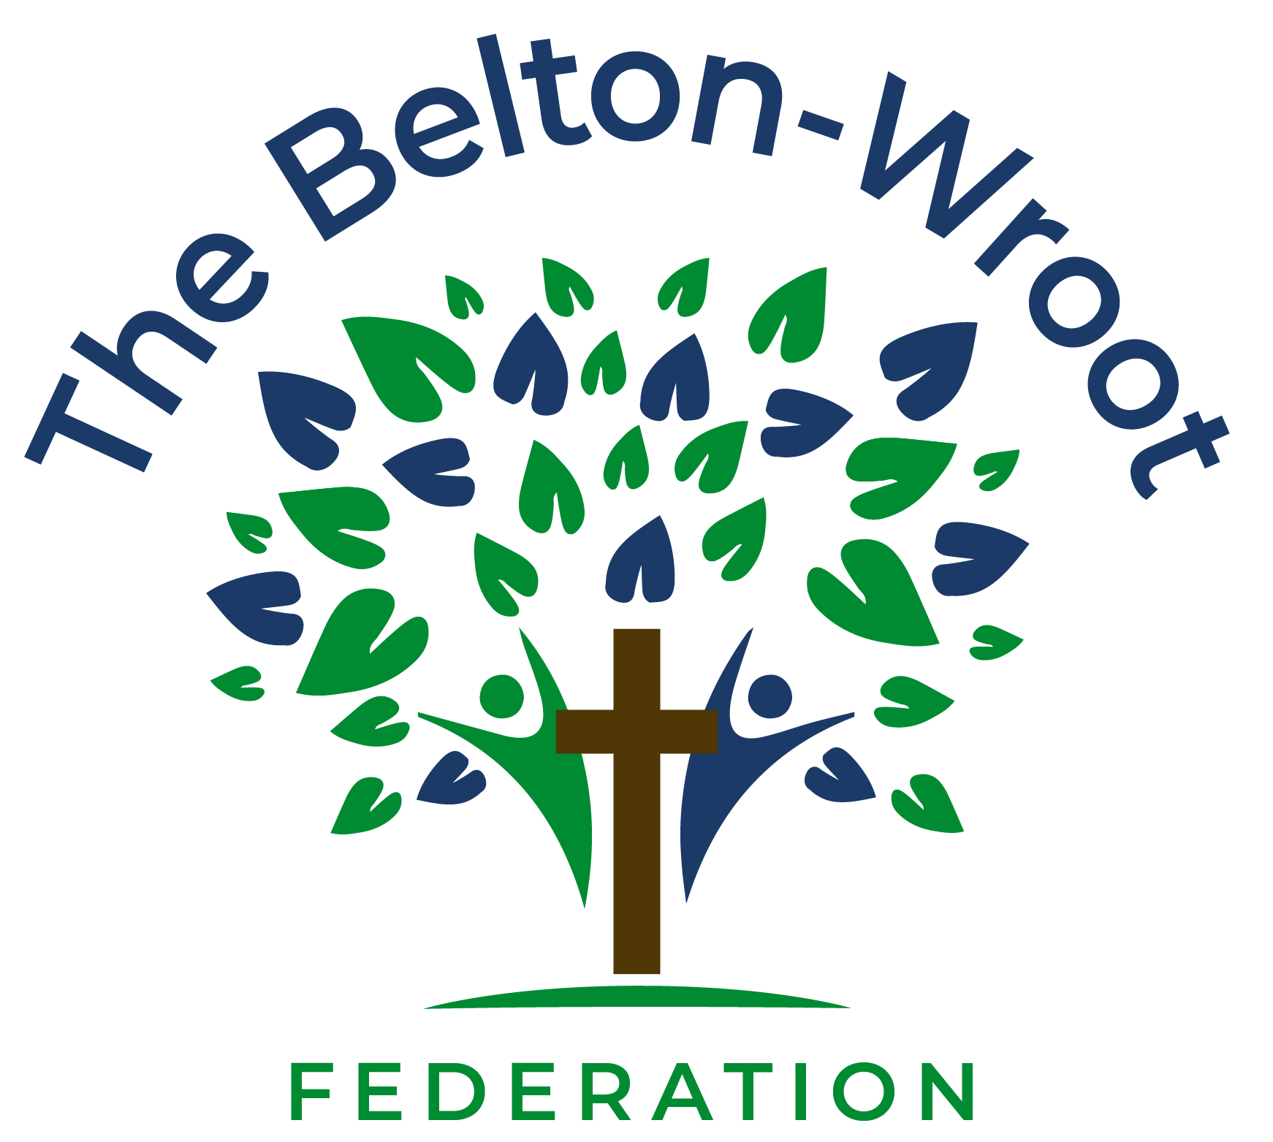
Dear Prospective Executive Headteacher,
Thank you for your interest in the position of Executive Headteacher at Belton and Wroot Federation.
This is an exciting opportunity to lead two thriving Church of England primary schools at the heart of their communities and to build upon the strong foundations established through excellent leadership, dedicated staff, supportive governance and strong partnerships with families and the wider community.
As Governors, we are seeking an inspirational, ambitious and values-driven leader who will embrace our vision and ethos while leading our federation confidently into the next stage of its development. We are looking for someone who places children at the centre of every decision, nurtures and develops staff, and continues to foster the strong relationships that make our federation such a special place to learn and work.
The successful candidate will join a federation that is proud of its achievements, ambitious for its future and committed to ensuring that every child is known, valued and encouraged to flourish. This is a rare opportunity to lead two distinctive schools united by a shared vision, strong values and a relentless commitment to providing the very best education for every child.

Two Unique Schools, One Federation Family
Belton All Saints CE Primary School and Wroot Travis CE Primary School are proud to serve the communities of the Isle of Axholme. Belton All Saints currently has 217 pupils on roll and Wroot Travis has 30 pupils, providing a distinctive federation model that combines the opportunities of a larger primary school with the close-knit community ethos of a small village school. Although differing in size and character, both schools share a common commitment to providing excellent educational experiences, high-quality pastoral care and opportunities that enable every child to flourish academically, socially, emotionally and spiritually.
Our federation enjoys a strong reputation for providing high-quality education, nurturing care and inclusive opportunities for all children. Families value the partnerships we have established, and the support and engagement of parents and carers are among our greatest strengths. Together, we have created welcoming, inclusive and ambitious learning environments where children are encouraged to be confident, resilient and successful learners.
Visitors to our schools frequently comment on the warm atmosphere, positive relationships and strong sense of belonging that exists throughout our federation. Our pupils are polite, enthusiastic and eager to learn. They take pride in their schools and are supported by dedicated staff who consistently place children's wellbeing, achievement and personal development at the heart of their work.

Our Vision and Values
As a federation of Church of England schools within the Diocese of Lincoln, our Christian vision underpins all aspects of school life.
"Be bold, be strong, for the Lord your God is with you." (Joshua 1:9)
Belton and Wroot Federation is proud to be a thriving church school family. Our vision is to provide rich, lifelong learning experiences and excellent provision, resulting in a happy, confident school community where we all grow, flourish, achieve success, feel safe and genuinely care for one another and the world around us.
At the heart of our federation are the Christian values of:
• Trust
• Love
• Hope
• Perseverance
• Wisdom
These values shape our relationships, our curriculum and our decision-making. We welcome and celebrate those of all faiths and none, creating communities where every individual is known, valued and encouraged to fulfil their God-given potential.
Our schools benefit greatly from strong partnerships with our local churches and the Diocese of Lincoln. Collective worship, spiritual development and service to others are integral elements of school life and contribute significantly to the nurturing environment that our children and families value so highly.

High Standards and Ambition
Our federation has gone from strength to strength in recent years and is well placed for future success. We are proud of our broad and engaging curriculum, our commitment to inclusion and our determination that every child receives the support, challenge and opportunities they need to thrive.
We have high expectations for behaviour, attitudes to learning and achievement. Pupils respond positively to these expectations and demonstrate resilience, respect and enthusiasm in all aspects of school life.
We are equally committed to ensuring that every child feels safe, valued and supported. Staff work closely with families and external agencies to meet the needs of all learners, including those who are disadvantaged and those with special educational needs and disabilities.
Recent Ofsted inspections recognised the calm, purposeful atmosphere within our schools, the high expectations established by leaders and the strength of our provision for pupils' personal development. Inspectors noted that pupils are polite and respectful to one another and highlighted personal development as a particular strength of our schools. Our most recent SIAMS inspection at Wroot Travis CE Primary School recognised the strength of our Christian distinctiveness and the positive impact of our vision and values.

The Opportunity
The successful candidate will inherit a federation with many strengths, a clear sense of purpose and significant potential for future growth and development. This role offers the opportunity to shape the strategic direction of two successful schools, develop talented staff, strengthen partnerships and ensure that every child continues to receive the very best educational experience.
We are looking for a leader who:
• Has a clear and compelling vision for excellence in education.
• Demonstrates strong strategic and operational leadership.
• Inspires and develops others.
• Values partnership and collaboration.
• Understands and embraces the distinctive nature of Church school leadership.
• Has the ambition and drive to build on existing successes while identifying new opportunities for growth and improvement.

Our Commitment to You
As Governors, we are committed to supporting the successful candidate. We value professional development and recognise the importance of providing appropriate challenge and support.
You will benefit from:
• A dedicated and supportive Governing Board.
• Experienced and committed staff teams.
• Engaged families and local communities.
• Strong partnerships with the Diocese of Lincoln and the Local Authority.
• Access to leadership development, professional networks, mentoring and school improvement support.
• Opportunities to collaborate with other schools and educational leaders.
This is a challenging, rewarding and fulfilling role that offers the opportunity to make a genuine difference to the lives of children, families and communities.
If you share our ambition, our values and our commitment to ensuring every child flourishes, we would be delighted to hear from you and encourage you to apply for this exceptional leadership opportunity.
Yours faithfully,
Maureen Collett
Chair of Governors
On behalf of the Governing Board of Belton and Wroot Federation

