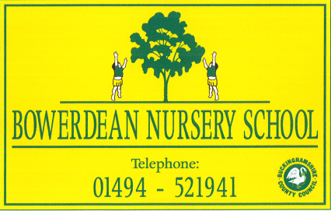

Executive Headteacher – Nursery Federation

Overview
We are looking for someone to take on this strategic role with a passion for and a commitment to early years, and to lead three outstanding schools into an exciting future.

Start date: 1st September 2021
Salary: L12 - L18, depending on experience
Closing date: midday, Tuesday 20th April 2021
Contract: Permanent
Hours: Full time, but open to negotiation

About us
This is an exciting and unique opportunity to lead the The Growing Together Federation which encompasses Bowerdean Nursery School, Mapledean Nursery School (both in High Wycombe) and Henry Allen Nursery School (in Amersham).

The schools work together, sharing a common vision and collective aims, but each is distinctive in character. Each is an established part of its community, working in close collaboration with parents to help their children thrive within happy and supportive environments. At our core is the knowledge that, through play, children can practise skills and come to understand and make sense of the world around them, growing into independent learners with resilient problem solving skills.

About the role
This is an excellent opportunity for someone to lead an unusual and exciting combination. Being graded Outstanding is not the end of our story. We want someone to grow the Federation beyond where it is now. We want to be excited about the future. We want children to be excited about learning.

About you
We are looking for a professional who will bring:
- Compassion and warmth to a dedicated team of staff and an exciting group of children and families.
- Clear strategic vision and a commitment for continuous quality improvement.
- A passion for Early Years Education and a strong commitment to improving outcomes for all children across the Federation.
- A thorough knowledge of and a strong commitment to safeguarding for all.
- Flexibility: enough to manage the day to day challenges of working across three sites; enough to take on the many roles that come your way and enough to support the growth and development of staff at all levels.
- Excellent communication skills and the ability to communicate clearly and effectively with all stake holders, outside agencies and partners.
- Inspirational leadership to identify the potential in others, encouraging and nurturing talent and expertise.
- Physical and emotional resilience, to face and embrace the varied challenges of the role.
- Energy, creativity and a good sense of humour.

We would be delighted to welcome you to visit us, safely of course:
- To visit Bowerdean please email office@bowerdean.bucks.sch.uk or call 01494 521941.
- To visit Mapledean please email office@bowerdean.bucks.sch.uk or call 01494 443256
- To visit Henry Allen please email office@henryallen.bucks.sch.uk or call 01494 726257.

References will be taken up following shortlisting, prior to interviews.
Please submit your application form to either email address and mark it for the attention of Karen Bates, Chair of Governors, by midday Tuesday 20th April 2021.

Interview Days: Wednesday 28th April and Thursday 29th April 2021, tbc

The Growing Together Federation is committed to the safeguarding and well-being of all children and expects all staff and volunteers to share this commitment. The successful applicant will be required to undertake an enhanced DBS check.

Available downloads
Application form
Job description
Person Specification
GTF history

